12/20/2023

Adarsh Gupta (13238704)

Data On Cloud

Practical Assignment

### **DOCUMENT CONTROL DETAIL**

**Document version control**

|  |  |
| --- | --- |
| **Document Title** | Data On Cloud Assignment Experiments |
| **Document Version** | 1.0 |
| **Prepared by** | Adarsh Gupta |
| **Seat No** | 13238704 |
| **Student ID** | 4824559 |
| **Reviewer** | Vaibhav Vasani Sir |

**Document submission details**

|  |  |
| --- | --- |
| **Date** | Jan 26, 2024 |
| **Classification** | Confidential |
| **Document Type** | Assignment Experiments |
| **Submitted To** | Vaibhav Vasani Sir |
| **Address** | Kalyan |
| **Email** | vaibhav.vasani@gmail.com |

**Document distribution list**

|  |  |  |  |
| --- | --- | --- | --- |
| **Sr. No.** | **Name** | **University/College** | **Purpose** |
| 01 | Adarsh Gupta | B.K Birla Kalyan | Educational |

### **Table Of Contents**

Table of Contents

**DOCUMENT CONTROL DETAIL** 1

**Table Of Contents** 2

Experiment No.1 3

Experiment No. 2 16

Experiment No. 3 20

Steps for Hosting Your Website On Google App Engine. 28

Experiment No. 4 36

Experiment No. 5 44

Experiment No.7 55

Steps to Creating a Free Tier AWS Account: 61

Experiment No.8 73

# Experiment No.1

**Study of Cloud Computing and Architecture**

**Types of Computing:**

A computer system uses many devices, arranged in different ways to solve many problems. This constitutes a computing environment where many computers are used to process and exchange information to handle multiple issues.

The different types of Computing are:

1. **Personal Computing:**

Description: Personal computing involves the use of computing devices by individual users. This includes desktops, laptops, tablets, and smartphones.

Characteristics: User centric, local data storage, diverse applications for personal and professional use.

1. **Cloud Computing:**

Description: Cloud computing relies on remote servers hosted on the internet to store, manage, and process data. Users access services and resources via the internet.

Characteristics: On demand access, scalability, cost effectiveness, and shared resources.

1. **Edge Computing:**

Description: Edge computing involves processing data closer to the source of generation rather than relying on a centralized cloud server. It reduces latency and enhances realtime processing.

Characteristics: Low latency, bandwidth efficiency, and decentralized data processing.

1. **Quantum Computing:**

Description: Quantum computing leverages the principles of quantum mechanics to perform computations using quantum bits (qubits), enabling the processing of complex problems at an exponential speed.

Characteristics: Parallelism, superposition, and quantum entanglement.

1. **Mobile Computing:**

Description: Mobile computing refers to the use of portable computing devices like smartphones and tablets. It emphasizes wireless communication and mobility.

Characteristics: Portability, wireless connectivity, location awareness.

1. **Grid Computing:**

Description: Grid computing involves connecting multiple computing resources to work together on a task, solving complex problems that require significant processing power.

Characteristics: Distributed computing, resource sharing, collaboration.

1. **Supercomputing:**

Description: Supercomputing refers to the use of extremely powerful computers capable of processing large volumes of data at extraordinary speeds. It is often used for scientific and research purposes.

Characteristics: High processing speed, largescale parallel processing.

1. **Green Computing:**

Description: Green computing focuses on designing, manufacturing, and using computers in an environmentally friendly manner. It aims to reduce the environmental impact of computing activities.

Characteristics: Energy efficiency, resource conservation, and waste reduction.

1. **Distributed Computing:**

Description: Distributed computing involves the use of interconnected computers to solve a complex problem. Tasks are divided among multiple computers that communicate and coordinate their actions.

Characteristics: Task distribution, collaboration, fault tolerance.

1. **Cluster Computing:**

The clustered computing environment is similar to parallel computing environment as they both have multiple CPUs. A major difference is that clustered systems are created by two or more individual computer systems merged together which then work parallel to each other.

➢ **NIST Definition for Cloud:**

A model for enabling ubiquitous, convenient, OnDemand network access to a shared pool of configurable computing resources that can be rapidly provisioned and released with minimal management effort or service provider interaction. This cloud model comprises five essential characteristics, three service, and four deployment models.

The NIST definition also includes:

* Broad network access
* Minimal management effort or service provider interaction
* Three service categories:
  1. Software as a service (SaaS)
  2. Platform as a service (PaaS)
  3. Infrastructure as a service (IaaS)

* **5 Essentials characteristics of Cloud:**

* 1. **OnDemand SelfService:**

Selfservice means that the cloud user can acquire the service independently: without going through an IT department, call center, or other middle man. To support selfservice:

* + The cloud provider must have an automated interface, such as a web portal or mobile app.
  + The user should be able to access the interface at any time.
  + The user should also be able to cancel the cloud service at any time.

* 1. **Broad Network Access:**

The cloud service must be broadly available over the communication network. Users should be able to access it from any location and internetenabled device.

* 1. **Resource Pooling:**

Multiple customers share the cloud service resources in a multitenancy model. This model raises privacy and security concerns, so users must protect their cloud data and assets by taking necessary security precautions.

* 1. **Rapid Elasticity:**

Elasticity refers to the flexibility of the cloud service to scale up or down automatically to meet the user’s needs. That allows the user to access the right level and kind of resources, including processing power, memory, network bandwidth, and storage, to accommodate the user’s varying workloads.

* 1. **Measured Service:**

A measured cloud service provides a metering capability that underpins the provider’s payasyougo pricing model. This model provides users with greater transparency and control over their cloud costs.

* **Types of Computing in Cloud Computing and Architecture**

The study of cloud computing and architecture delves into various types of computing that underpin the delivery and consumption of IT resources over the internet. Understanding these different types is crucial for effectively designing, implementing, and utilizing cloudbased solutions. Here's a breakdown of the key types of computing you can explore in your assignment:

**1. Cloud Deployment Models:**

These models define the ownership and location of the cloud infrastructure:

**Public Cloud:** Public clouds are owned and operated by thirdparty providers like Amazon Web Services (AWS), Microsoft Azure, or Google Cloud Platform (GCP). They offer readily available resources on a payasyougo basis, ideal for costeffectiveness and scalability.

[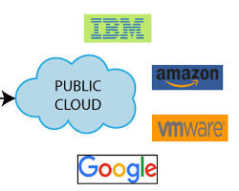Opens in a new window[](https://www.javatpoint.com/public-cloud)www.javatpoint.com](https://www.javatpoint.com/public-cloud)

**Private Cloud:** Private clouds are dedicated computing environments built and managed within an organization's own infrastructure. They provide greater control, security, and customization but require significant upfront investment and ongoing maintenance.

[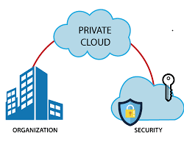Opens in a new window[](https://www.javatpoint.com/private-cloud)www.javatpoint.com](https://www.javatpoint.com/private-cloud)

**Hybrid Cloud**: Hybrid clouds combine public and private cloud resources, allowing organizations to leverage the benefits of both. They offer flexibility, scalability, and security for sensitive data.

[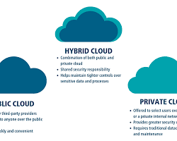Opens in a new window[](https://www.cisecurity.org/insights/blog/what-you-need-to-know-about-hybrid-cloud-environments)www.cisecurity.org](https://www.cisecurity.org/insights/blog/what-you-need-to-know-about-hybrid-cloud-environments)

**MultiCloud:** Multicloud environments utilize services from multiple public cloud providers. This approach fosters vendor independence and redundancy but can increase complexity and management overhead.

[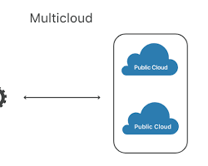Opens in a new window[](https://www.cloudflare.com/learning/cloud/what-is-multicloud/)www.cloudflare.com](https://www.cloudflare.com/learning/cloud/what-is-multicloud/)

**2. Cloud Service Models:**

These models define the level of abstraction and control offered by cloud services:

**Infrastructure as a Service (IaaS):** IaaS provides fundamental building blocks like virtual servers, storage, and networking. Users have complete control over the infrastructure but manage the underlying software and applications themselves.

[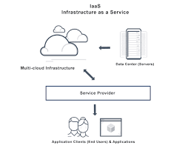Opens in a new window[](https://avinetworks.com/glossary/infrastructure-as-a-service-iaas/)avinetworks.com](https://avinetworks.com/glossary/infrastructure-as-a-service-iaas/)

**Platform as a Service (PaaS):** PaaS offers a complete development and deployment environment with preconfigured operating systems, programming languages, and middleware. Users focus on building and deploying applications without managing the underlying infrastructure.

[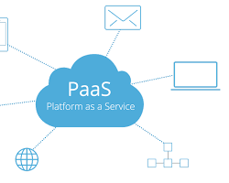Opens in a new window[](https://blog.iron.io/what-is-platform-as-a-service/)blog.iron.io](https://blog.iron.io/what-is-platform-as-a-service/)

**Software as a Service (SaaS):** SaaS delivers readytouse applications accessed through a web browser or mobile app. Users subscribe to the service and manage only their data and configurations.

[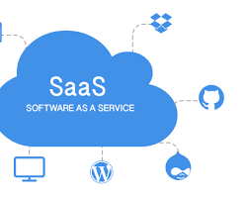Opens in a new window](https://www.avesta.co.th/software-as-a-service-saas/)

**Serverless Computing:** Serverless computing abstracts away server management entirely. Users deploy code in response to events without provisioning or managing servers. This simplifies development and scales automatically.

[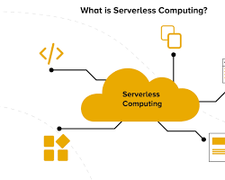Opens in a new window[](https://appinventiv.com/blog/what-is-serverless-computing/)appinventiv.com](https://appinventiv.com/blog/what-is-serverless-computing/)

**3. HighPerformance Computing (HPC):**

HPC leverages clusters of interconnected computers to tackle complex scientific, engineering, and financial simulations. Cloud providers offer HPC services ondemand, enabling organizations to access vast computing power without significant upfront investments.

**4. Edge Computing:**

Edge computing processes data closer to its source, at the network edge, minimizing latency and bandwidth requirements. This is particularly beneficial for realtime applications like IoT and autonomous systems. Cloud platforms can integrate edge computing resources for distributed processing.

**5. Fog Computing:**

Fog computing sits between the cloud and edge, offering decentralized computing and storage closer to the edge devices. It's suitable for applications requiring local processing power and collaboration but not realtime responsiveness.

* **Evolution of Cloud Computing**

Cloud computing is all about renting computing services. This idea first came in the 1950s. In making cloud computing what it is today, five technologies played a vital role. These are distributed systems and its peripherals, virtualization, web 2.0, service orientation, and utility computing.

* **Distributed Systems:**

It is a composition of multiple independent systems but all of them are depicted as a single entity to the users. The purpose of distributed systems is to share resources and also use them effectively and efficiently. Distributed systems possess characteristics such as scalability, concurrency, continuous availability, heterogeneity, and independence in failures. But the main problem with this system was that all the systems were required to be present at the same geographical location. Thus to solve this problem, distributed computing led to three more types of computing and they wereMainframe computing, cluster computing, and grid computing.

* **Mainframe computing:**

Mainframes which first came into existence in 1951 are highly powerful and reliable computing machines. These are responsible for handling large data such as massive inputoutput operations. Even today these are used for bulk processing tasks such as online transactions etc. These systems have almost no downtime with high fault tolerance. After distributed computing, these increased the processing capabilities of the system. But these were very expensive. To reduce this cost, cluster computing came as an alternative to mainframe technology.

* **Cluster computing:**

In 1980s, cluster computing came as an alternative to mainframe computing. Each machine in the cluster was connected to each other by a network with high bandwidth. These were way cheaper than those mainframe systems. These were equally capable of high computations. Also, new nodes could easily be added to the cluster if it was required. Thus, the problem of the cost was solved to some extent but the problem related to geographical restrictions still pertained. To solve this, the concept of grid computing was introduced.

* **Grid computing:**

In 1990s, the concept of grid computing was introduced. It means that different systems were placed at entirely different geographical locations and these all were connected via the internet. These systems belonged to different organizations and thus the grid consisted of heterogeneous nodes. Although it solved some problems but new problems emerged as the distance between the nodes increased. The main problem which was encountered was the low availability of high bandwidth connectivity and with it other network associated issues. Thus. cloud computing is often referred to as “Successor of grid computing”.

* **Virtualization:**

It was introduced nearly 40 years back. It refers to the process of creating a virtual layer over the hardware which allows the user to run multiple instances simultaneously on the hardware. It is a key technology used in cloud computing. It is the base on which major cloud computing services such as Amazon EC2, VMware vCloud, etc work on. Hardware virtualization is still one of the most common types of virtualization.

* **Web 2.0:**

It is the interface through which the cloud computing services interact with the clients. It is because of Web 2.0 that we have interactive and dynamic web pages. It also increases flexibility among web pages. Popular examples of web 2.0 include Google Maps, Facebook, Twitter, etc. Needless to say, social media is possible because of this technology only. It gained major popularity in 2004.

* **Service orientation:**

It acts as a reference model for cloud computing. It supports lowcost, flexible, and evolvable applications. Two important concepts were introduced in this computing model. These were Quality of Service (QoS) which also includes the SLA (Service Level Agreement) and Software as a Service (SaaS).

* **Utility computing:**

It is a computing model that defines service provisioning techniques for services such as compute services along with other major services such as storage, infrastructure, etc which are provisioned on a payperuse basis.

* **Studying Various File Service Storage providers that offer Cloud Storage:**

**Google Drive** Offers 15 GB of free storage space and strong file sharing capabilities.

**OneDrive** Offers 5 GB of free storage space and can be accessed from any device.

**Dropbox** Offers data storage plans ranging from 2 GB to unlimited storage space.

**IDrive** Offers a hybrid cloud storage solution that includes cloud storage and online backup Functionality.

**Box** Offers multiple service options, including a business plan with unlimited storage.

**iCloud** Makes it easy to upgrade Apple devices.

**pCloud** A cloud storage provider based in Switzerland.

**Icedrive** Allows users to access their data directly from their computer's operating system.

Other cloud storage providers include: **Mega, Amazon S3, Sync.com.**

* **File Synchronization:**

Cloud file syncing (Synchronization) is an application that keeps files in different locations up to date through the cloud. For cloud file syncing, a user sets up a cloudbased folder, to which the desired files are copied. This folder makes the files accessible via a web interface for multiple users, on whatever device they are using.

* **Client Software:**

Client software is a program that's installed on a computer to communicate with other software over a network. Client software allows a device to access services or functionality provided by server software. Client software doesn't always need a network connection to run on a computer. Clients are often referred to as "service requesters".

* **List the common features included in DaaS:**

Desktop as a Service (DaaS) is a cloud computing offering where a service provider distributes virtual desktops to endusers over the Internet, licensed with a peruser subscription.

* **Data Access:** DaaS platforms offer a means to access data stored in the cloud. This could be through APIs, web interfaces, or other methods.
* **Data Integration:** DaaS often includes tools for integrating data from various sources. It can involve data cleansing, transformation, and aggregation.
* **Data Security:** DaaS providers typically have security measures in place to protect the data. This includes encryption, access control, and compliance with data protection regulations.
* **Scalability:** DaaS platforms can scale up or down according to your needs. This flexibility is useful for handling data growth.
* **Data Backup and Recovery:** Data in DaaS solutions is often backed up and can be recovered in case of data loss or disasters.
* **Data Analytics:** Some DaaS platforms include analytics tools or integrations, allowing users to analyze the data they access.
* **Realtime Data:** DaaS can provide realtime or nearrealtime access to data, which is useful for applications requiring uptodate information.
* **Monitoring and Reporting:** Many DaaS providers offer monitoring and reporting tools, allowing you to track data usage, performance, and access patterns.
* **Cost Management:** DaaS often operates on a payasyougo model, and providers offer cost management tools to help you control expenses.
* **Compliance and Governance:** DaaS platforms may include features to help organizations adhere to data governance and compliance requirements, such as GDPR or HIPAA.
* **Data Versioning:** Some DaaS solutions offer data versioning capabilities, which allow you to access historical data snapshots.
* **Collaboration Tools:** DaaS can facilitate data sharing and collaboration within teams or with external partners.

➢ **Explore any 5 Desktopas aService and include the corresponding screenshots in the writeup. Perform a comparative analysis of all of them:**

1. **Amazon Workspaces:** 
   * Each user gets their own personal desktop that can either be Windows or Linux OS.
   * Provides a highquality cloud desktop experience that is costeffective and performs as well as traditional desktops.
   * Offers persistent file storage, custom application deployment, and quick scalability.

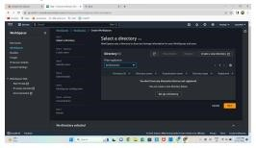

1. **Microsoft Azure Virtual Desktop:** 
   * Offers services for artificial intelligence, analytics, and the Internet of Things (IoT).
   * Provides robust integration with Microsoft products, such as Active Directory and Visual Studio, making it an ideal choice for enterprises that already use those products. • Offers a personal desktop and a shared virtual computer.
   * Pricing varies depending on whether each user gets their own virtual machine or many users share a virtual machine.

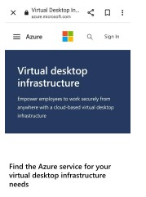

1. **IBM Cloud:** 
   * Offers a VDI solution that can be accessed from any device with an internet connection.
   * Provides a secure and scalable infrastructure.
   * Offers a variety of pricing options, including payasyougo and reserved instances.

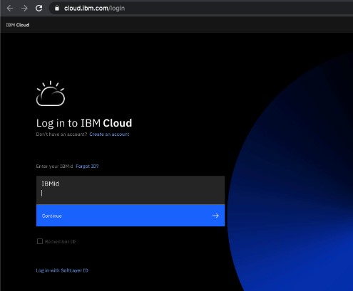

1. **VMware:** 
   * Offers a VDI solution that can be accessed from any device with an internet connection.
   * Provides a secure and scalable infrastructure.
   * Offers a variety of pricing options, including payasyougo and reserved instances.

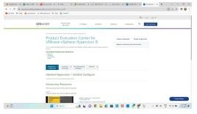

1. **Paperspace DesktopasaService:** 
   * Offers a VDI solution that can be accessed from any device with an internet connection.
   * Provides a secure and scalable infrastructure.
   * Offers a variety of pricing options, including payasyougo and reserved instances.

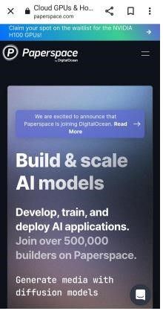

|  |  |  |  |  |  |  |
| --- | --- | --- | --- | --- | --- | --- |
| **DaaS Provider** | **Price** | **Mobile**  **App**  **Availability** | **Storage Space** | **User**  **Interface** | **Sharing**  **Capability** | **Chat**  **Facility** |
| **Amazon**  **Workspaces** | $7.25  $26/month | Yes | 80gb/user | User  Freindly | Yes | Yes |
| **Microsoft Azure**  **Virtual esktop** | $10  $140/month | Yes | 12gb/ user | User  Freindly | Yes | Yes |
| **IBM Cloud** | $0.05  $0.50/ hour | Yes | 25gb/ user | User  Friendly | Yes | Yes |
| **VMware** | $8  $16/month | Yes | 10gb/ user | User  Friendly | Yes | Yes |
| **Paperspace** | $8  $21/month | Yes | 50gb/ user | User  Freindly | Yes | Yes |

➢ **Contrast and Compare Between DaaS and IaaS:** • **DaaS (Desktop as a Service):**

**Definition:** DaaS is a cloud computing service that provides virtual desktop environments hosted and managed by a thirdparty provider.

**Use Case:** DaaS is primarily used to deliver virtual desktops to endusers, enabling remote work, centralized management, and simplified desktop provisioning.

**Management:** DaaS is fully managed by the service provider, which includes OS updates, security patches, and hardware maintenance.

**Scalability:** DaaS allows for easy scalability, making it suitable for businesses with fluctuating or remote workforce requirements.

**Software and Applications:** Users access virtual desktops with preinstalled or customizable software and applications via the internet.

* **IaaS (Infrastructure as a Service):**

**Definition:** IaaS is a cloud computing service that provides virtualized computing resources such as virtual machines, storage, and networking ondemand.

**Use Case:** IaaS is used by businesses to build, manage, and scale their IT infrastructure without investing in physical hardware. It's suitable for a wide range of applications.

**Management:** In IaaS, users have more control over the infrastructure, including the operating system, applications, and security settings.

**Scalability:** IaaS offers scalable resources, allowing businesses to adjust their computing power and storage capacity as needed.

**Software and Applications:** Users are responsible for installing, configuring, and managing their own software and applications on the virtual machines.

* **Comparison:**

**Management Control:** DaaS provides a more handsoff approach to management, while IaaS gives users greater control over their virtual infrastructure.

**Use Cases:** DaaS is specialized for delivering virtual desktops, while IaaS is versatile and can be used for a wide range of computing needs.

**Scalability:** Both DaaS and IaaS offer scalability, but DaaS is more geared toward accommodating changes in the number of virtual desktops, whereas IaaS can scale various infrastructure components.

# Experiment No. 2

**Step 1:**Open VMware workstation and click on create new Virtual Machine.

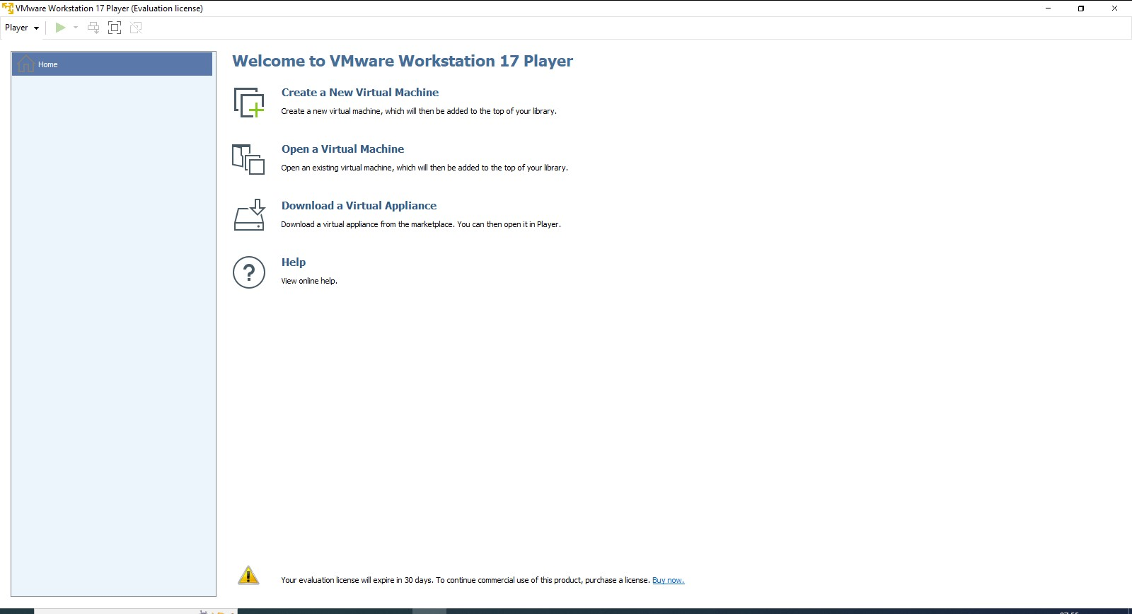

**Step 2:**Browse iso file and check whether it is detected or not and then click on next.

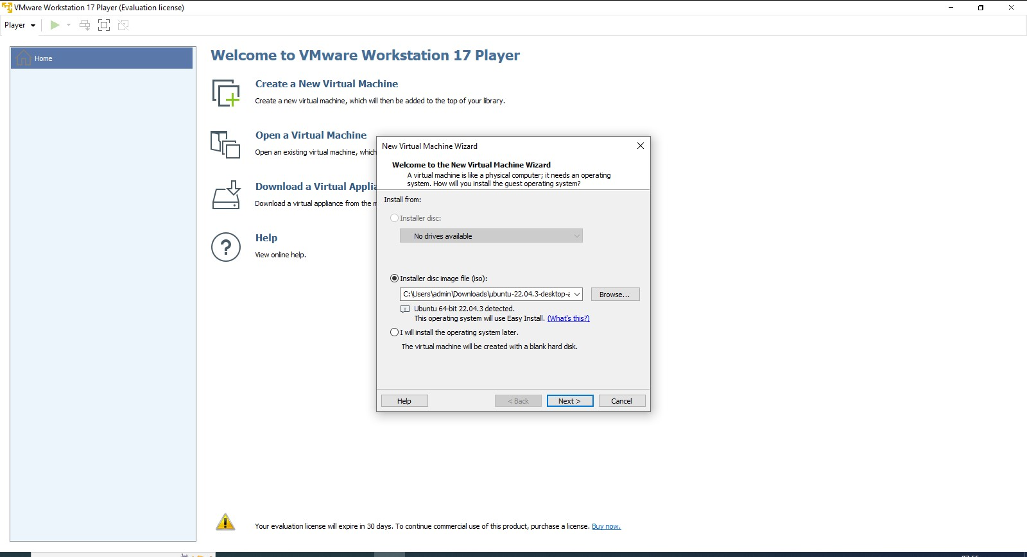

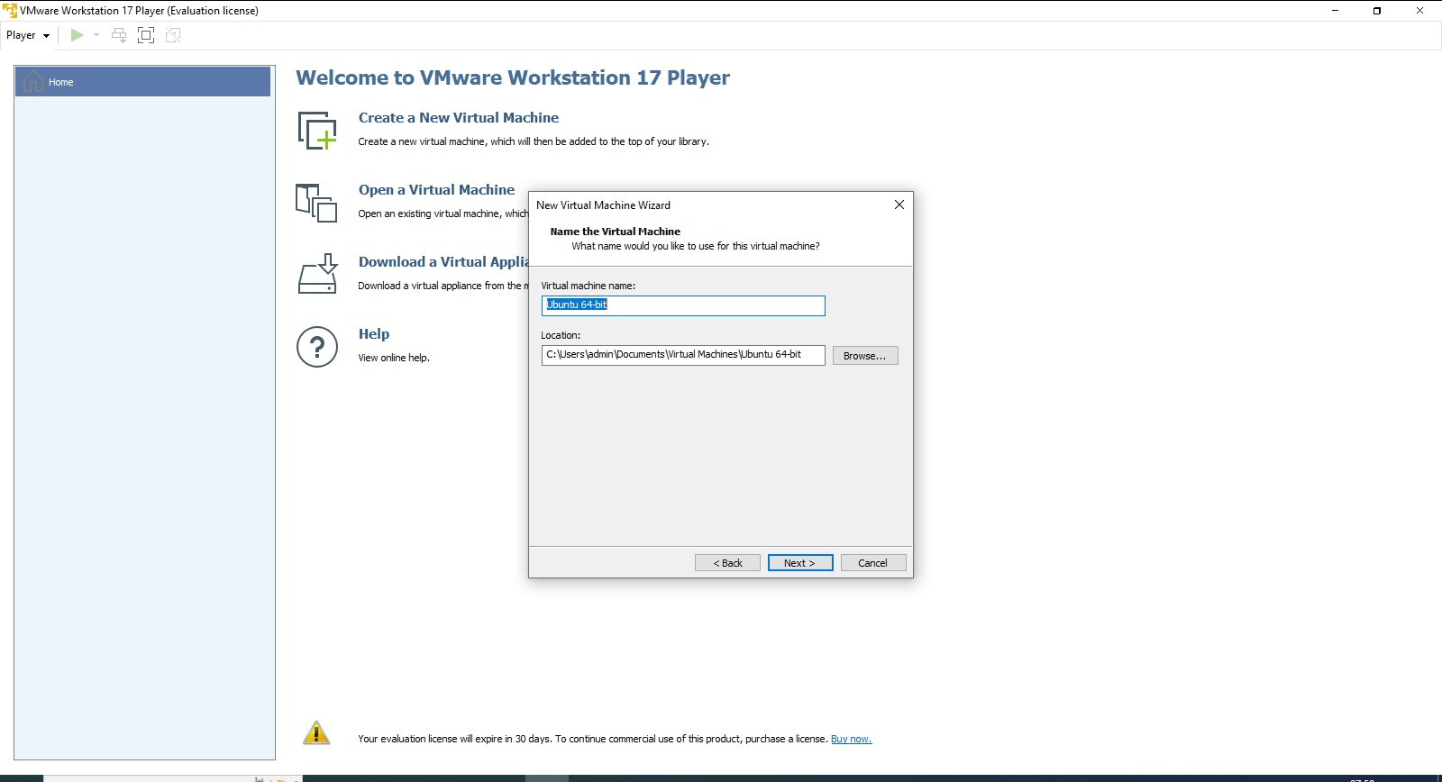**Step 3:**Enter the Full Name, Username and Password of your choice and click on next.

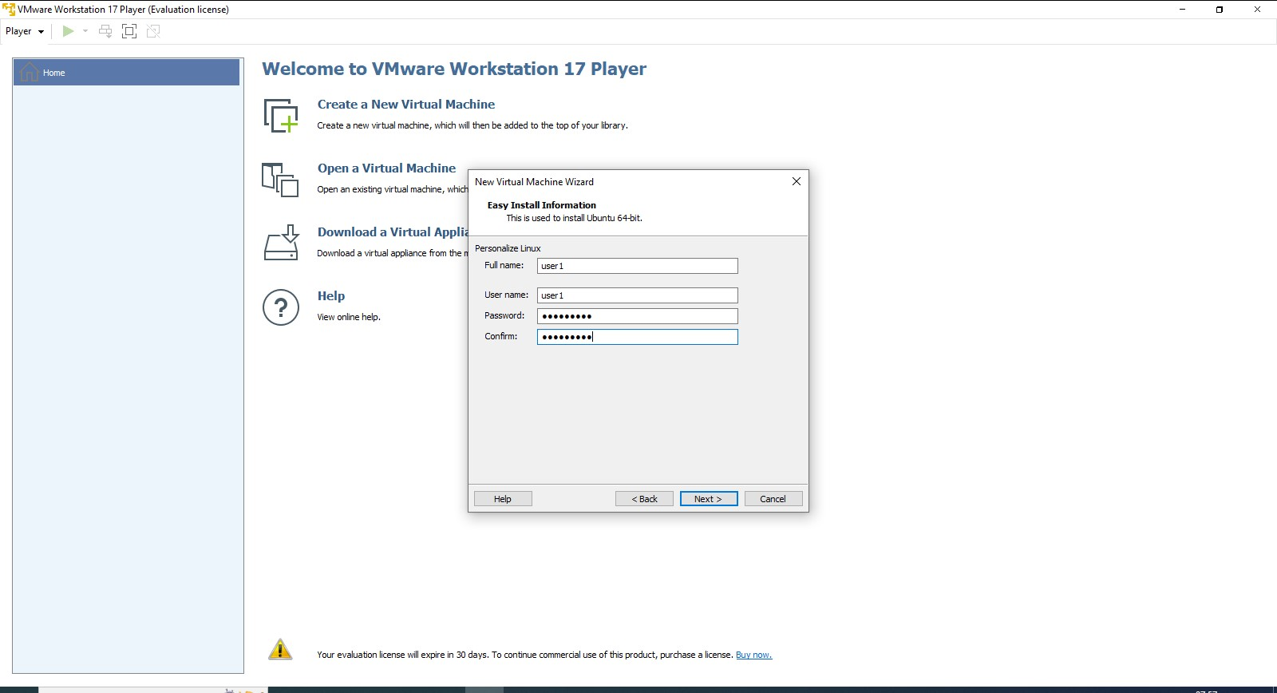

**Step 4:**Select the path where you want to install the VM or else you can kept it as by default and then click on next.

**Step 5:**Keep Maximum disk size as 21.0 GB and check the store a virtual disk as a single file option and click on next.

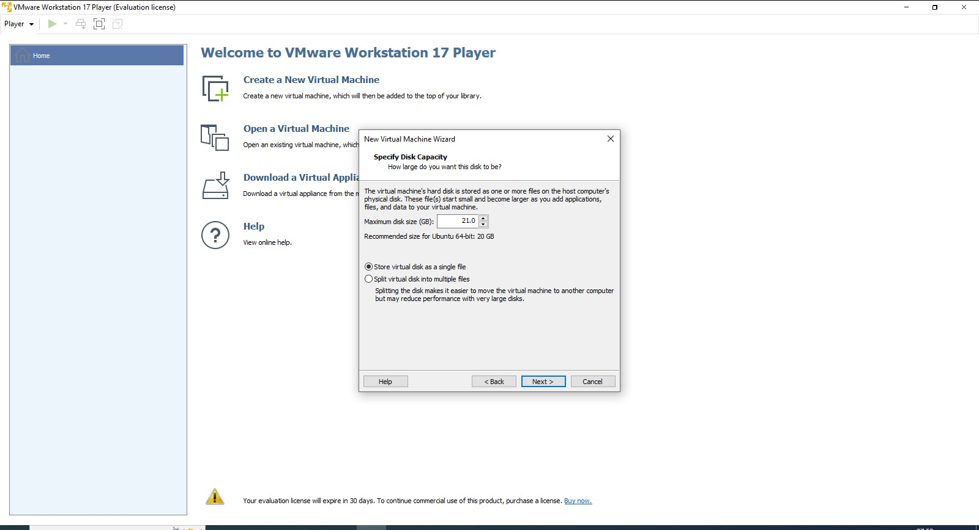

**Step 6:**Check the checkbox of Power on this VM after creation and click on finish.

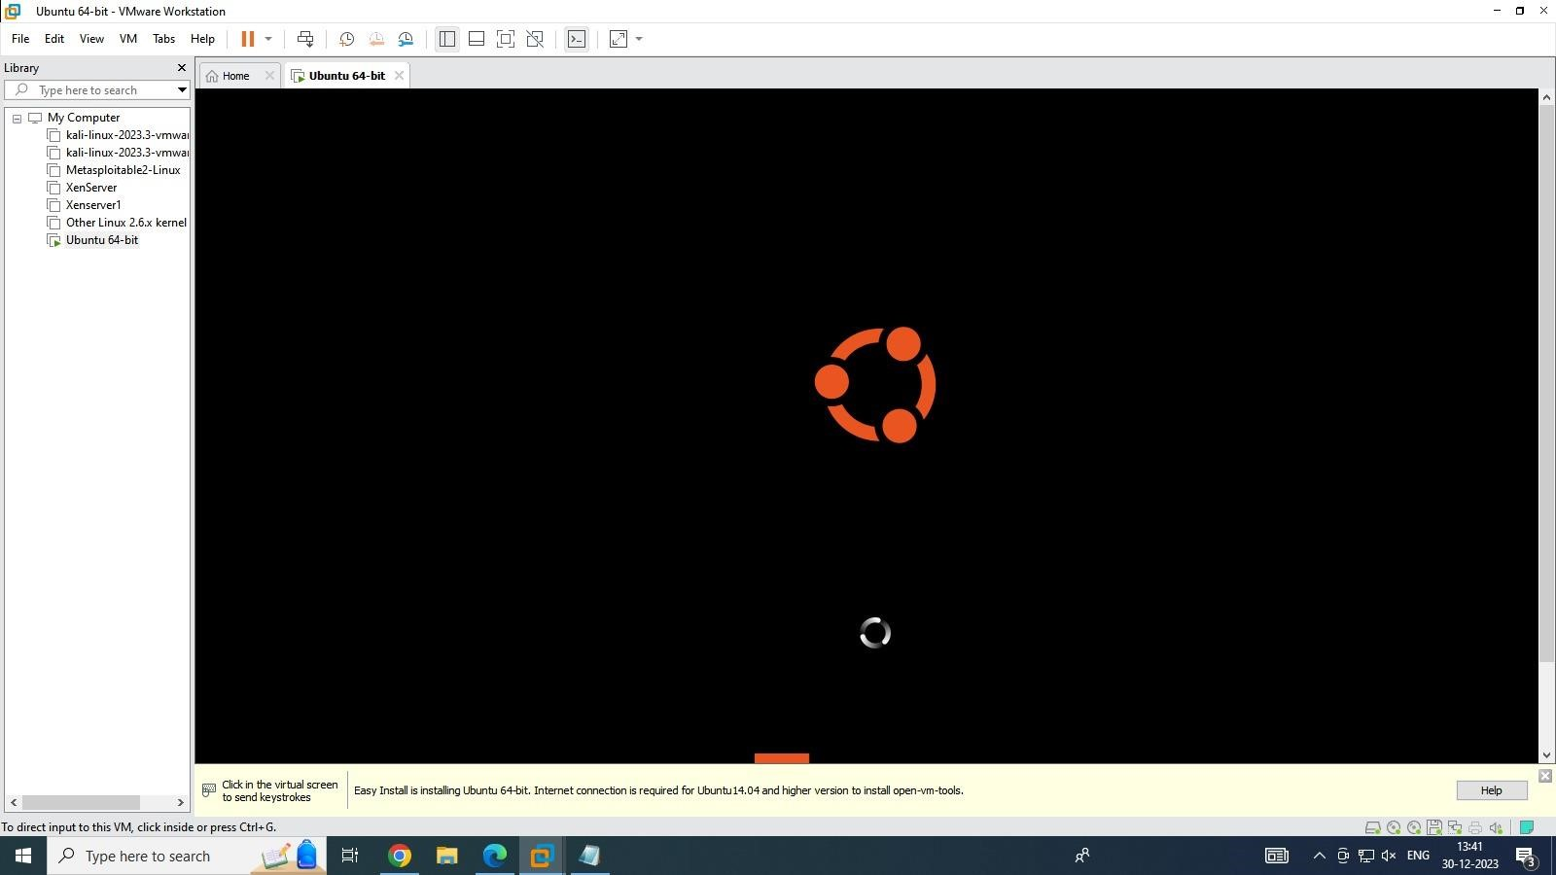

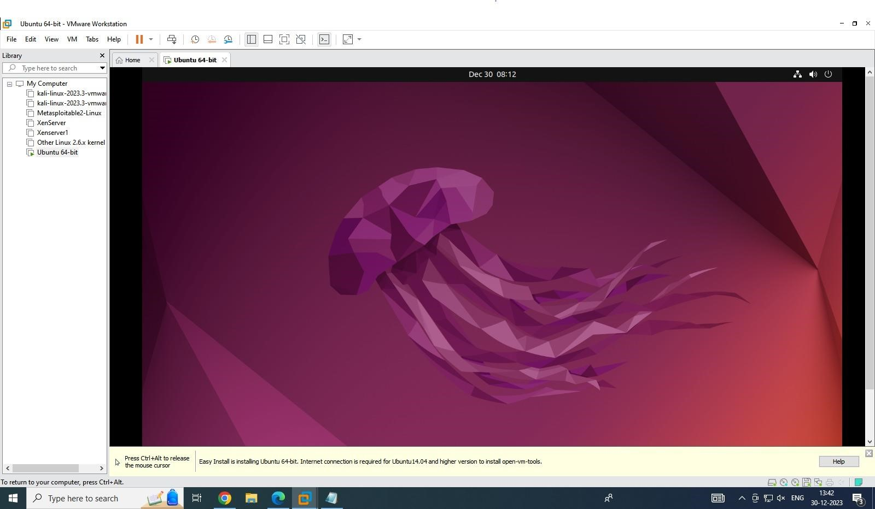

# Experiment No. 3

This feature is helpful to deploy your static websites (HTML, CSS, and JavaScript) like a portfolio, project documentation, or anything that you want! It even allows you to configure a custom domain name (but we’ll focus only on the hosting part in this tutorial).

But, there is one limitation, since it’s a static service, it does not support server-side scripts (PHP, Python, etc.).

**1. Create a new GitHub repository**

As mentioned above, we’ll use GitHub Pages to host our static website. In this first step, you will need to create a new repository on your account.

***Note:****If you don’t have a GitHub account yet, you can create one on*[*the homepage*](https://github.com/)*.*

To do so, [open the “Create a new repository” page](https://github.com/new) on GitHub.

Feel free to choose a funky name for your repository! But, take care because this name will be one part of your website URL.

For this tutorial, I will name my repository: “my-cool-website”.

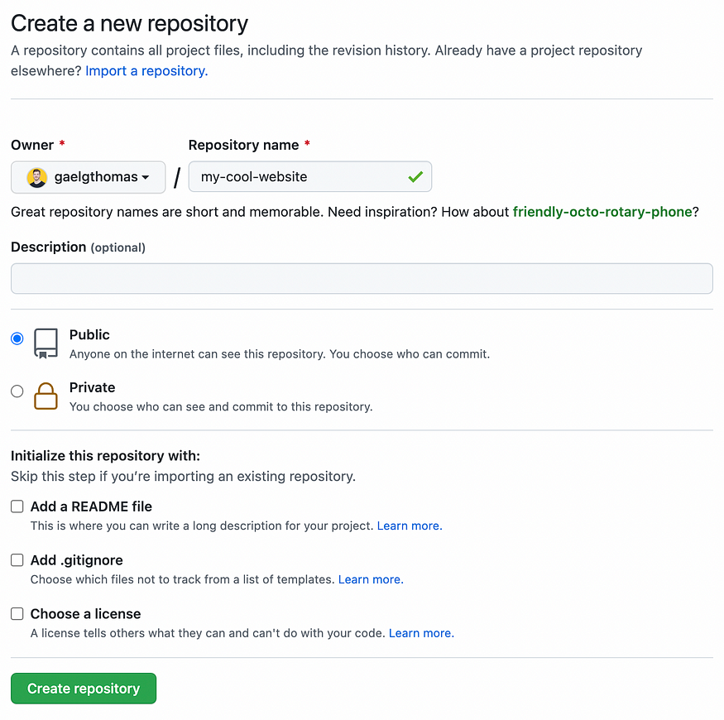

“Create a new repository” page on GitHub

**2. Clone the repository on your computer**

Once you created your repository, you will be redirected to its page. There, you can copy/paste the HTTPS or SSH link and clone the repository on your computer.

$ git clone [HTTPS or SSH URL]

**3. Create a static website**

Time for creativity! 🎨

I invite you to open your repository in your favorite IDE (VSCode isn’t it? 😉) and create an index.html file. It will be the entry point of our website.

Below is the template that I will use.

<!*DOCTYPE* *html*>  
<html>  
 <head>  
 <title>My Cool Website</title>  
 </head>  
 <body>  
 <h1>Welcome to my website! ⭐️</h1>  
 <p>How was your day? 🎉</p>  
 </body>  
</html>

**4. Push your code to GitHub**

Are you satisfied with your index.html file? If not, don’t worry. You’ll learn how to update it later in the coming steps! ⏭

When your code is ready, you will need to save it on GitHub. You can type the commands below to do it:

$ git add index.html  
$ git commit -m "Initialize website"  
$ git push origin main

Until here, you must be doing the same thing as for your other GitHub projects.

To verify that everything is working correctly, you can open your repository on GitHub and verify that the index.html file is displayed. If so, you’re ready for the next step!

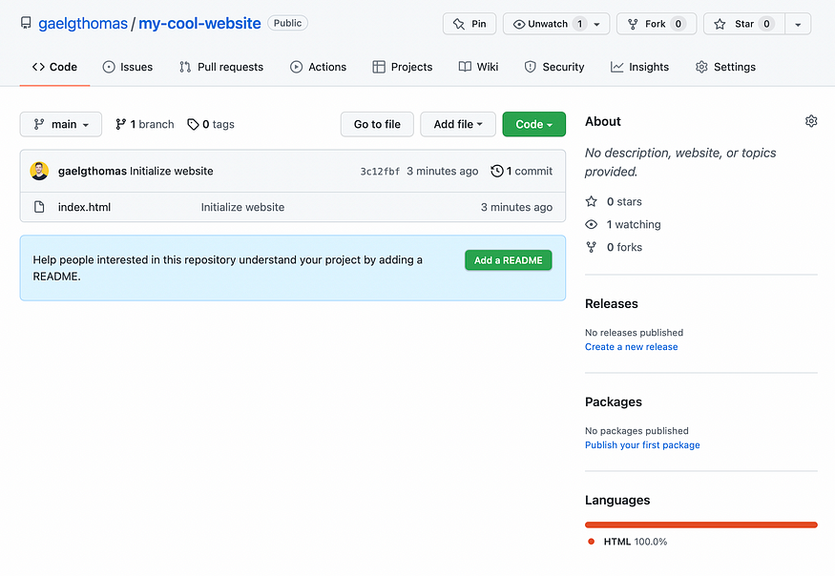

“Repository” page on GitHub (with the `index.html` file)

**5. Open your repository settings**

Let’s deploy your website and make it available to the world! 🌐

On your repository page, you have a menu at the top. Click on the image below on the last option called “Settings”, then “Pages” in the sidebar.

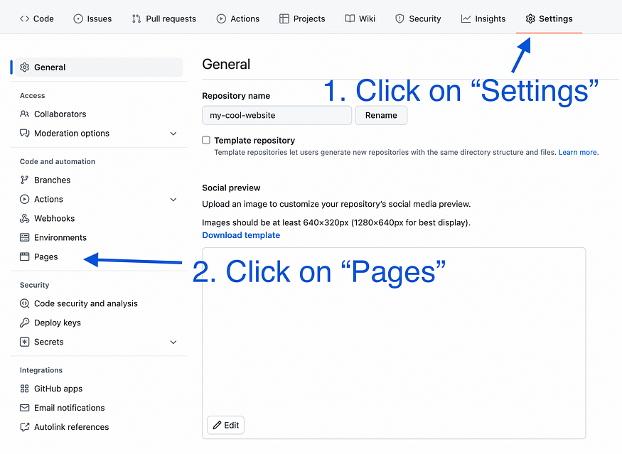

“Repository Settings” page on GitHub

After clicking on “Pages”, you will land on the GitHub Pages configuration. That’s where you will ask GitHub to deploy your website online and create an URL for it.

Two settings are available:

* **The deployment branch:** which branch of your repository will be deployed.
* **The deployment folder (by default “/ root”):** which repository folder you want to use as an entry point. I recommend you stick to the default option. But, you will see that you can also select “/docs” if you want to create a GitHub website for your documentation pages (stored under the “/docs” repository.

Let’s stick to the most default options and select “main” as your deployment branch and keep “/ (root)” as the deployment folder.

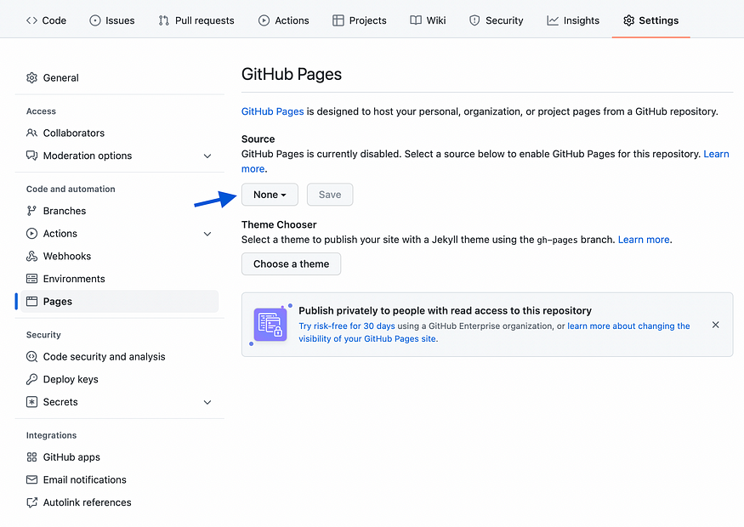

“Repository Page Setting” on GitHub (before activating GitHub Pages)

Once you click on the “Save” button, the page reloads, and… TADA! 🥁

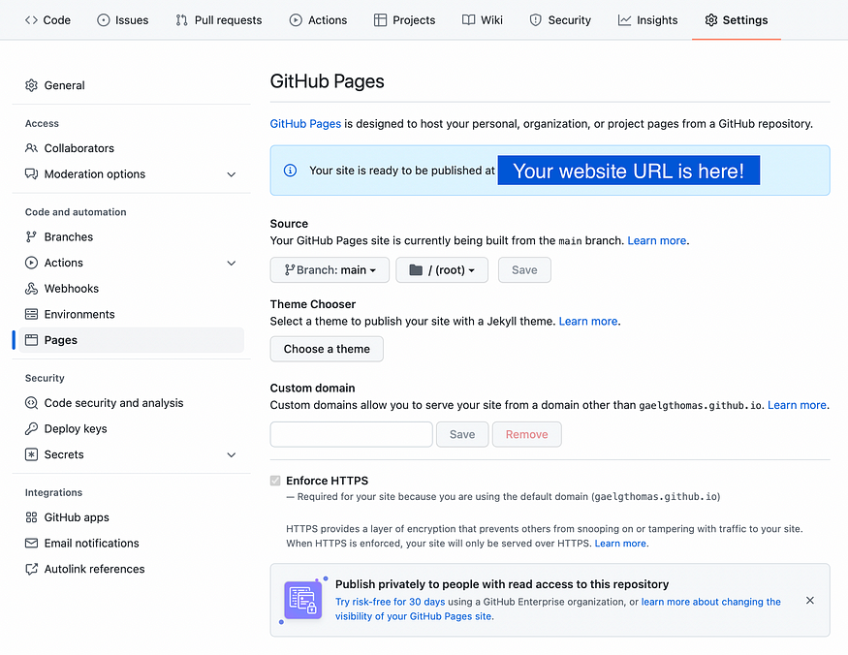

“Repository Page Setting” on GitHub (after activating GitHub Pages)

**Your website is live! 🎉**

***Note:****As you can see, the URL is based on your GitHub username and repository name. https://github-username.github.io/repository-name/*

Let’s click on your URL to see the online version of your website.

Here’s mine!

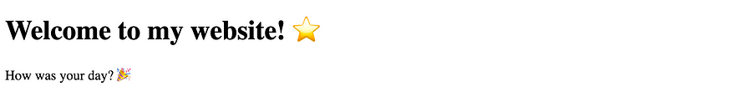

“My Cool Website” hosted on GitHub Pages

**6. Add a new page**

Talking about improvements, one page is not a lot for a website. What do you think about creating a new page? 📃

Now that everything is set up let’s return to our IDE and create an about.html page.

As we did with the index.html Feel free to create the code of your choice!

Here is the template I will use for this new page:

<!*DOCTYPE* *html*>  
<html>  
 <head>  
 <title>About - My Cool Website</title>  
 </head>  
 <body>  
 <h1>About my website! 🎙</h1>  
 <p>Thanks for following this tutorial. 🙏</p>  
 </body>  
</html>

Then, let’s create a button on the homepage (index.html) to open the about page with a click.

<!*DOCTYPE* *html*>  
<html>  
 <head>  
 <title>My Cool Website</title>  
 </head>  
 <body>  
 <h1>Welcome to my website! ⭐️</h1>  
 <p>How was your day? 🎉</p>  
 <a href="./about">Read the about page</a>  
 </body>  
</html>

**7. Update your website**

A new page is born! Let’s make it real! 🆕

The last step of this tutorial will teach you how to update your static website after its first release.

Now that everything is configurated, we will refer to step 4, “Push your code to GitHub”. In this previous part, we pushed our code to our repository. Here, the process will be the same with our new updates.

We want to save our about.html page and update the index.html with the new changes.

Let’s do it using the same Git commands as step 4.

$ git add index.html about.html  
$ git commit -m "Add an about page"  
$ git push origin main

Once it’s done, wait a few minutes, come back to your website URL, reload, and your changes should appear!



“My Cool Website” home page updated with a “Read the about page” link



“My Cool Website” about page

# Steps for Hosting Your Website On Google App Engine.

**Step1:** Go to the App Engine dashboard on the Google Cloud Platform Console and press the Create button.

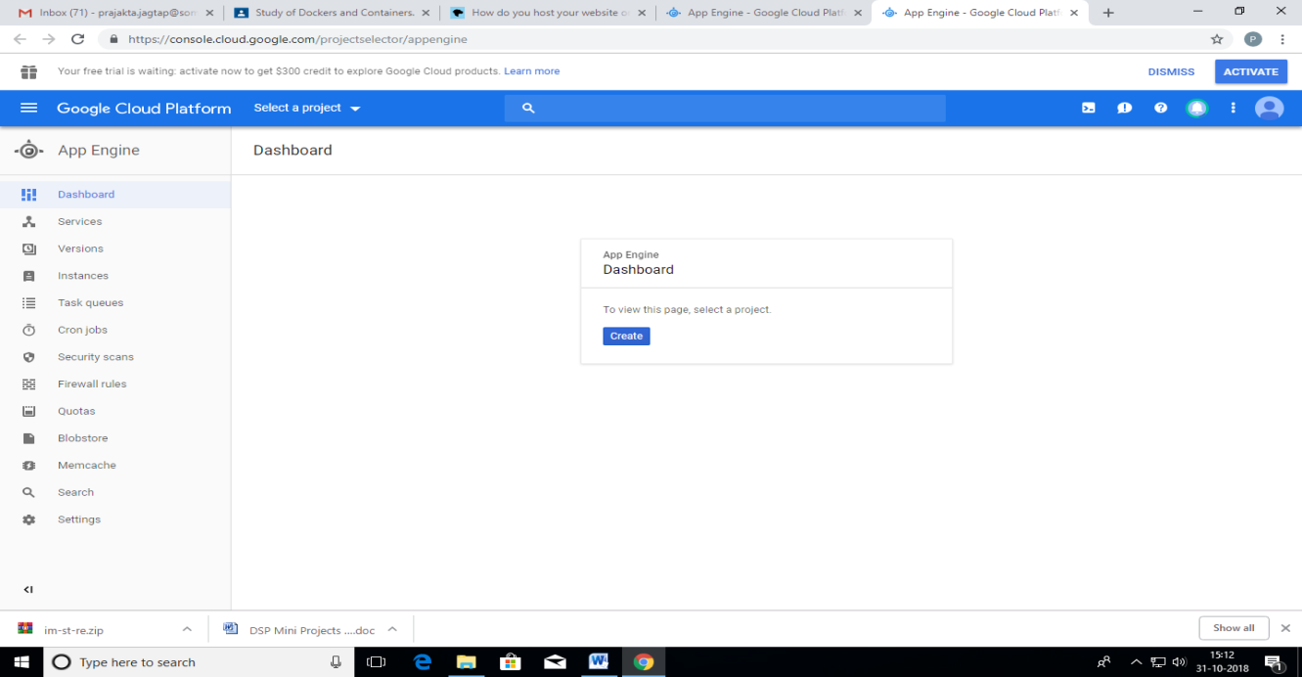

**Step 2**: If you've not created a project before, you'll need to select whether you want to receive email updates or not, agree to the Terms of Service, and then you should be able to continue.

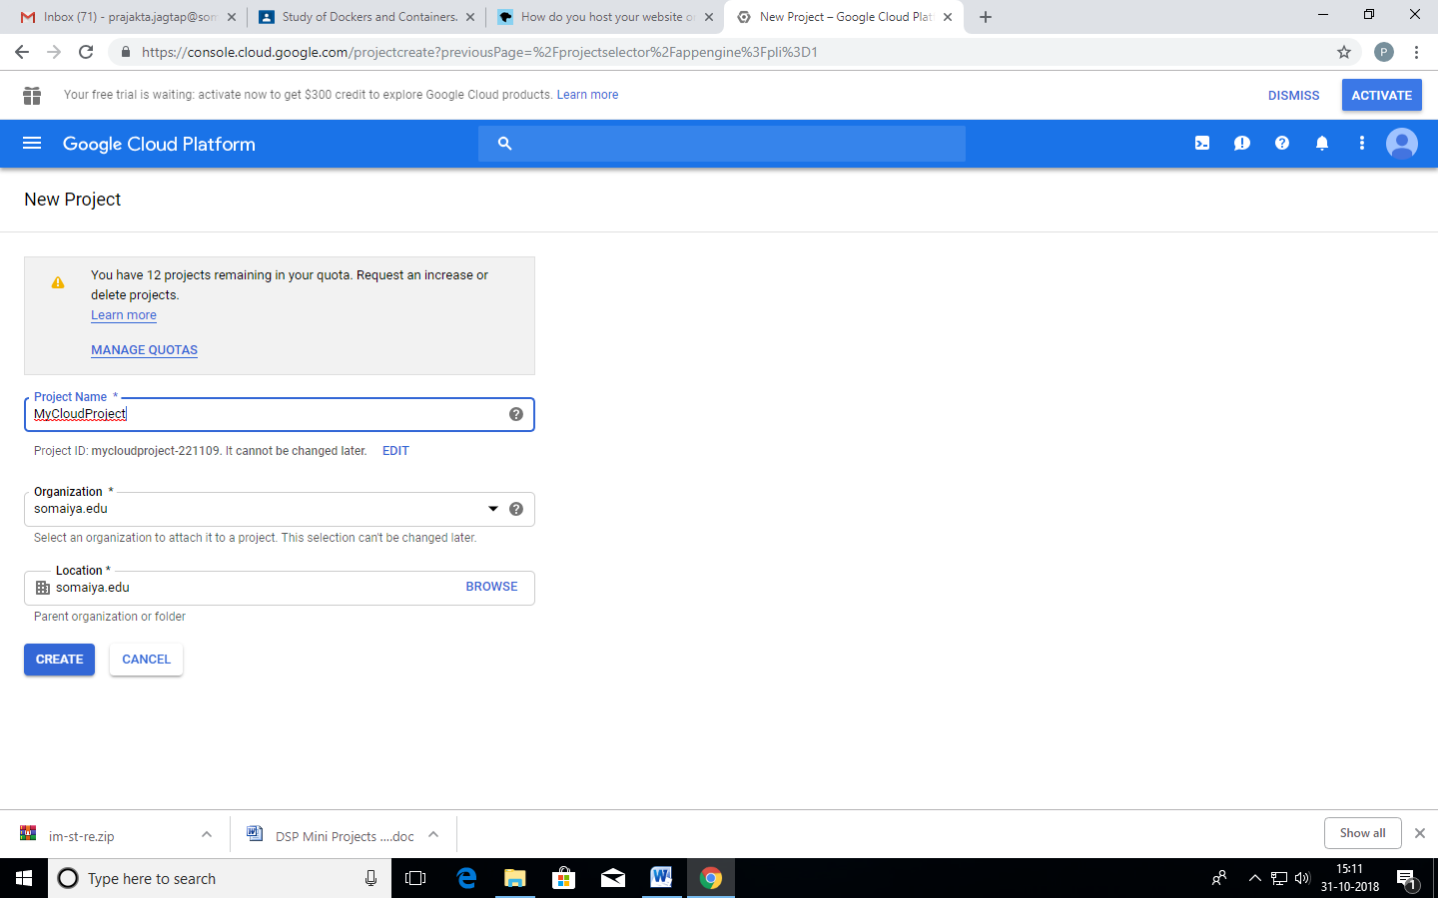

**Step 3:** Enter a name for the project, edit your project ID and note it down.

Project Name: MyCloudProject

Project ID: 133319421626

**Step 4:** Click the *Create* button to create your project.

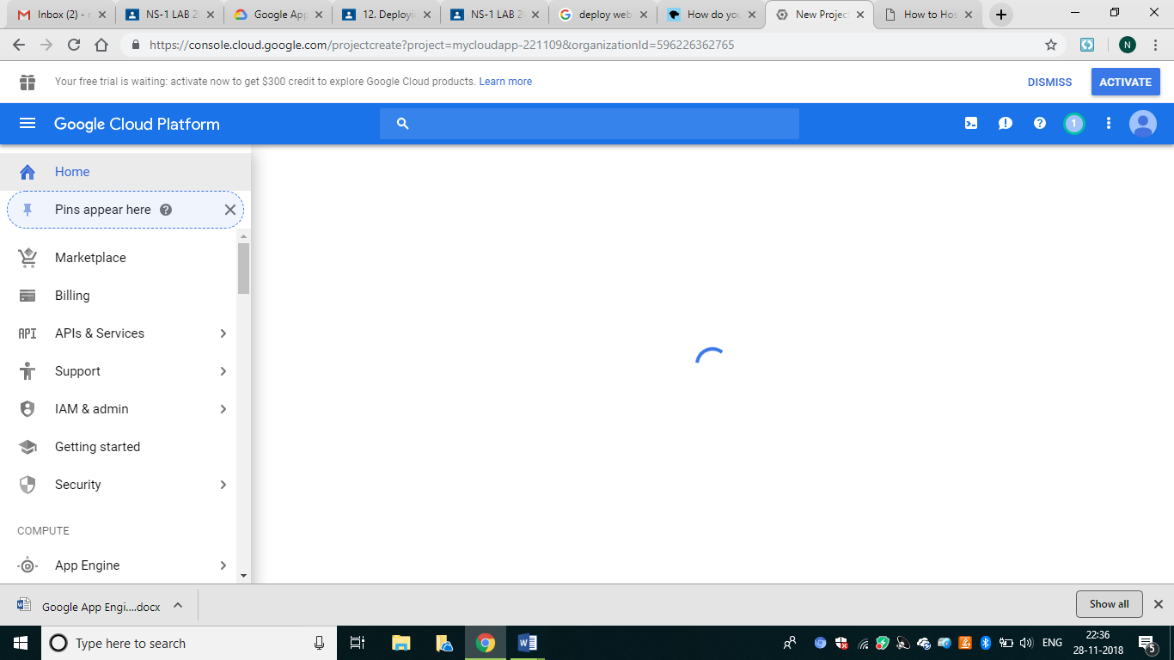

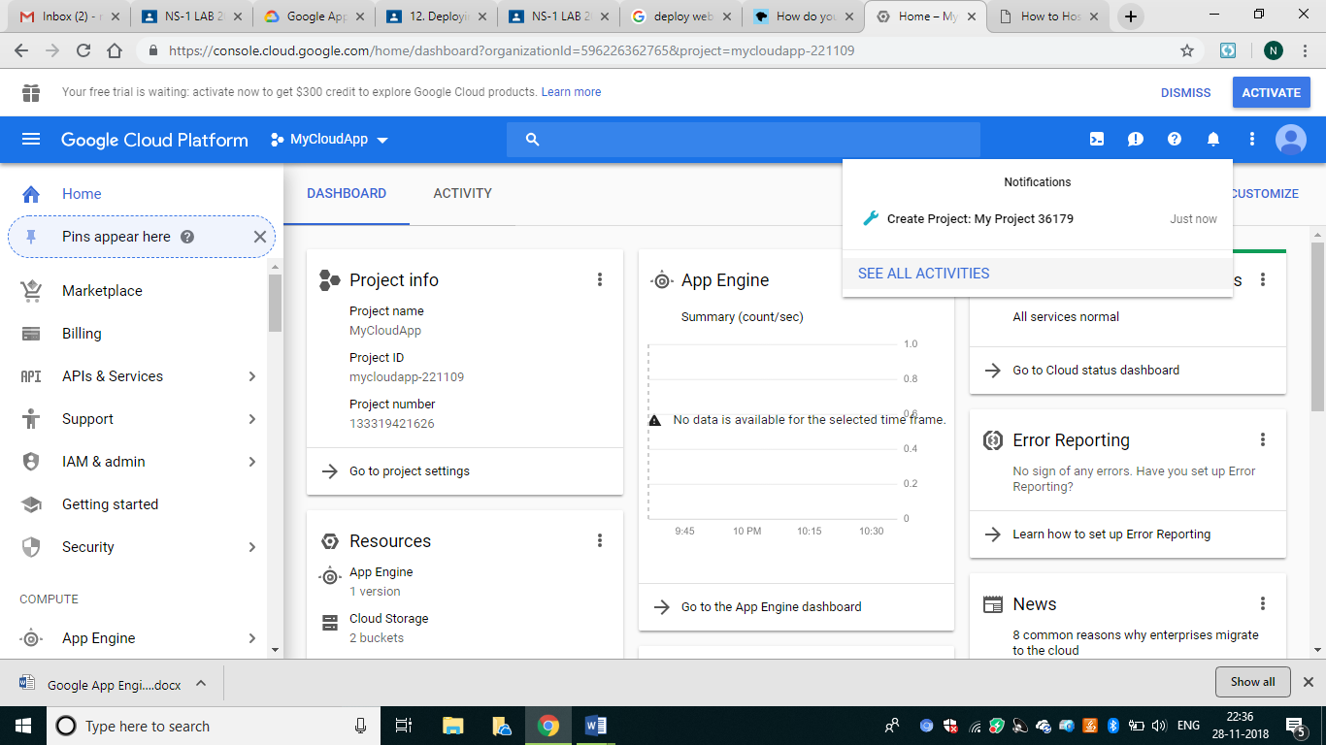

[**Creating an application**](https://developer.mozilla.org/en-US/docs/Learn/Common_questions/How_do_you_host_your_website_on_Google_App_Engine#Creating_an_application)

Step 1: We'll need a sample application to publish. If you've not got one to use, download and unzip this sample app (<http://gaesamplesite.appspot.com/downloads.html>)

**For trial you use this. But for practical Execution you have to create your own application**

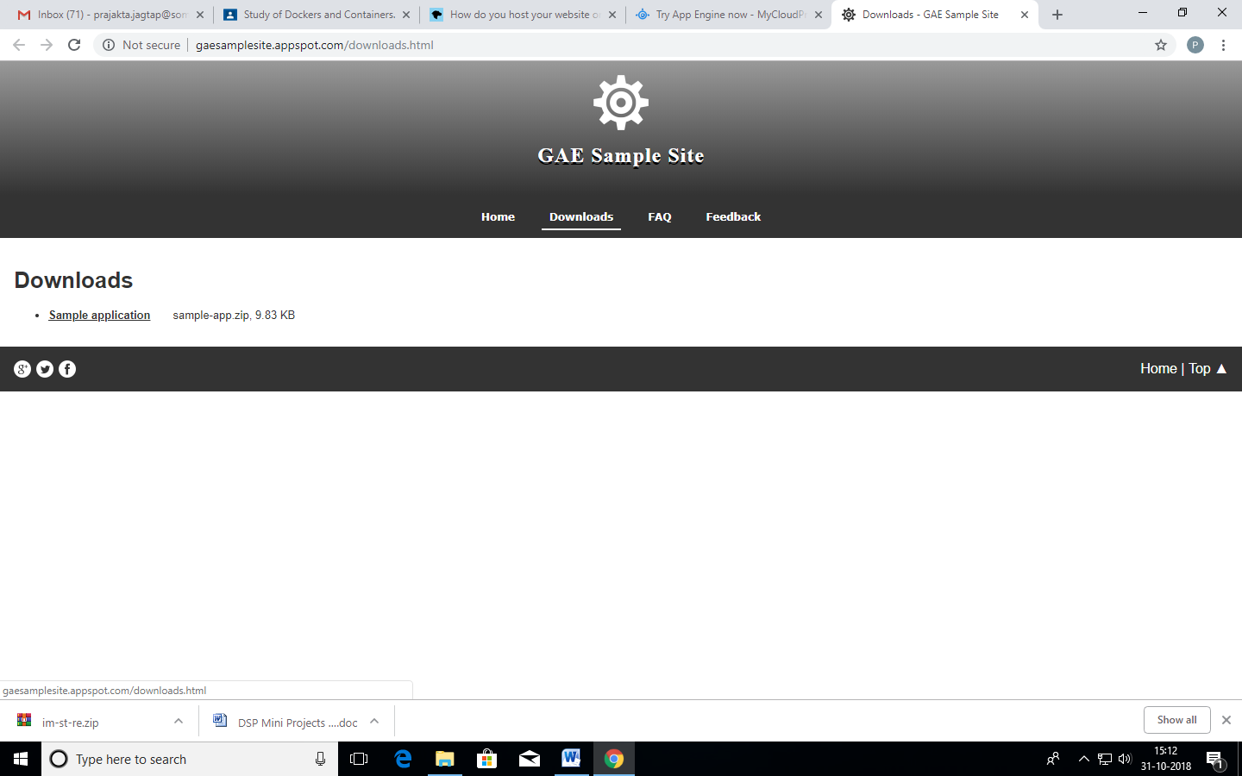

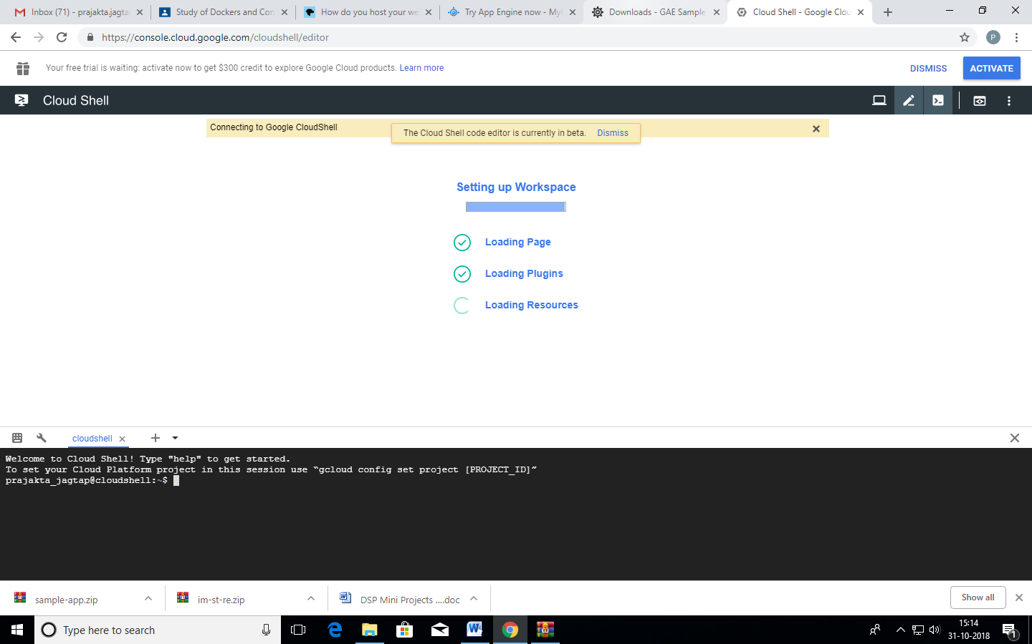

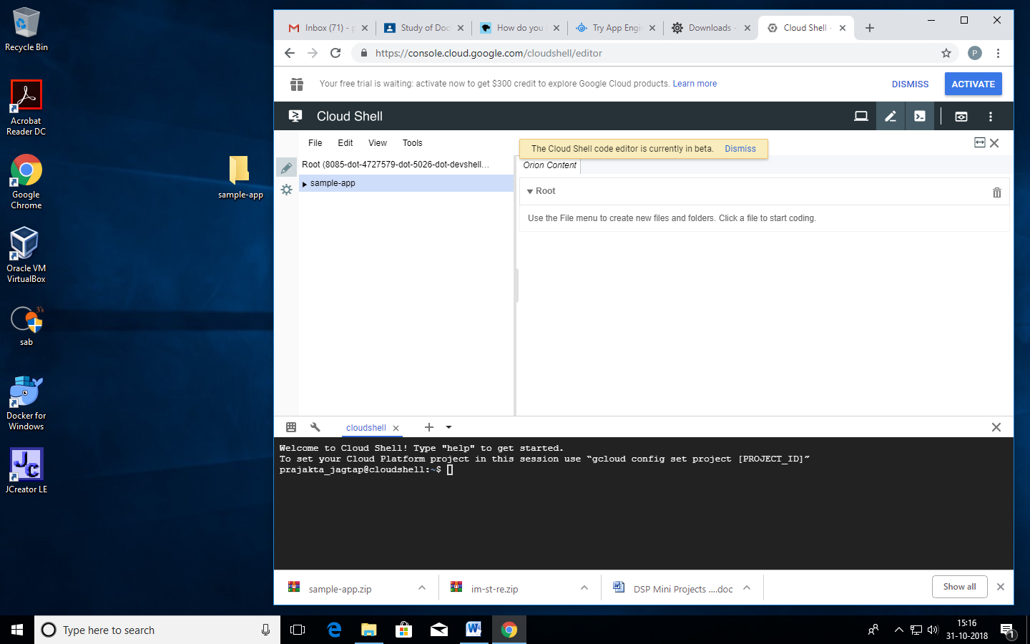

**Step 2**: It includes the website folder contains your website content and app.yaml is your application configuration file. Your website content must go inside the website folder, and its landing page must be called index.html, but apart from that it can take whatever form you like. The app.yaml file is a configuration file that tells App Engine how to map URLs to your static files. You don't need to edit it.

**Publishing your Application** [**Section**](https://developer.mozilla.org/en-US/docs/Learn/Common_questions/How_do_you_host_your_website_on_Google_App_Engine#Publishing_your_application)

Now that we've got our project made and sample app files collected together, let's publish our app.

Step 1: Open [Google Cloud Shell](https://console.cloud.google.com/cloudshell/editor) (<https://console.cloud.google.com/cloudshell/editor>)

Step 2: Drag and drop the sample-app folder into the left pane of the code editor.

Step 3: Run the following in the command line to select your project:

gcloud config set project gaesamplesite

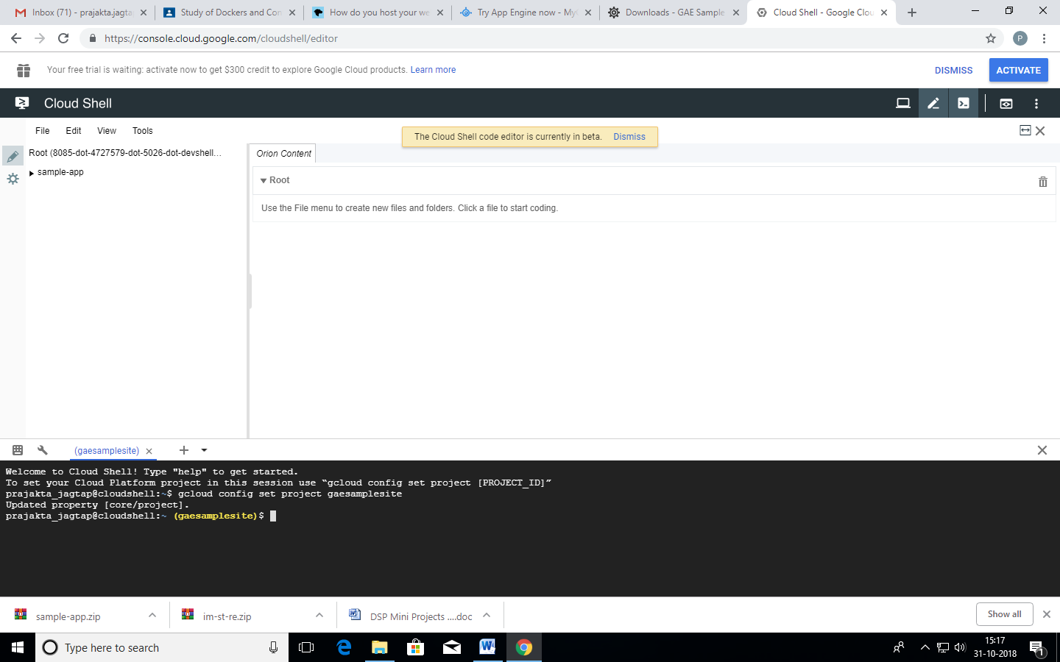

**Step 4**: Run the following command to go to your app's directory:

cd sample-app

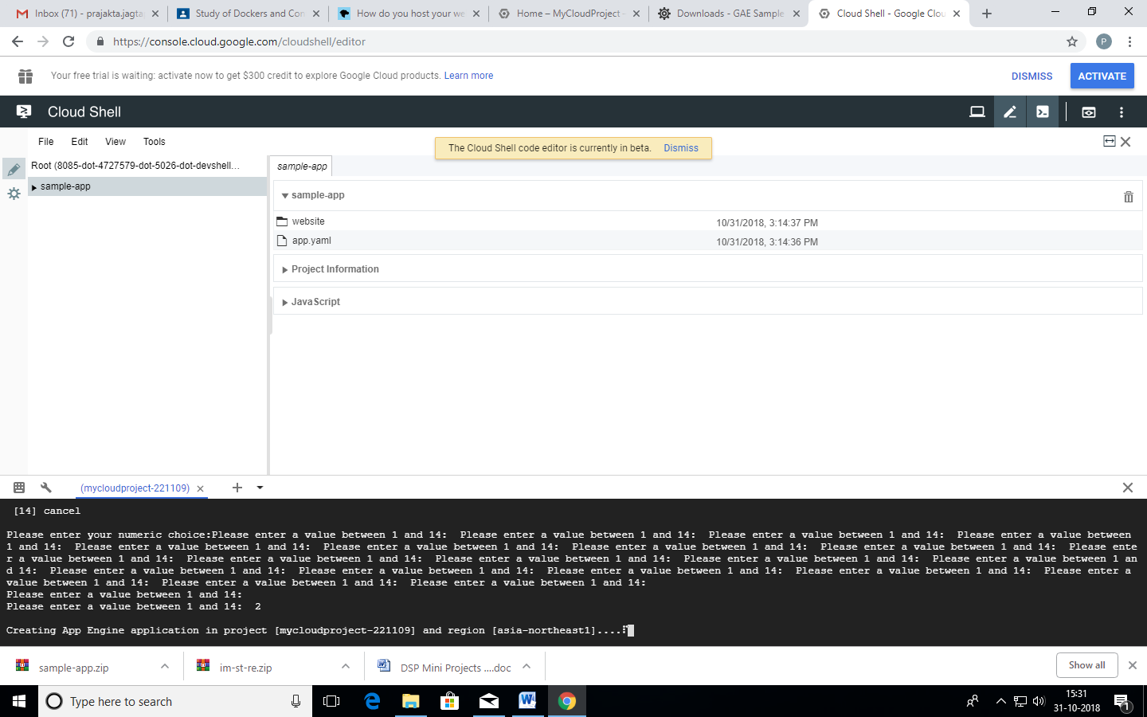

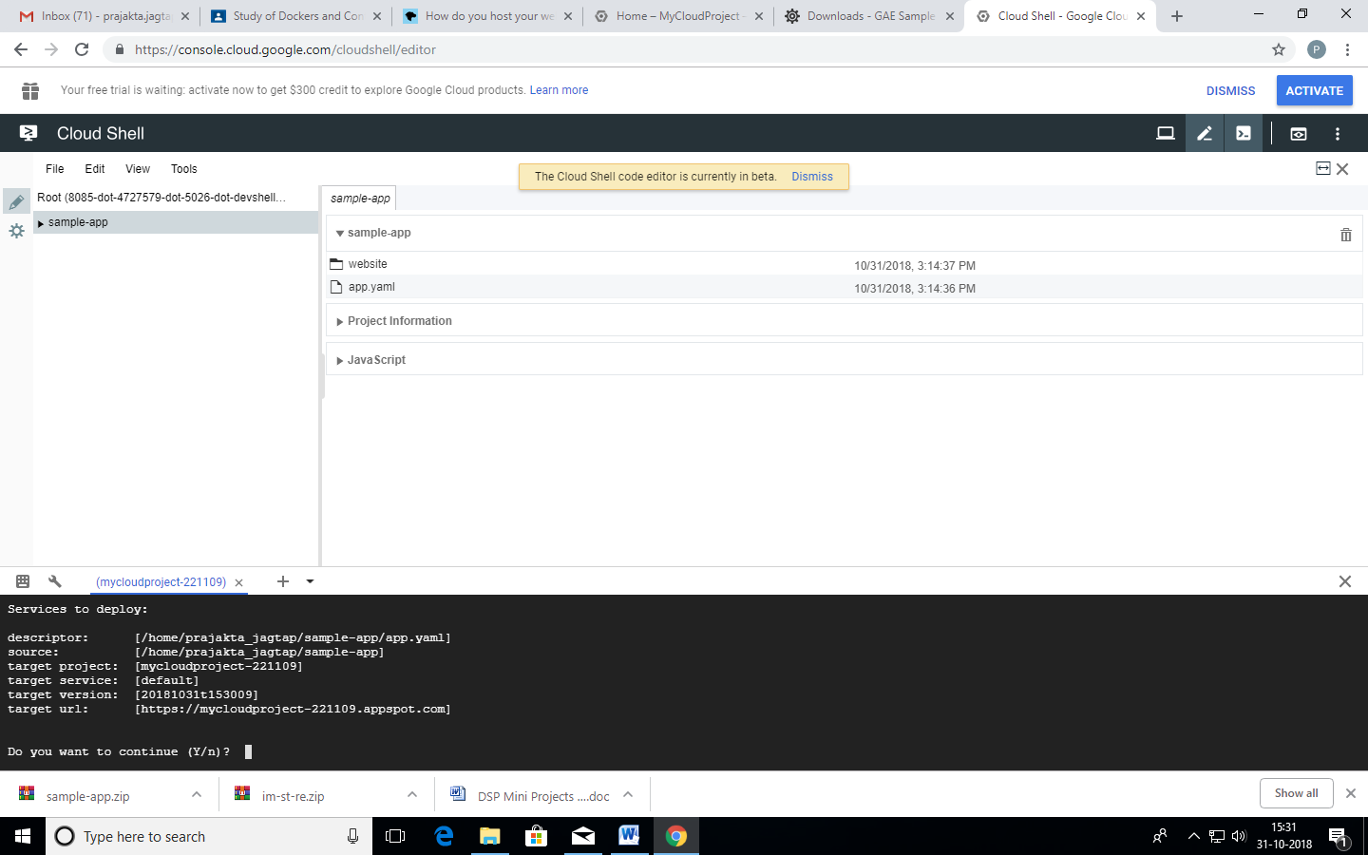

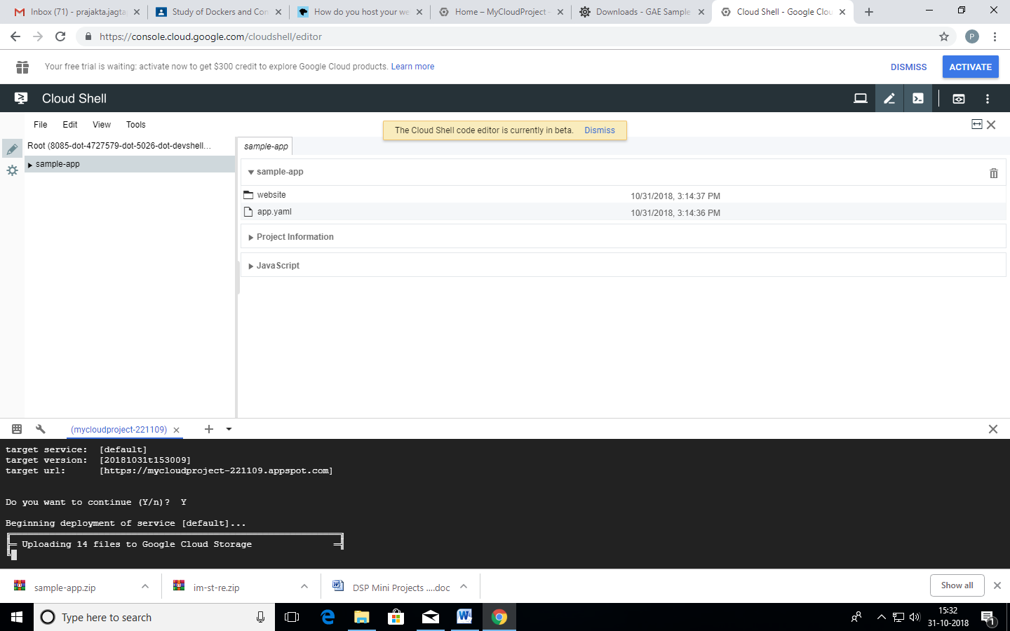

**Step 5.** Upload your app to App Engine:

gcloud app deploy

* Enter a number to choose the region where you want your application located.
* Enter Y to confirm.

Now navigate your browser to your-project-id.appspot.com to see your website online.

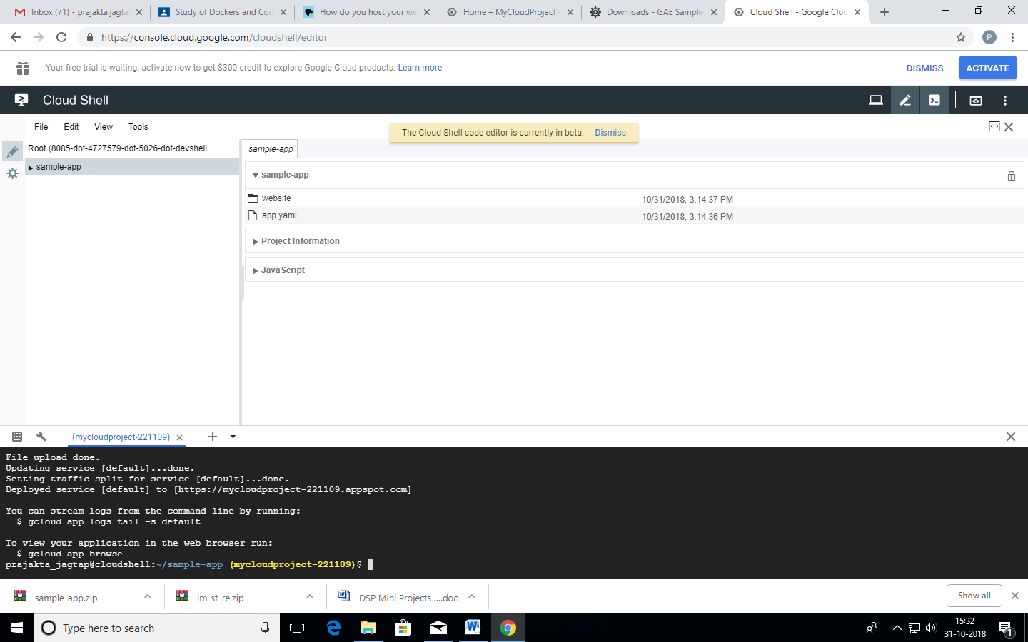

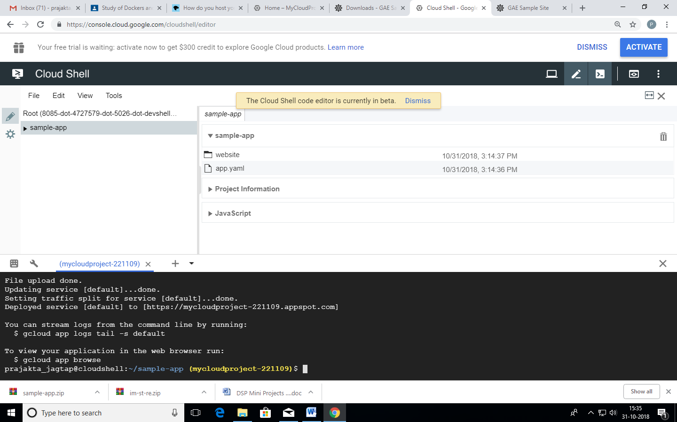

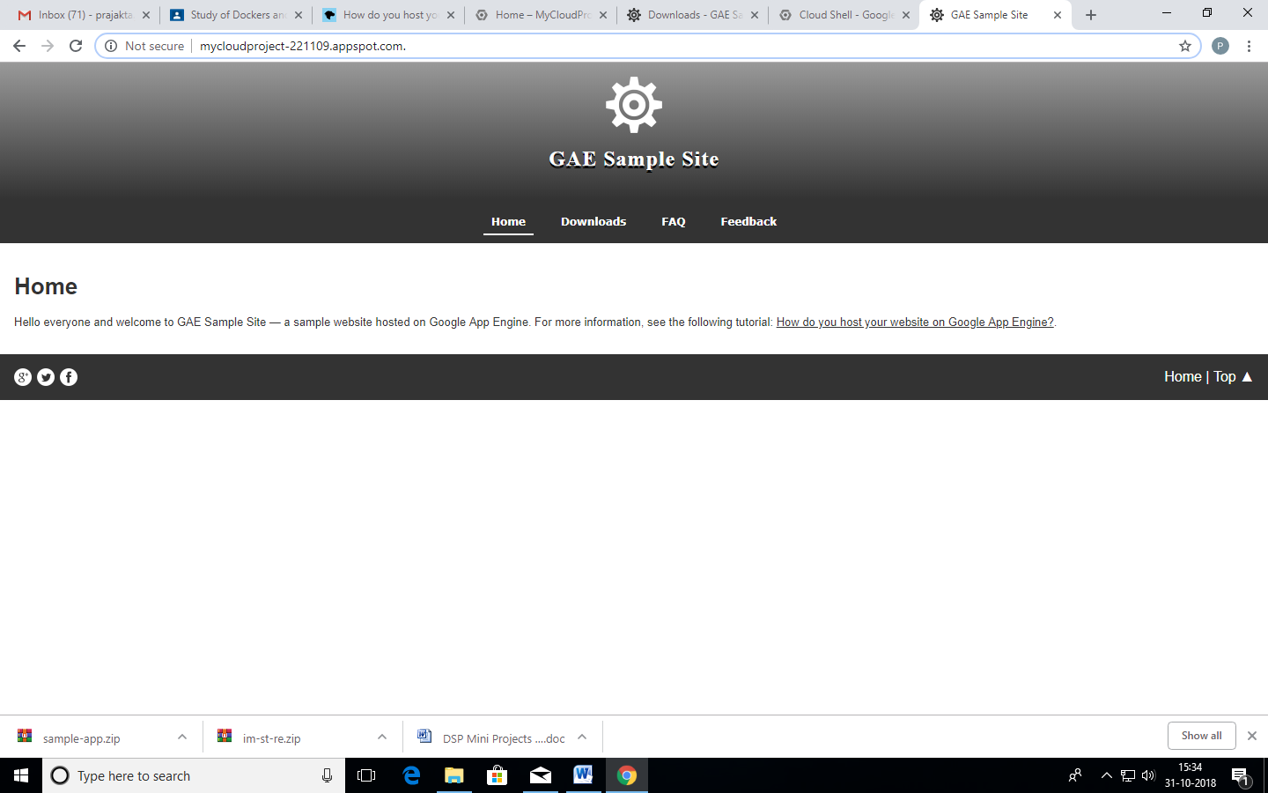

**Reference**

[**https://developer.mozilla.org/en-US/docs/Learn/Common_questions/How_do_you_host_your_website_on_Google_App_Engine**](https://developer.mozilla.org/en-US/docs/Learn/Common_questions/How_do_you_host_your_website_on_Google_App_Engine)

# Experiment No. 4

1. CLoudtop

* + 1. When you open the Cloudtop website it displays this page. It can also be an Online Computer

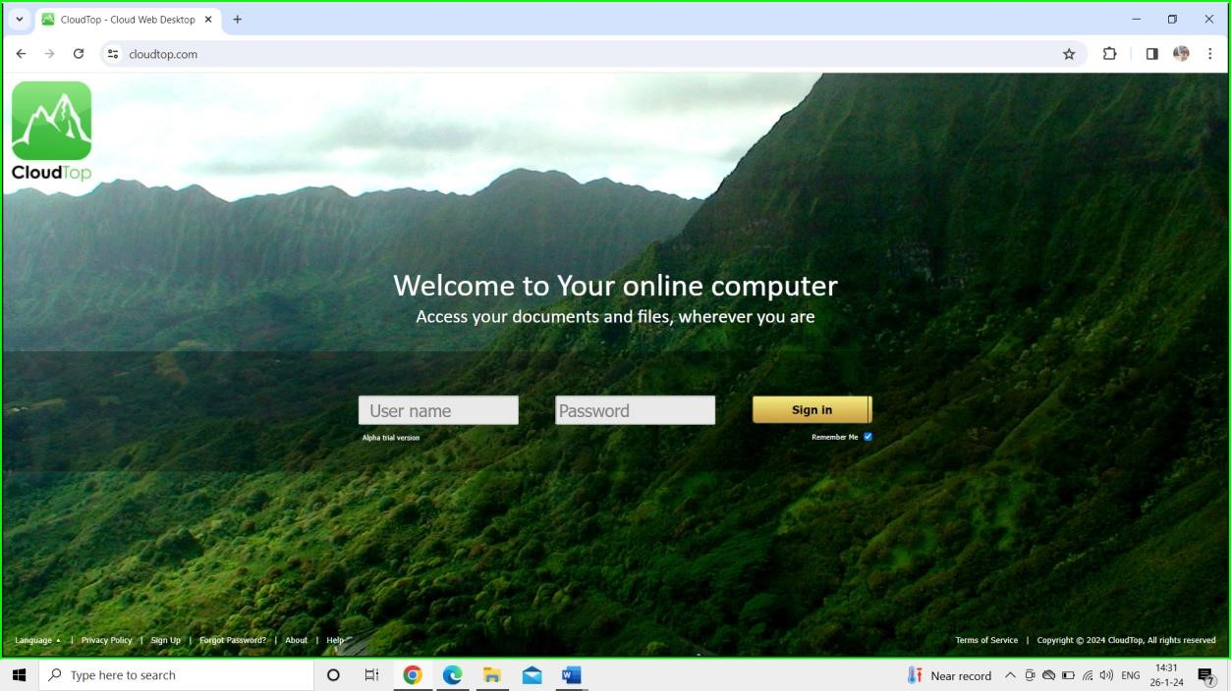

* + 1. You can also know about the cloudtop on their platform.

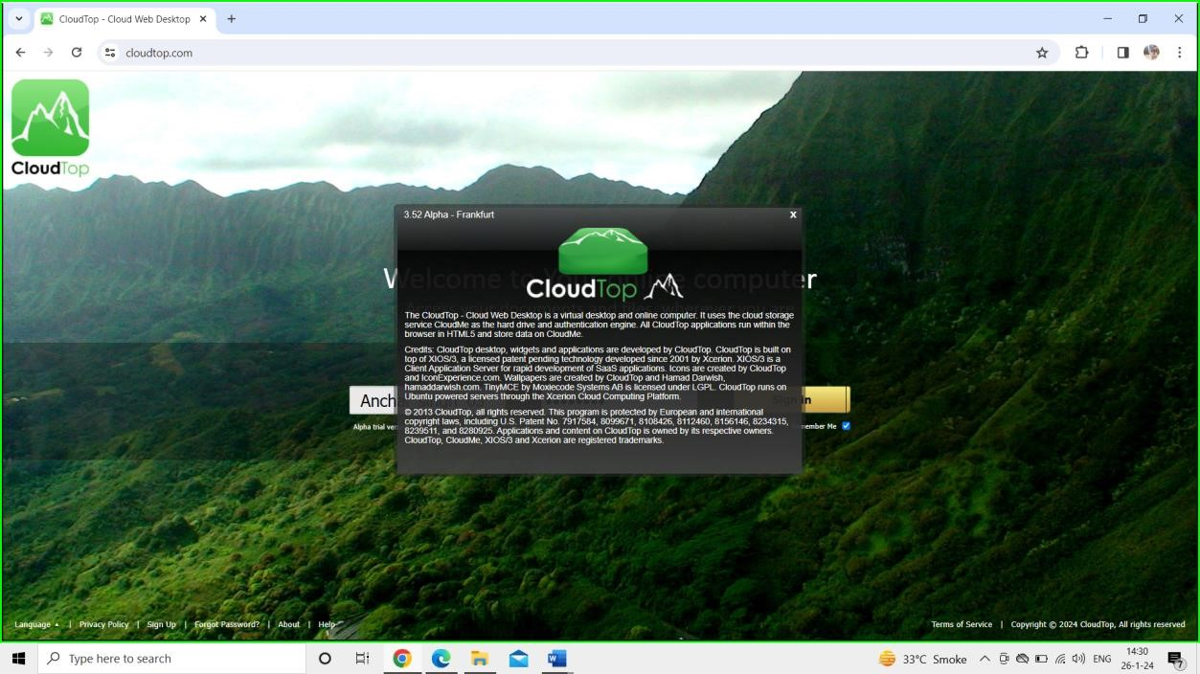

* + 1. It allows you to Sign in and create an account. After that you can login and use the platform as your online computer.

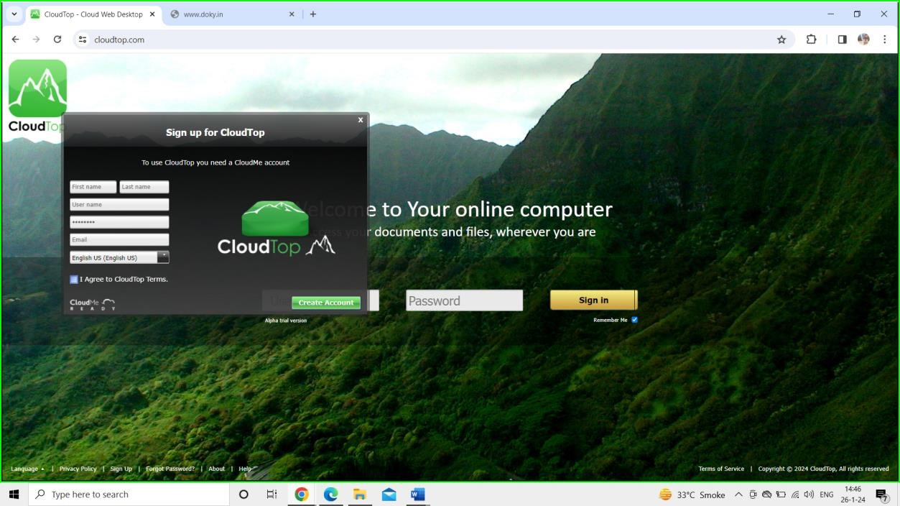

1. QUBES OS

* 1. Qubes OS is a securityfocused operating system that allows you to organize your digital life into compartments called “qubes.”

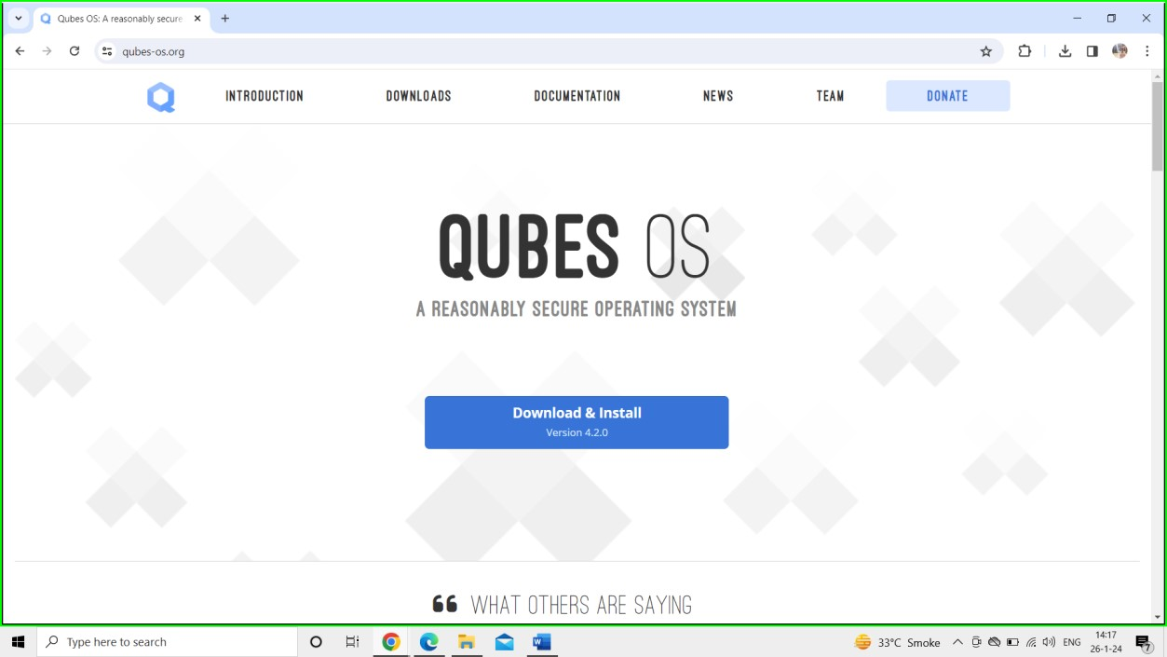

* 1. Qubes OS provides Secure Compartmentalization , Operating System Freedom and Serious Privacy

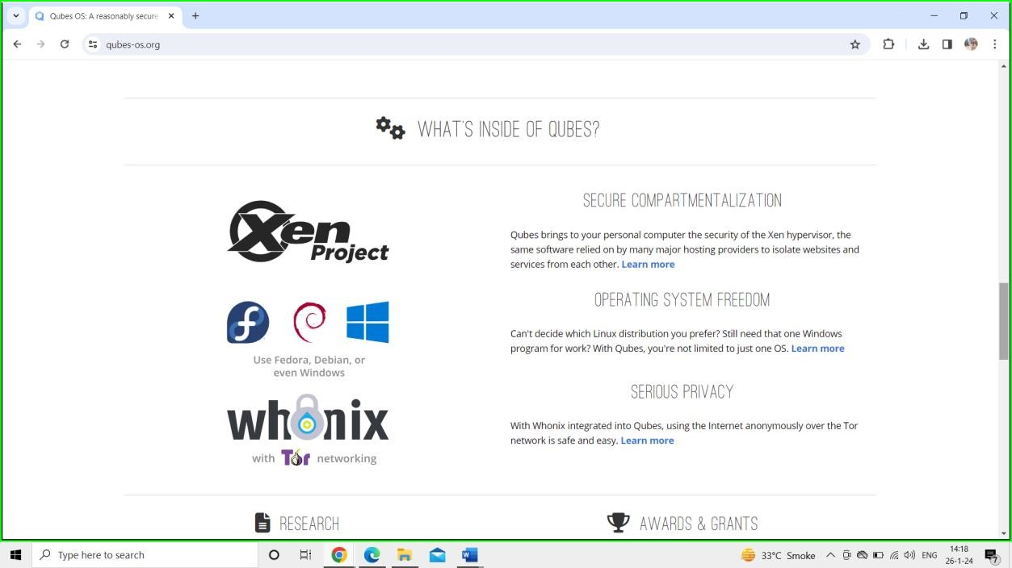

* 1. Qubes OS and its few Features

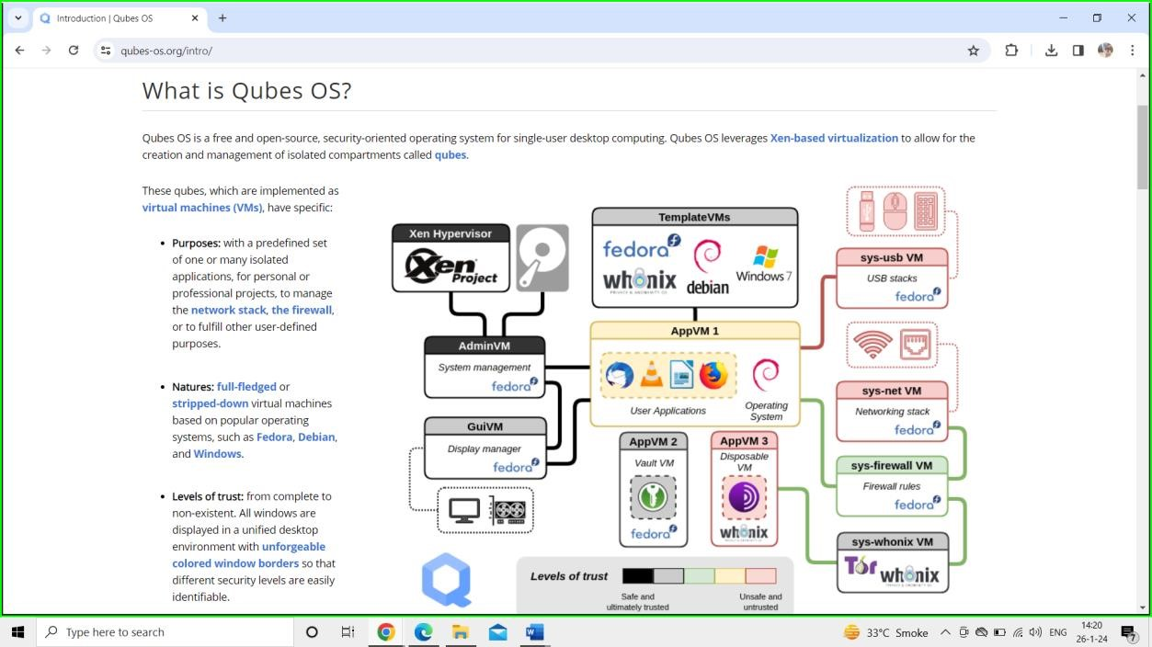

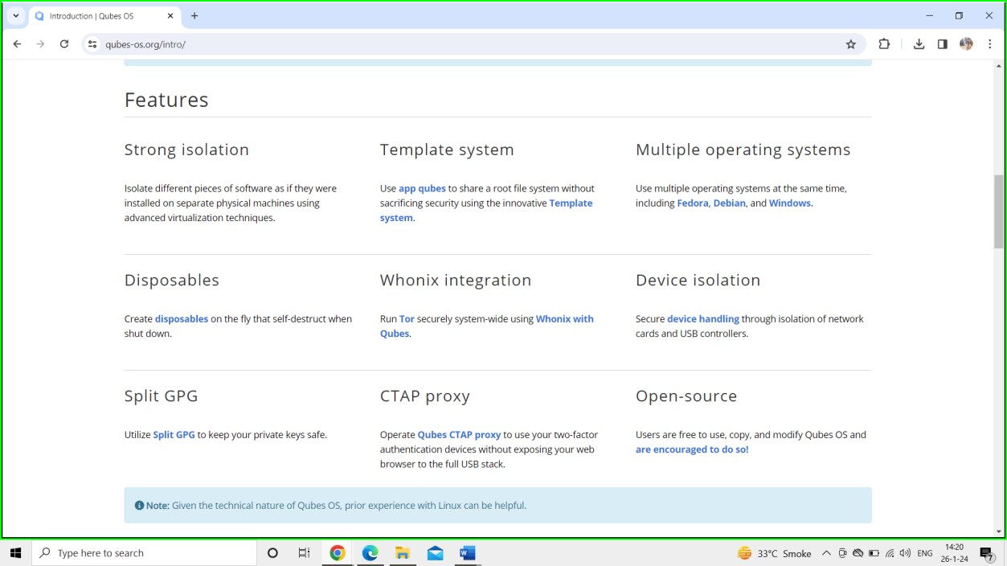

1. CloudMe

* 1. CloudMe service combines cloud storage with synchronization of data, allowing you to sync your mobile camera roll with for example your tablet or TV, to sync files across computers and mobile devices, and to share and receive files with friends and colleagues.

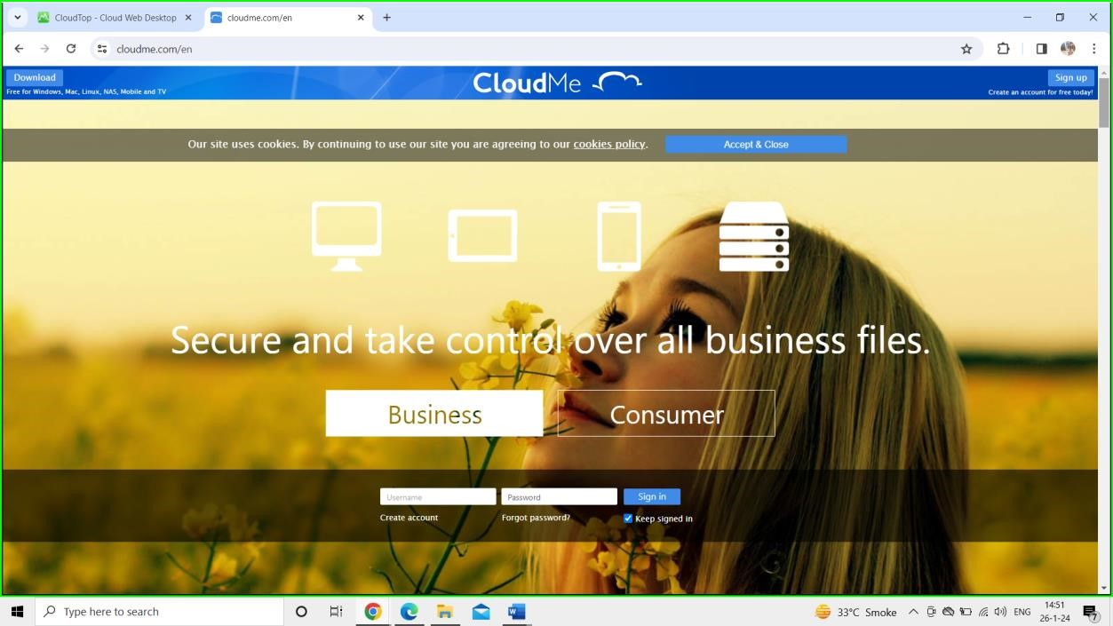

* 1. You can get started as an business or as an consumer with different pay plans.

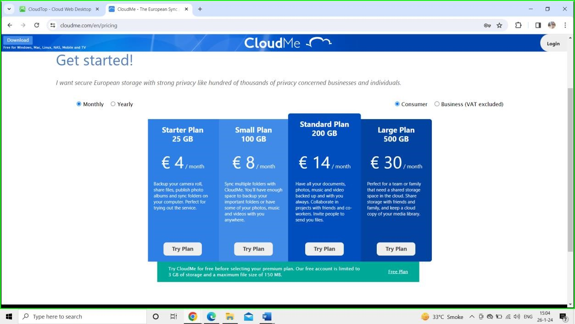

* 1. Consumers also have an access to free plan. They can sign up for free account with their own Email Id and Personal Details for free.

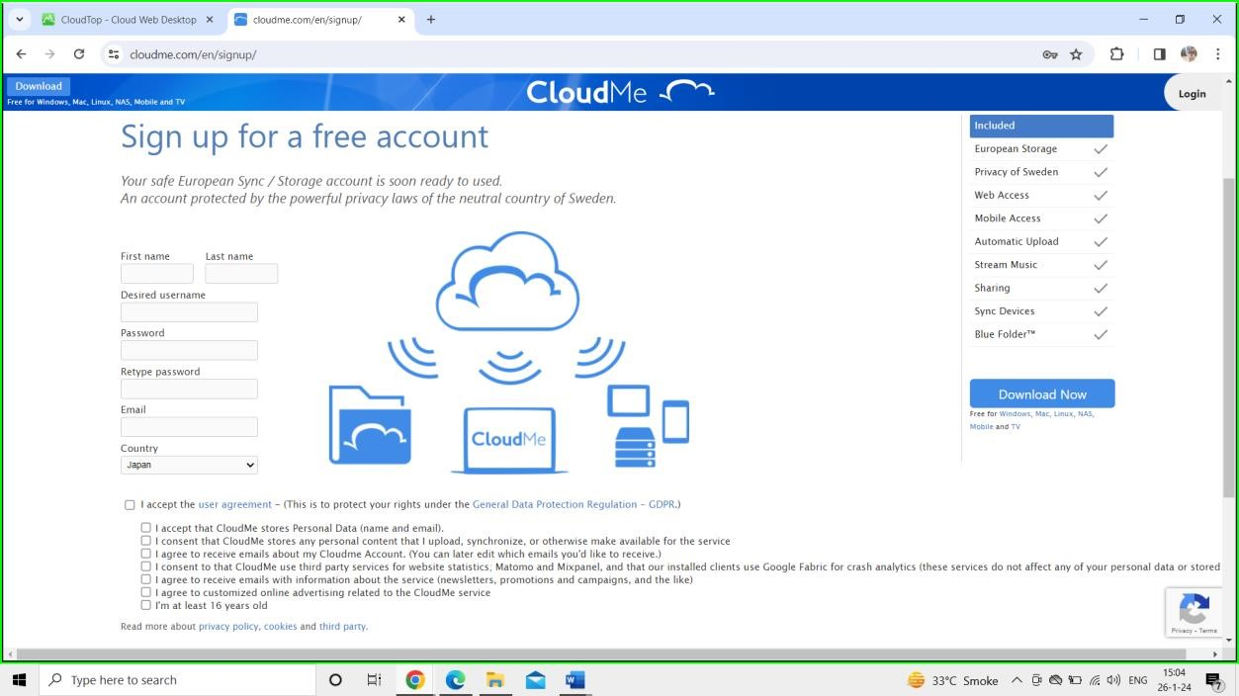

* 1. Businesses can have an different plan that they can try to use CloudMe

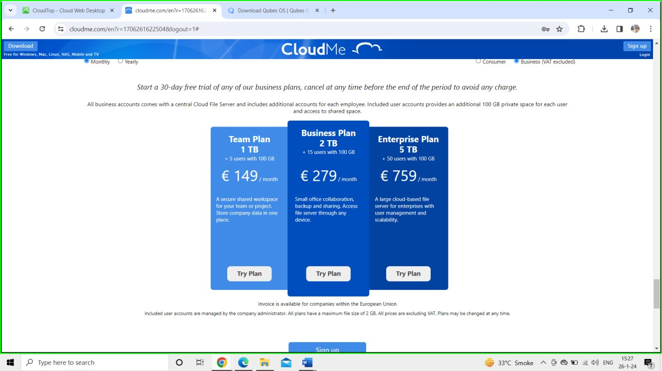

* 1. Once you have a sign in as a consumer or as an business you can use cloud me for storage purposes.

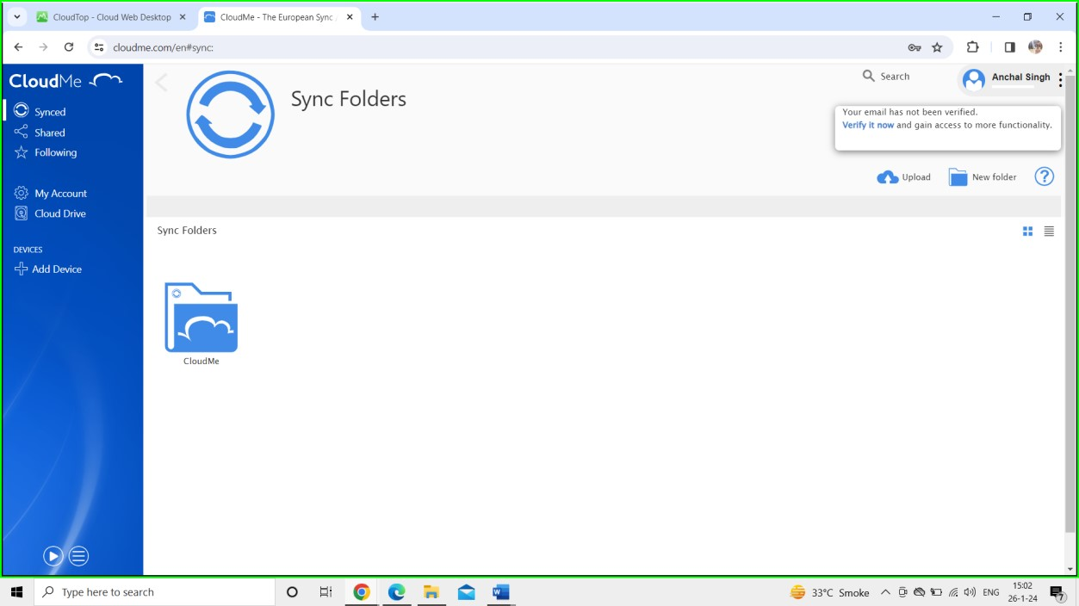

➢ **COMPARITIVE ANALYSIS:**

1) CloudMe:

* Key Features:
  + Cloud storage and filesharing service.
  + Crossplatform support.
* Strengths:
  + Emphasis on simplicity and userfriendliness.
  + Collaborative features for file sharing.
* Considerations:
  + May lack some advanced features compared to larger cloud providers.

2) Qubes:

* Key Features:
  + Securityfocused operating system.
  + Uses compartmentalization for enhanced security.
* Strengths:
  + Strong emphasis on security and isolation.
  + Allows for running multiple virtual machines for different tasks.
* Considerations:
  + Can be complex for nontechnical users.
  + Hardware compatibility may be a consideration.

3) ZeroPC:

* Key Features:
  + Cloudbased virtual desktop.
  + File management and collaboration tools.
  + Integration with multiple cloud storage services.
* Strengths:
  + Unified access to various cloud storage services, allowing users to manage and organize files in one place.
  + Collaboration features for sharing and editing files.
  + Virtual desktop functionality for a centralized workspace.
* Considerations:
  + The user interface and user experience may vary in terms of intuitiveness.
  + Depending on the user's needs, some features may be more robust in dedicated services from specific cloud storage providers.

# Experiment No. 5

Open URL:

<https://www.cloudskillsboost.google/paths/125>

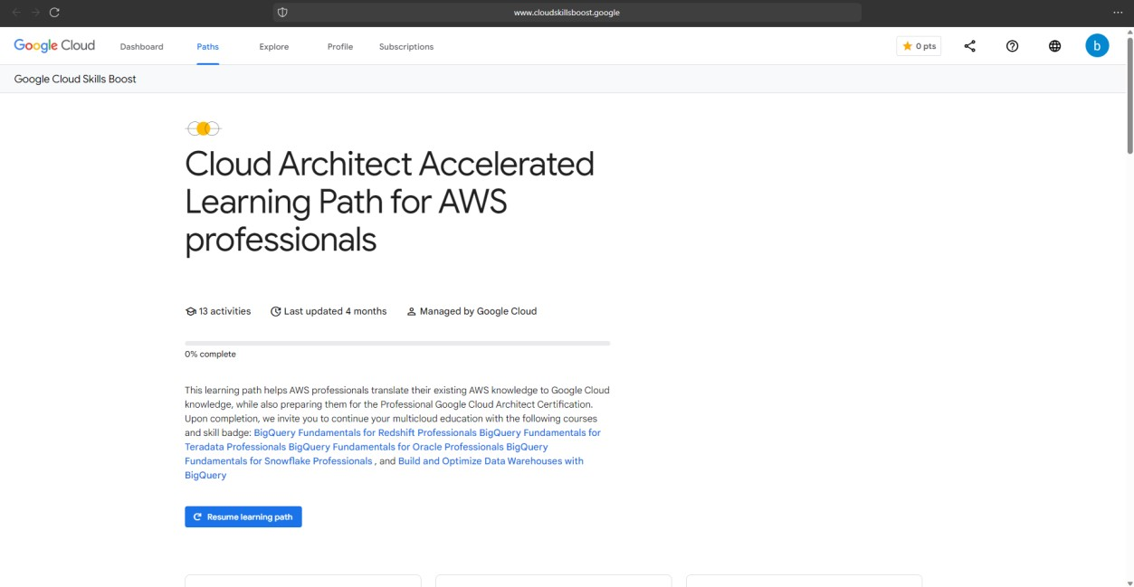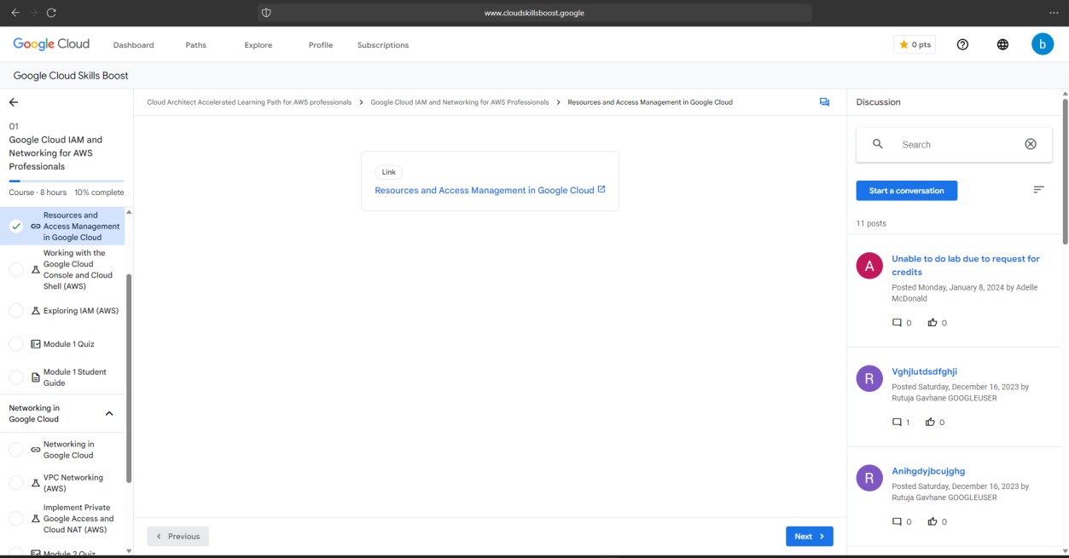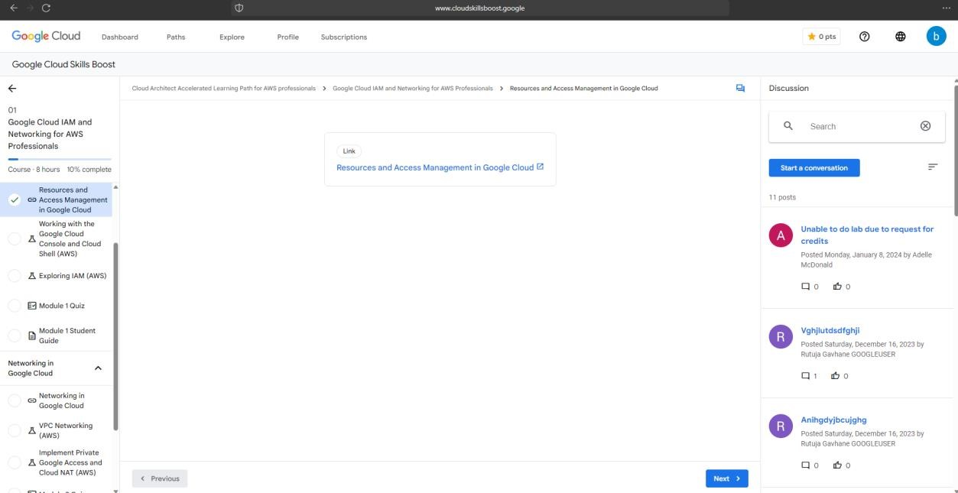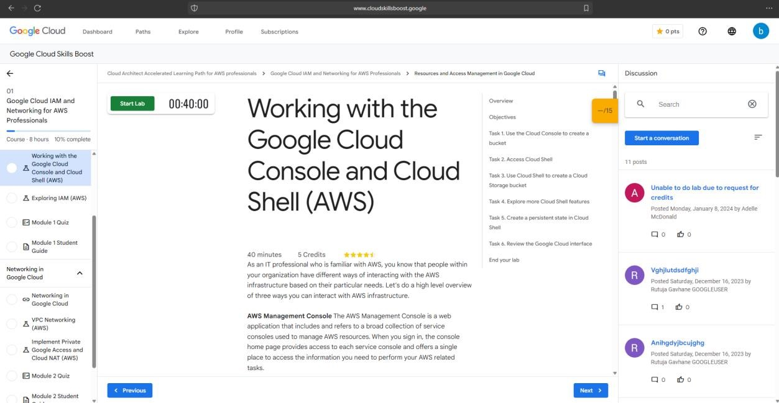

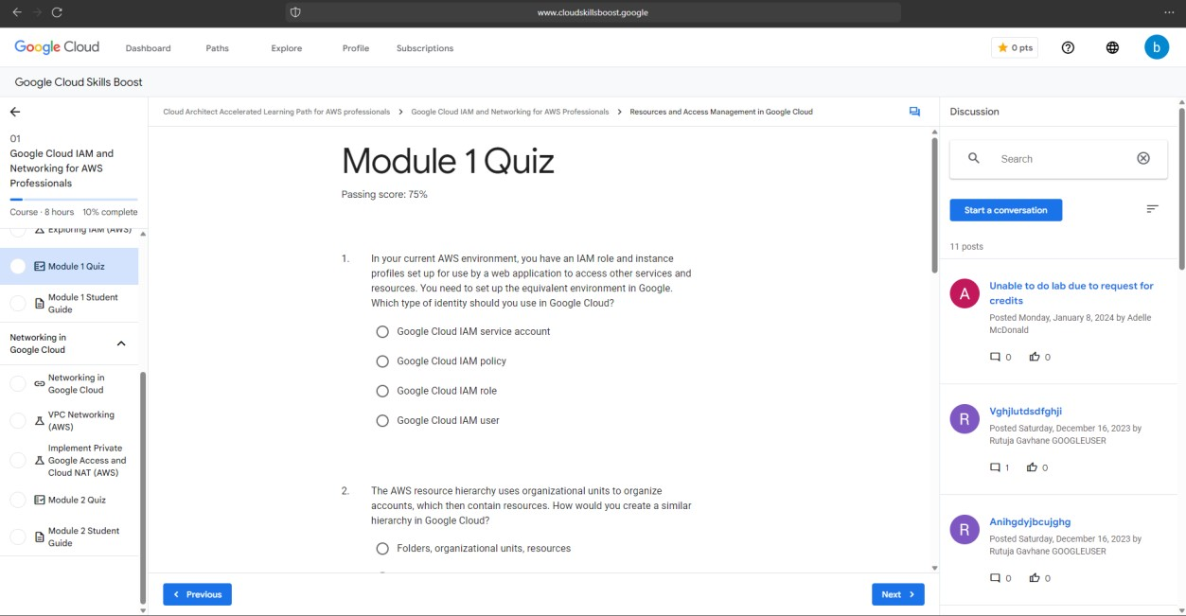

[https://www.cloudskillsboost.google/paths/7](https://www.cloudskillsboost.google/paths/72)

[2](https://www.cloudskillsboost.google/paths/72)

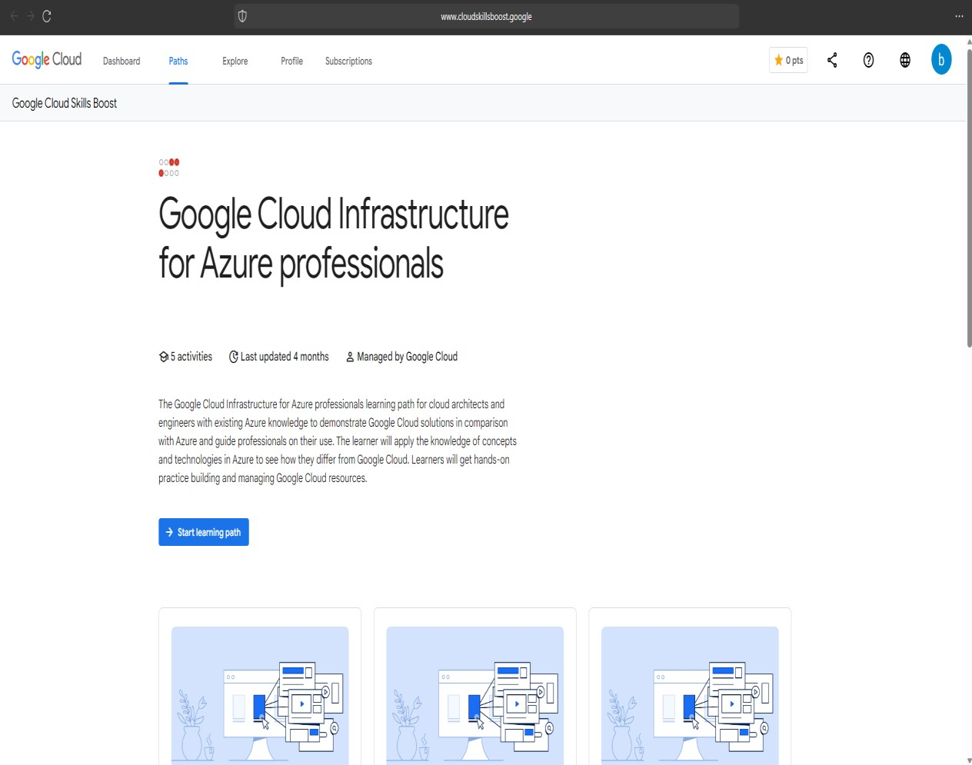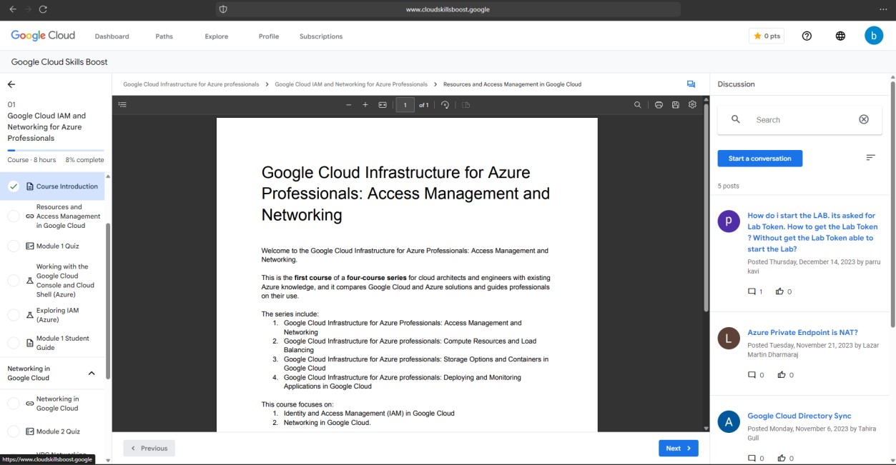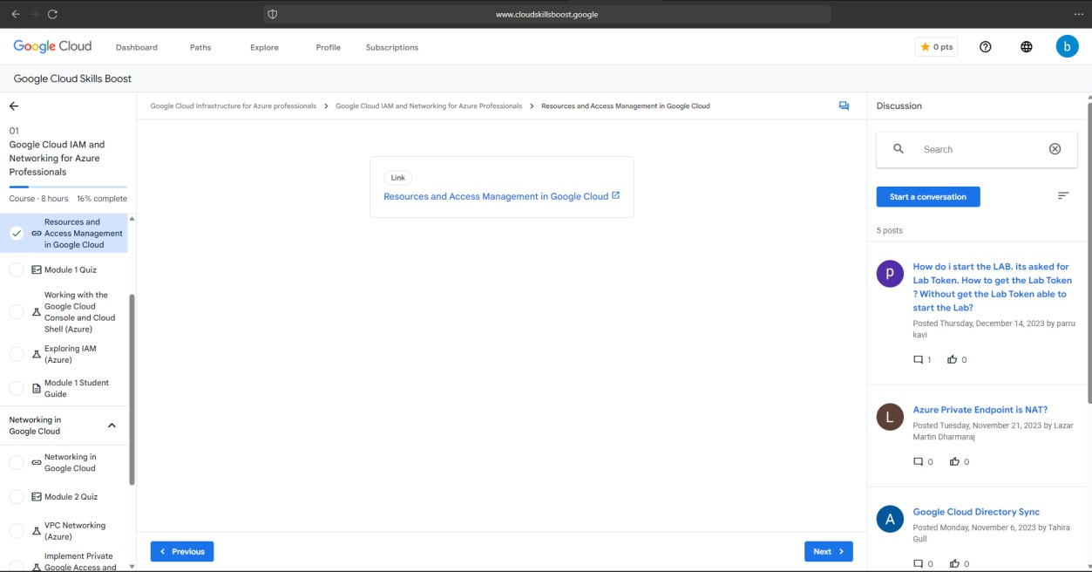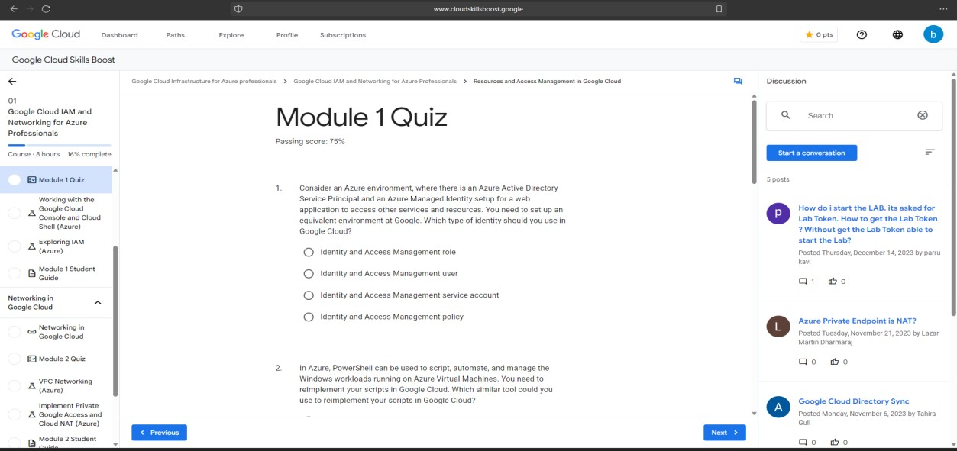

Experiment No. 6

**Step 1:** Download the Citrix Hypervisor (XenServer) .iso file Download Launch Virtualbox Create a New VM by selecting New. **Name:** XenServer **Machine Folder:**

C:\VMs **Type:** Linux

**Version:** Other (64bit)

**Memory Size:** 8192 MB

**Hard disk:** Create a virtual hard disk now

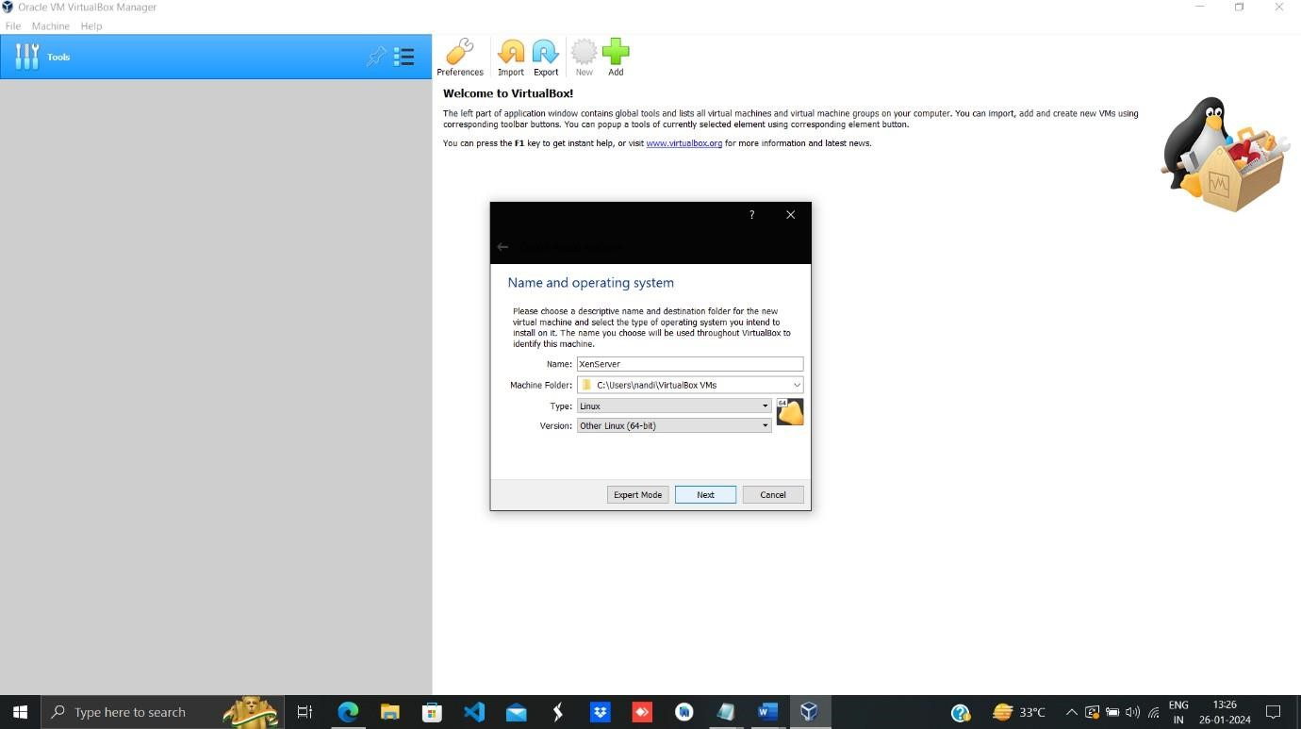

**Step**

**2:**

Start

the

VM

and

select

the

XenServer

iso

file



Start.

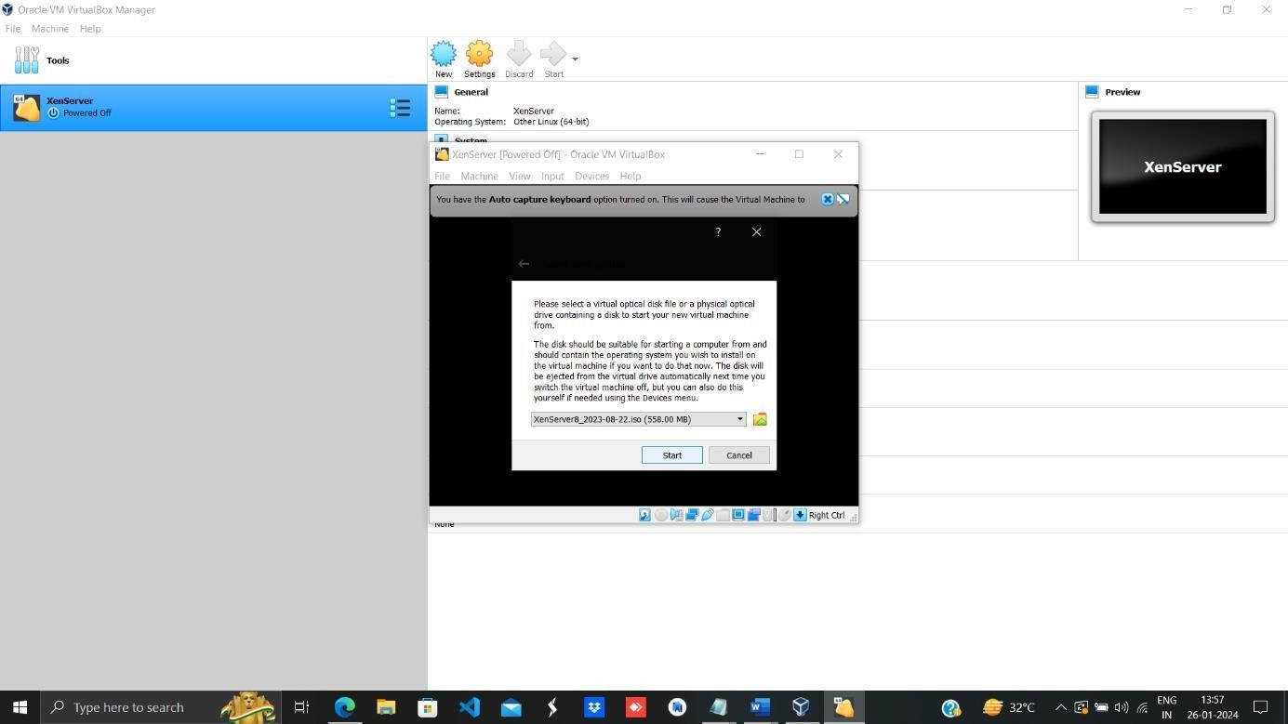

**3:** Keymap (US) → Ok

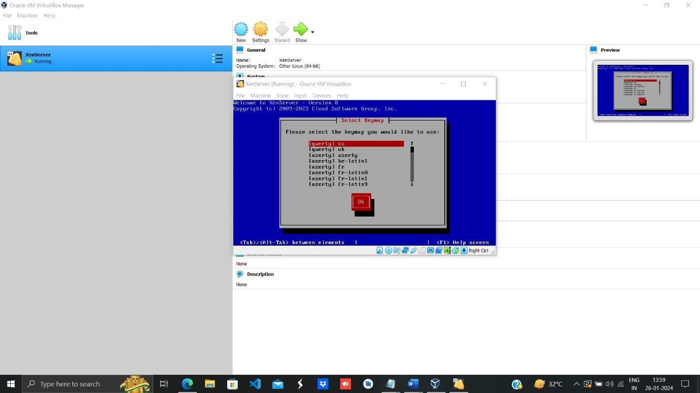

**Step 4:** Click on Accept EVA.

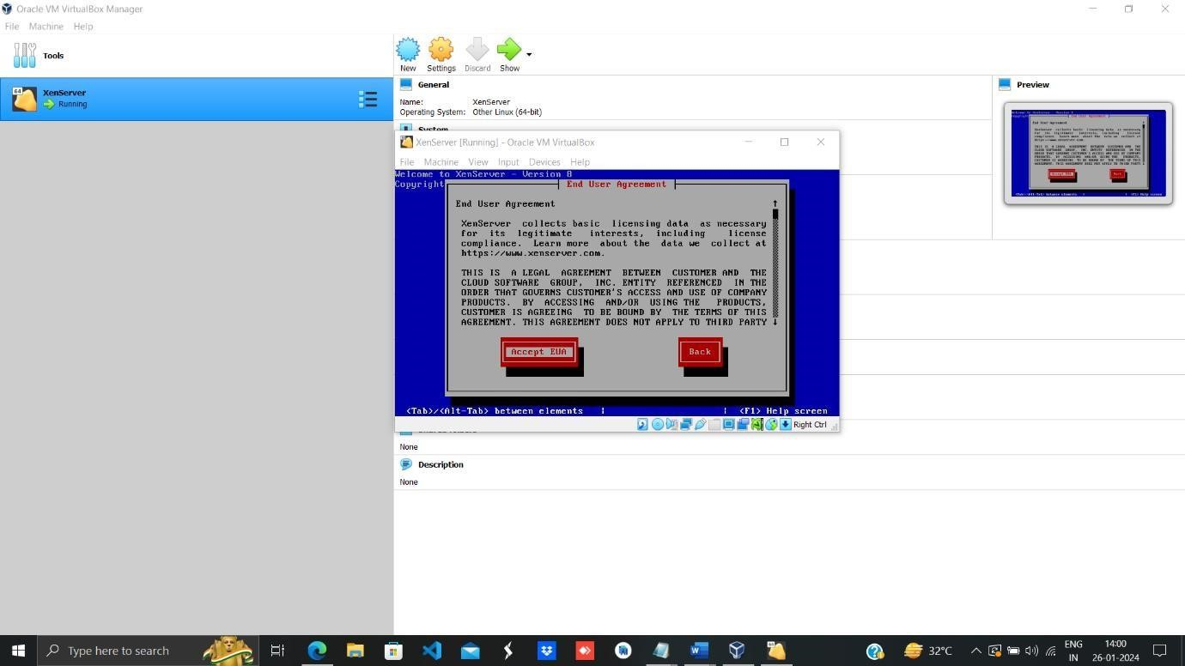

**5:** Primary Disk → Ok.

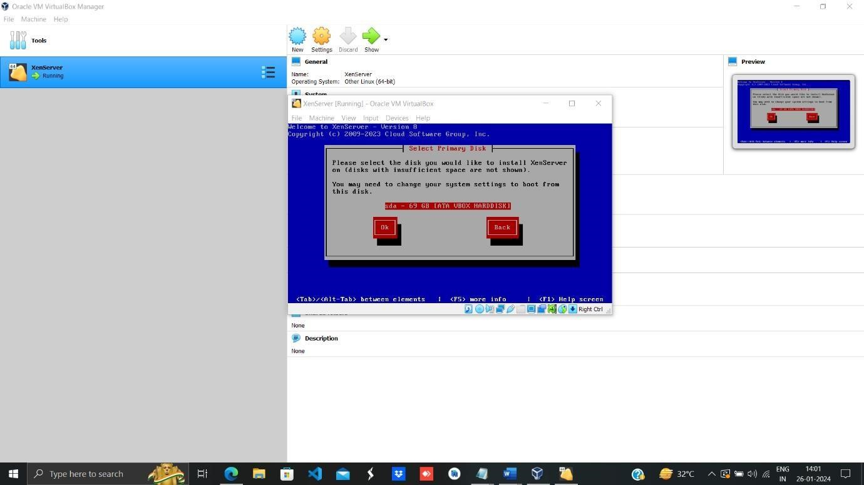

**Step 6:** Select virtual Machine Storage Ok.

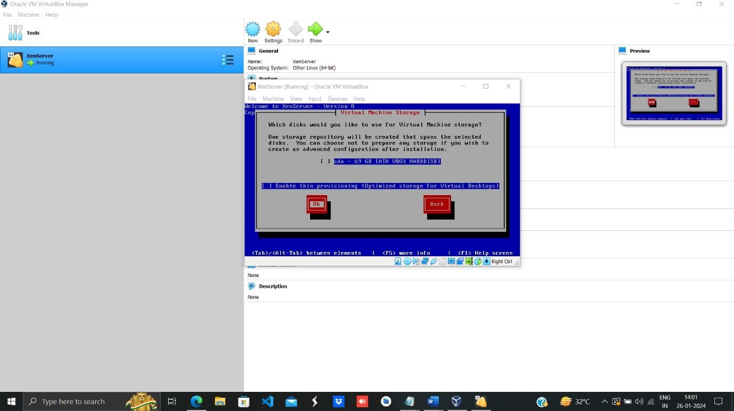

**7:** installation Source → Ok.

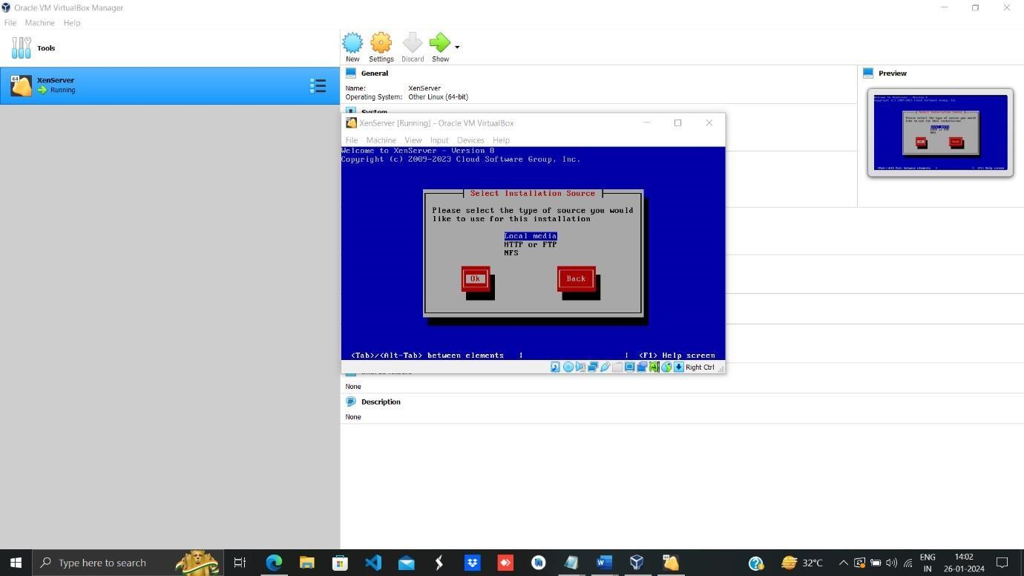

**Step 8:** Select installation source Ok.

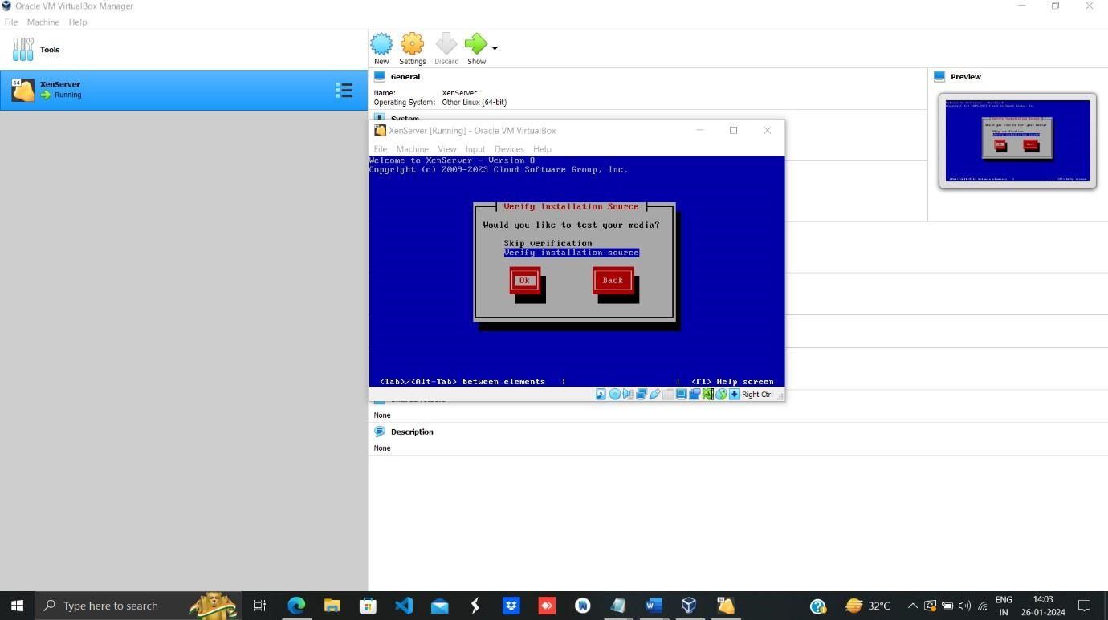

**Step 9:** Set the password as per your choice it should must contain at least 6 characters.

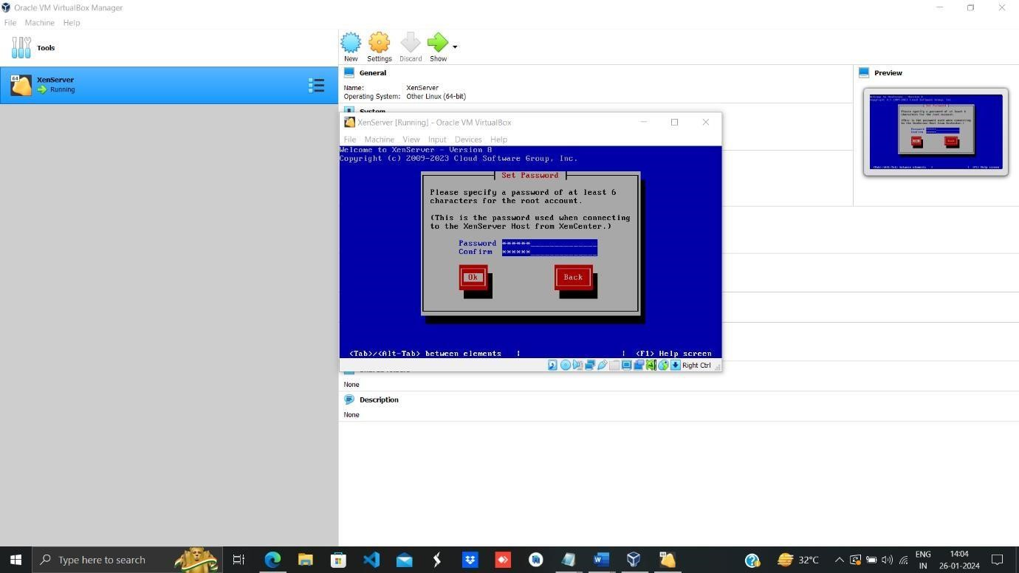

**Step 10:** Select Automatic Configuration and click on Ok.

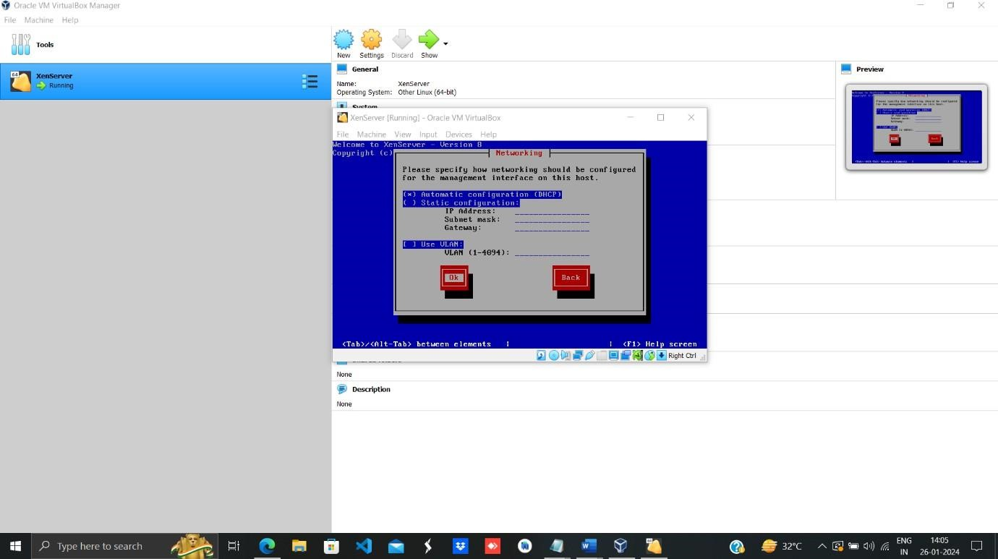

**Step 11:** Select Time Zone as Asia and click on ok.

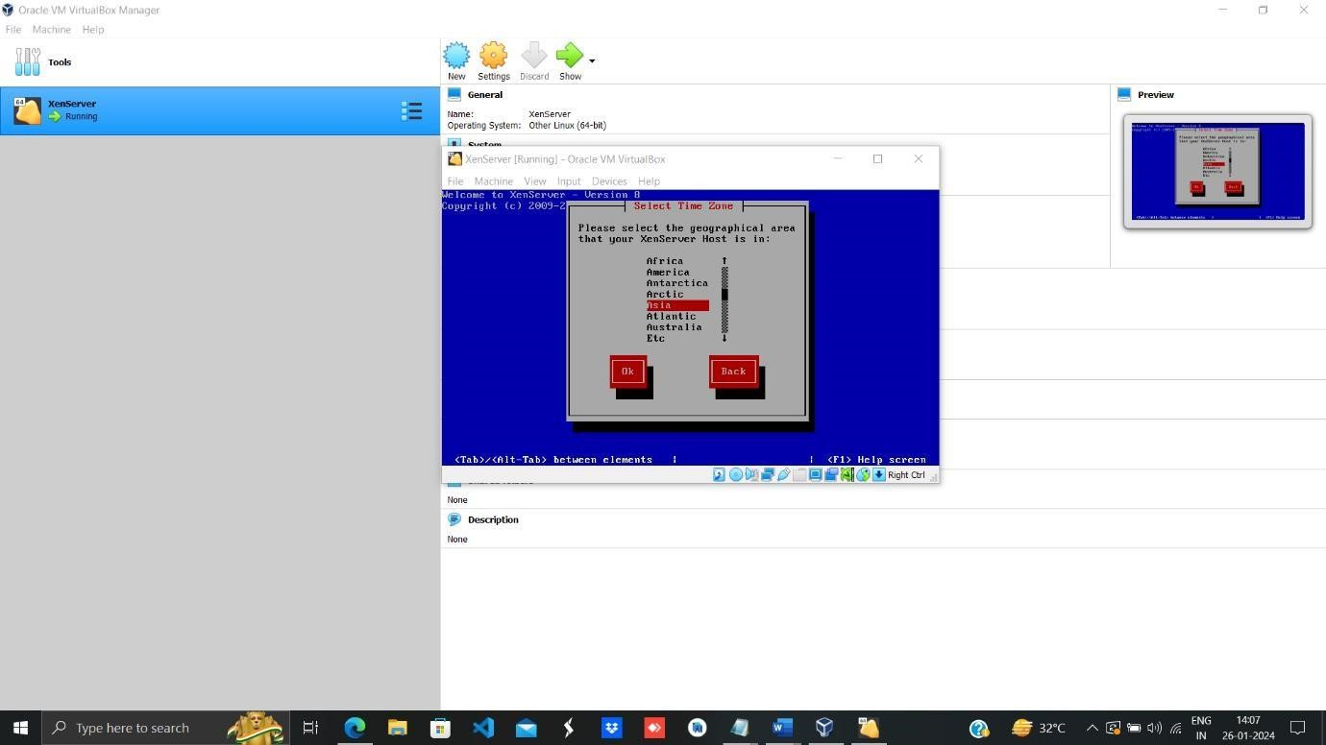

**Step 12:** Select Kolkata and click on Ok.

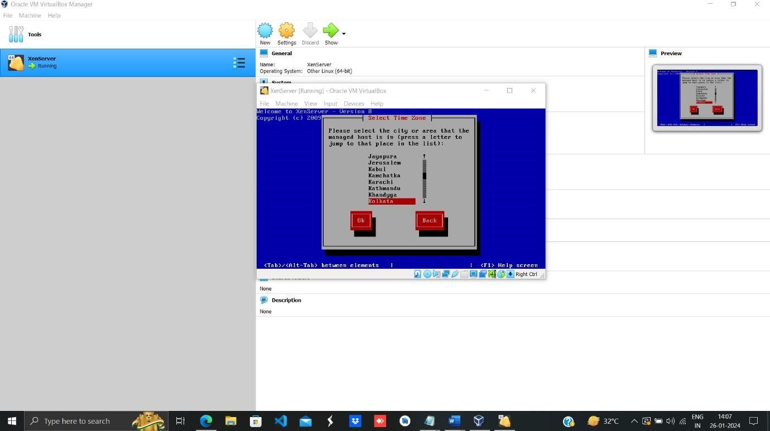

**Step 13:** Click on Install XenServer.

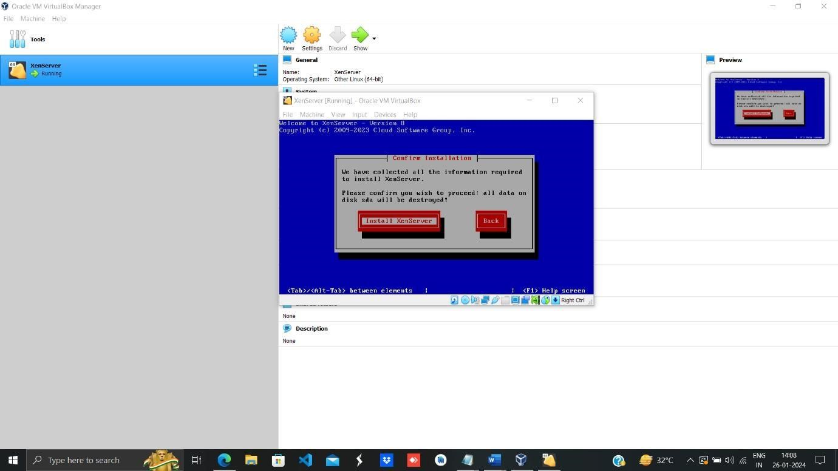

# Experiment No.7

**Step 1:** Visit [https://portal.azure.com.](https://portal.azure.com/) Open your web browser and go to [https://portal.azure.com.](https://portal.azure.com/) Login to Azure using Birla college email id Log in with your Birla college email credentials.

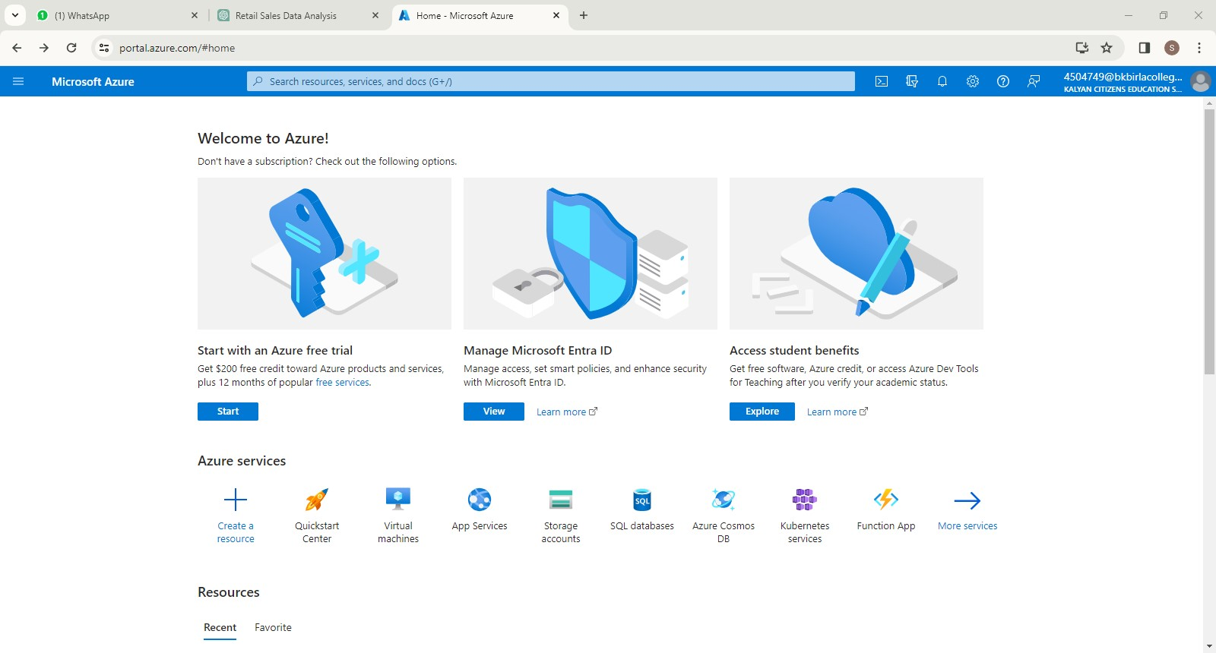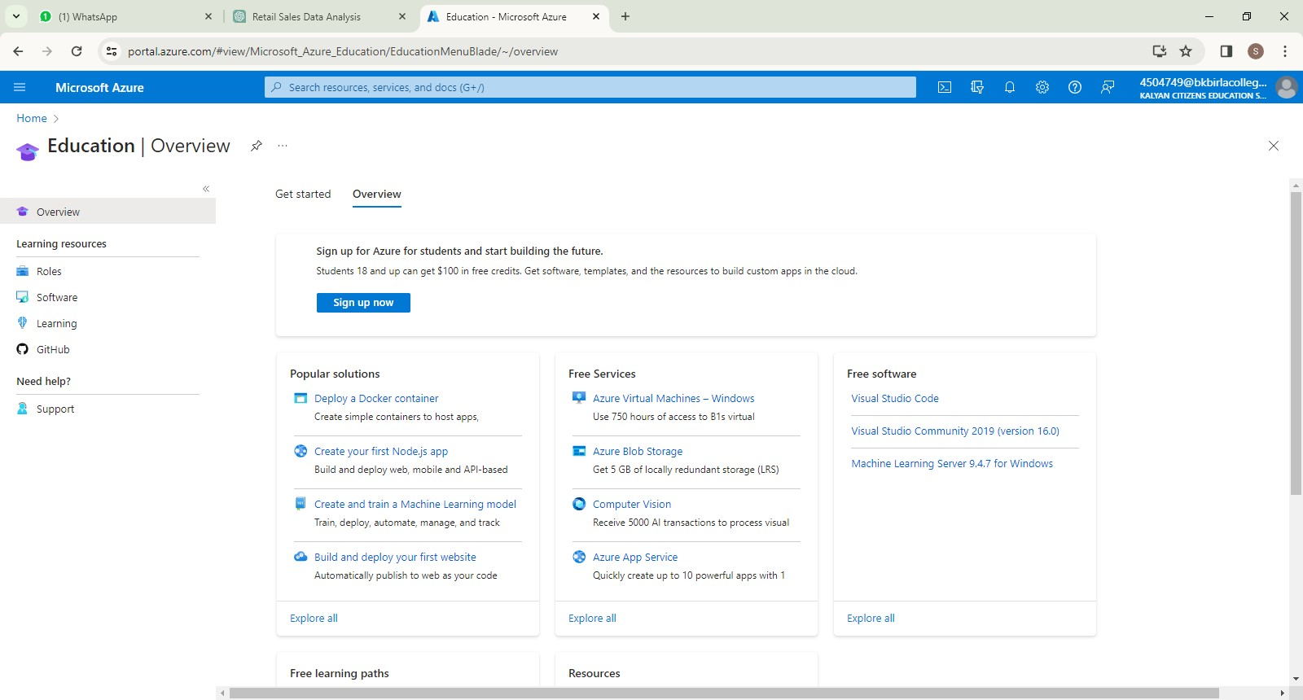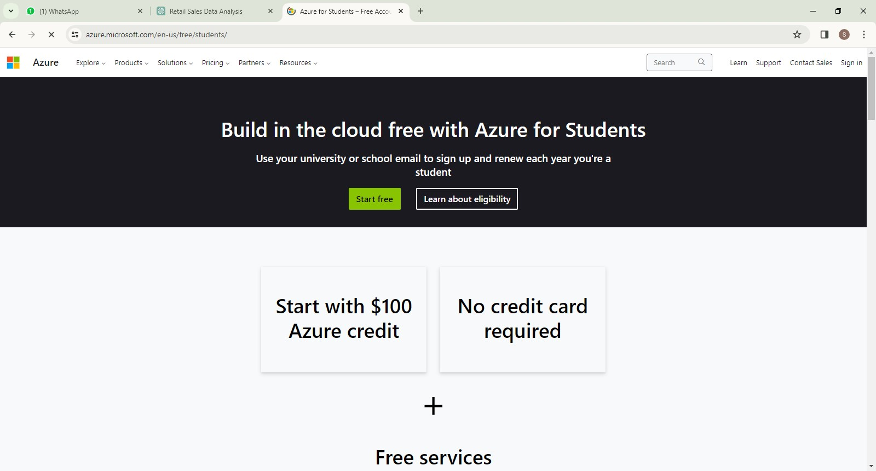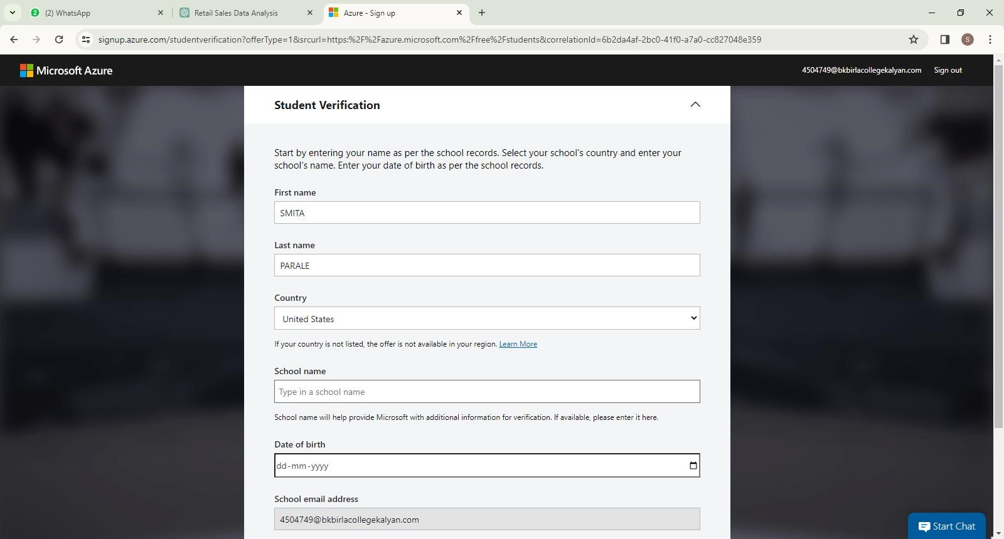

**Step 2:** Create Windows Server VM

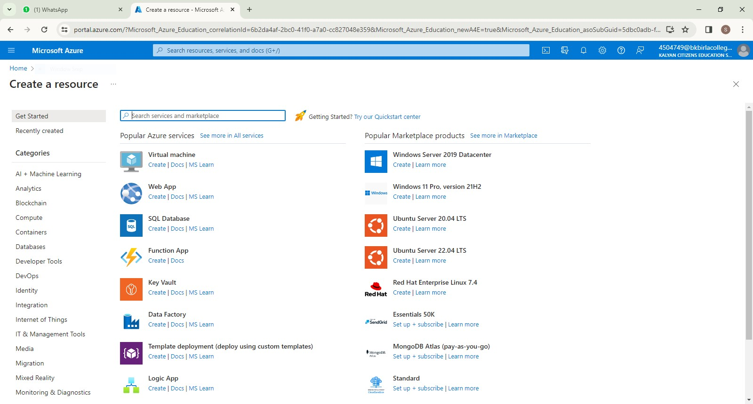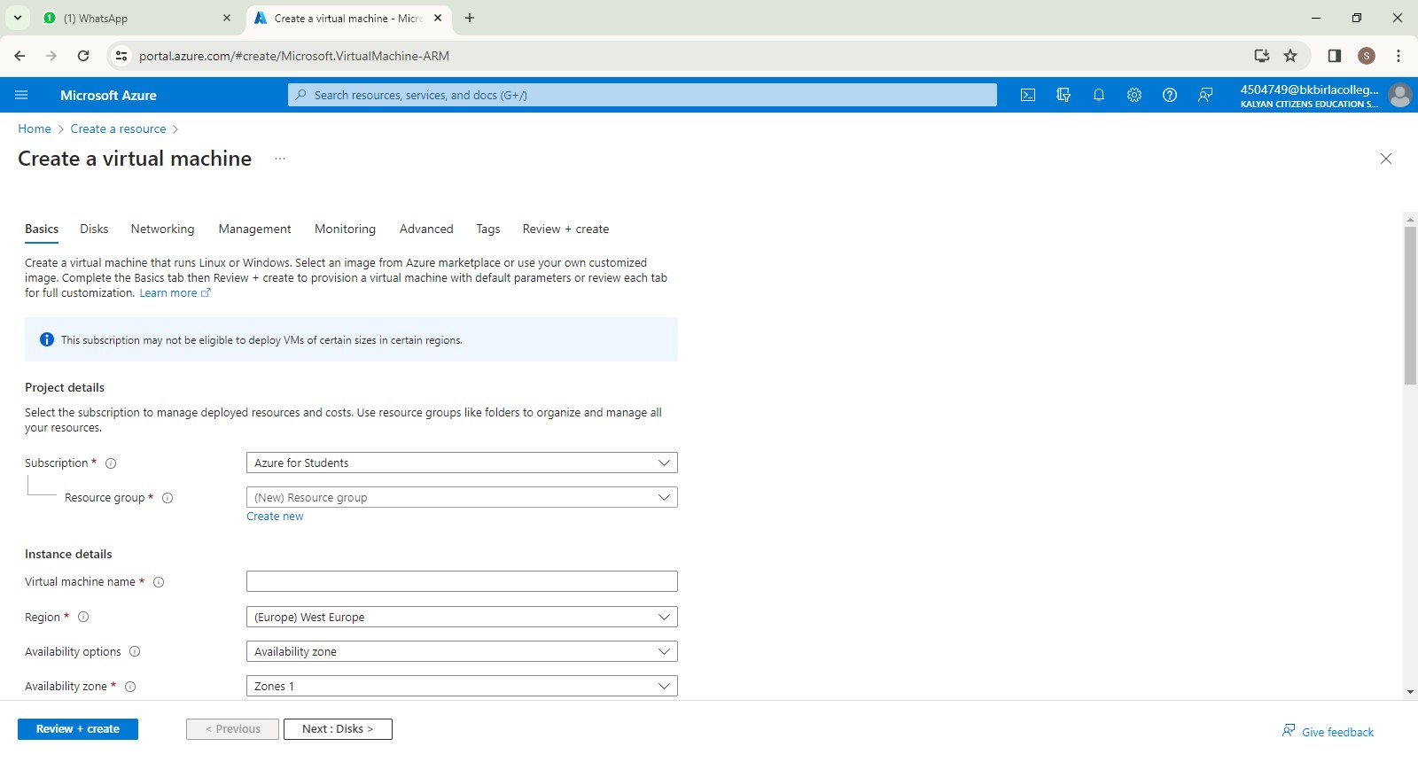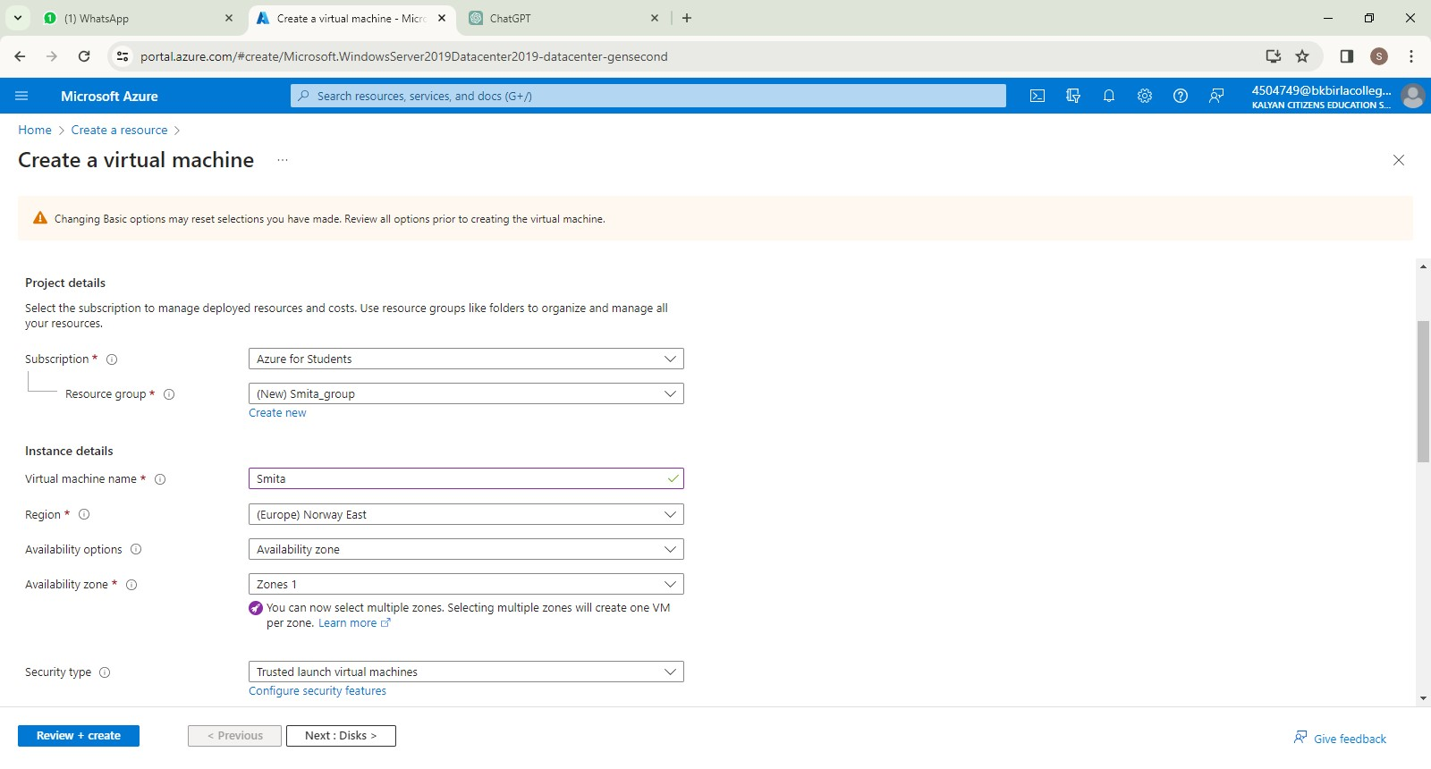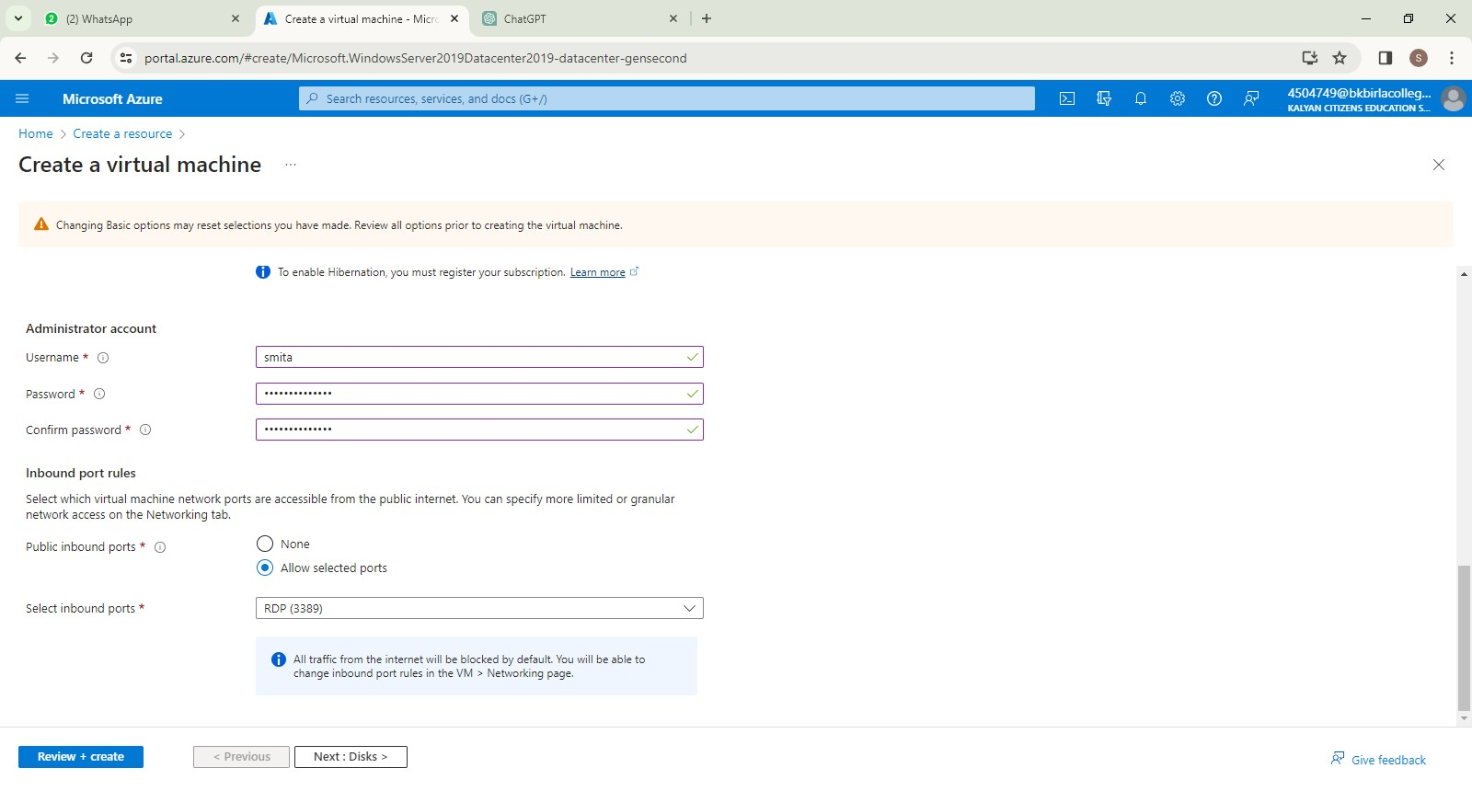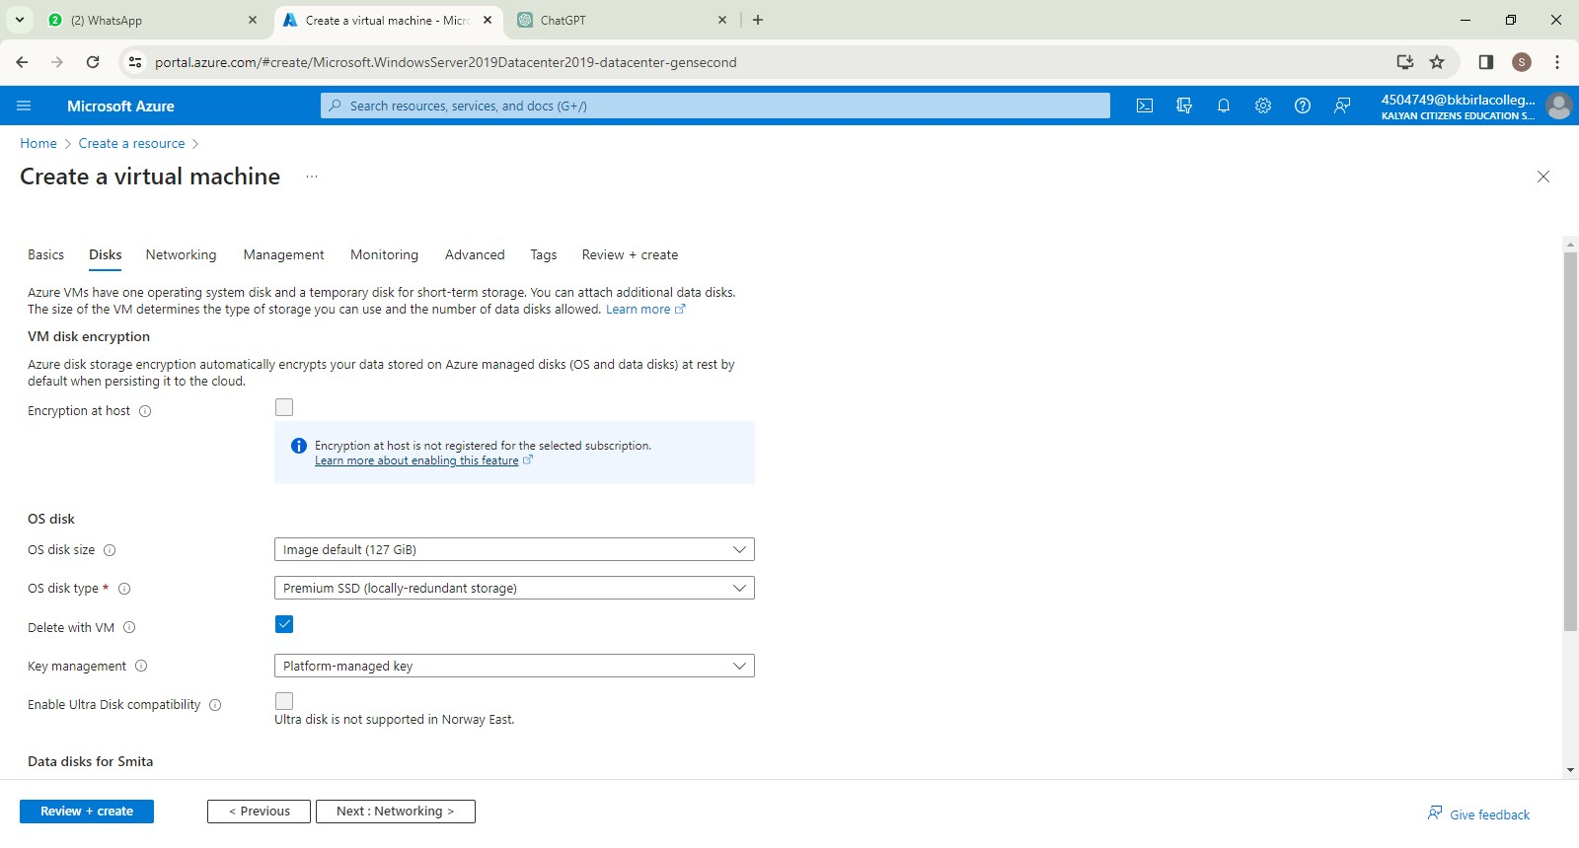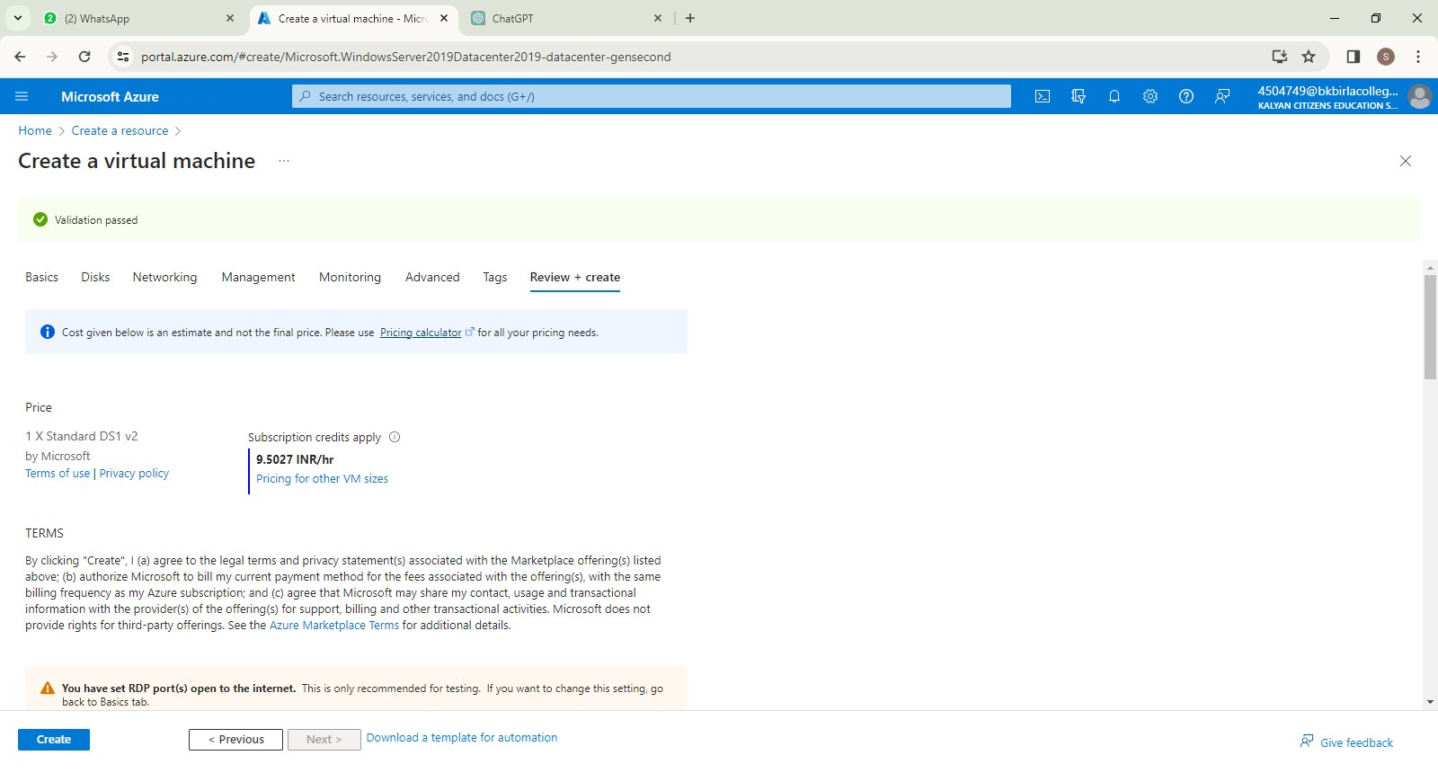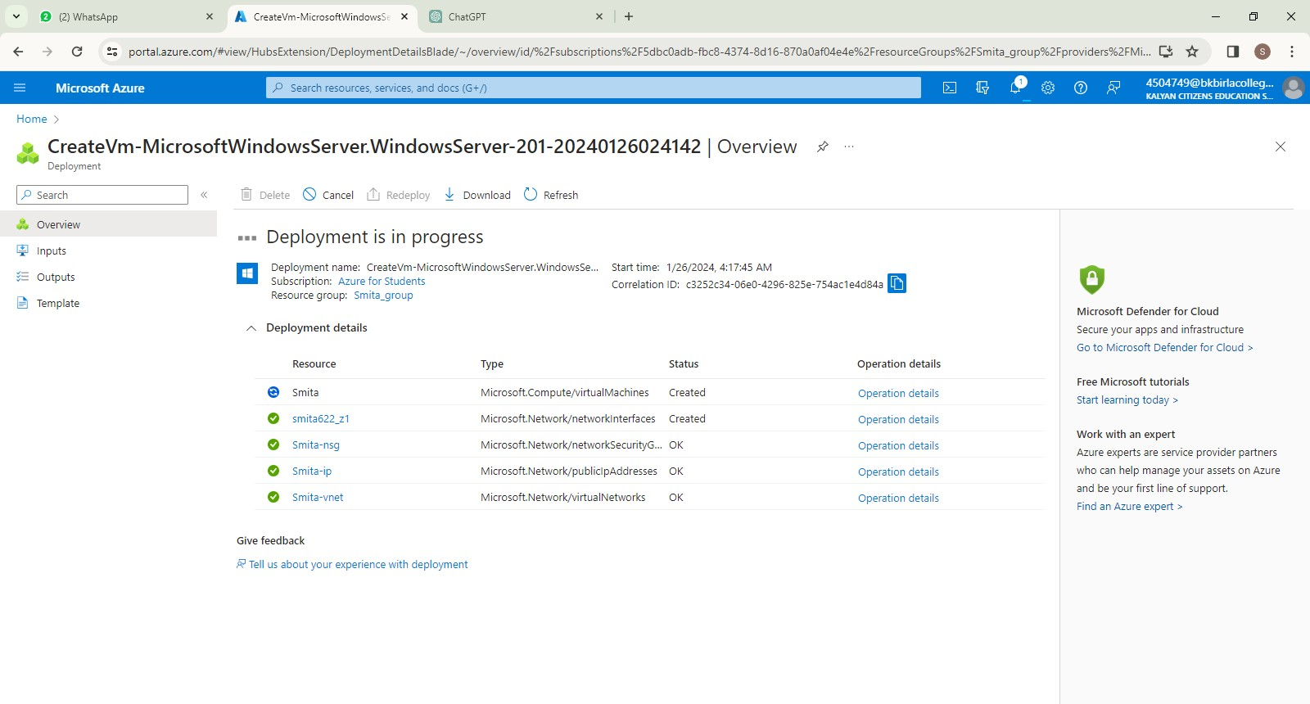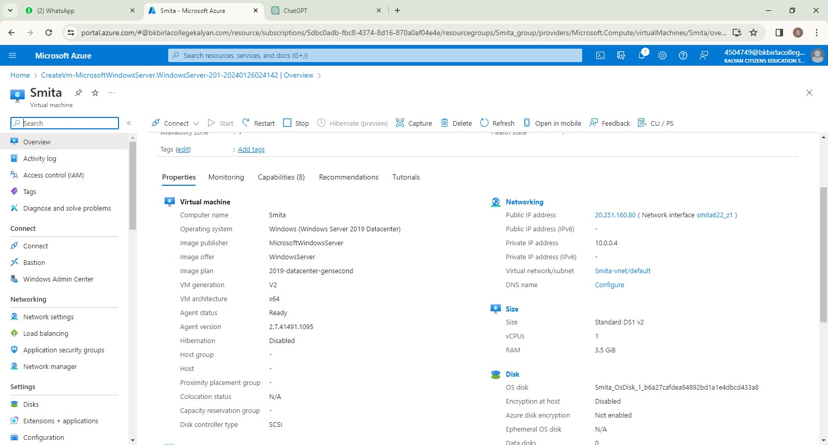

# Steps to Creating a Free Tier AWS Account:

1. Open the [Amazon Web Services (AWS) home page](https://aws.amazon.com).
2. Choose **Create an AWS Account**.  
   **Note:** If you signed in to AWS recently, choose **Sign in to the Console**. If **Create a new AWS account** isn't visible, first choose **Sign in to a different account**, and then choose **Create a new AWS account**.

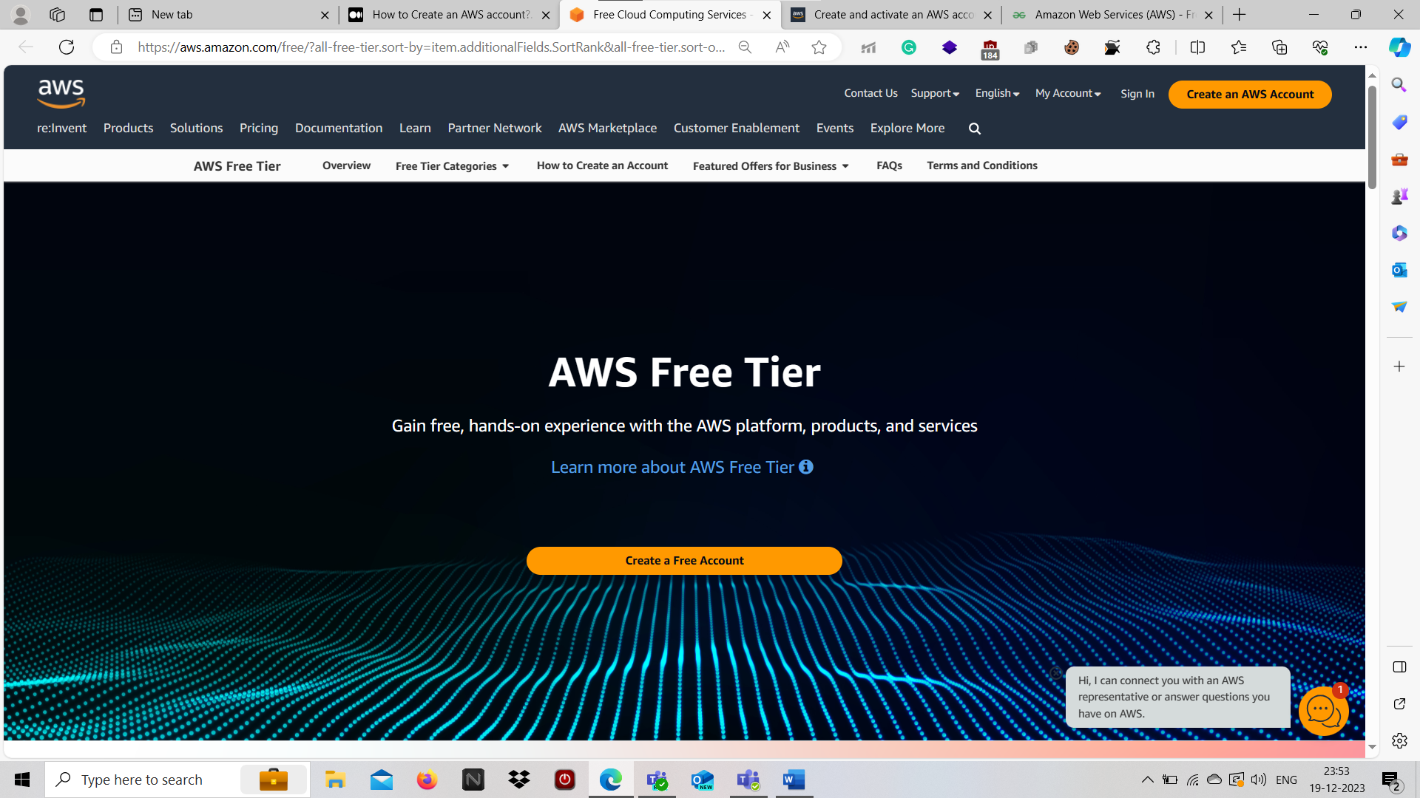

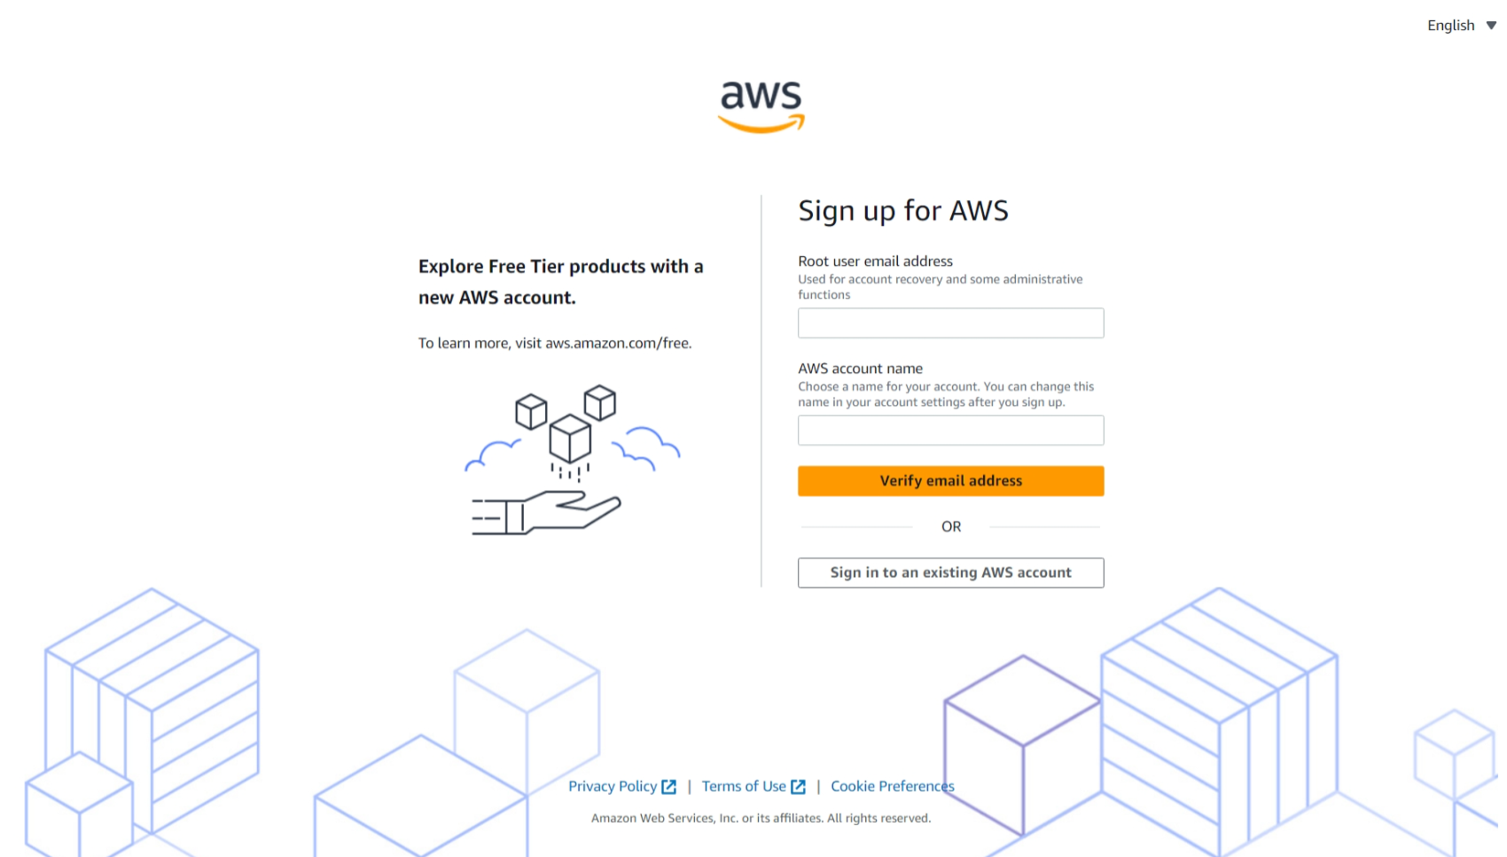

1. Enter the valid required details like Email address, Password and AWS account name. Then click **verify email address**.

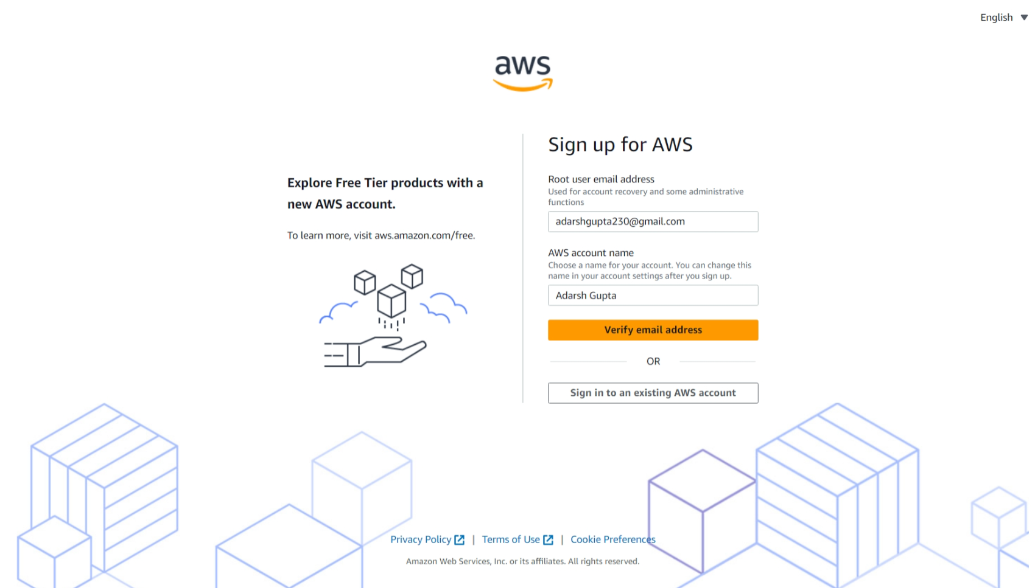

1. Check respective email. After receiving verification code, to copy the verification code.

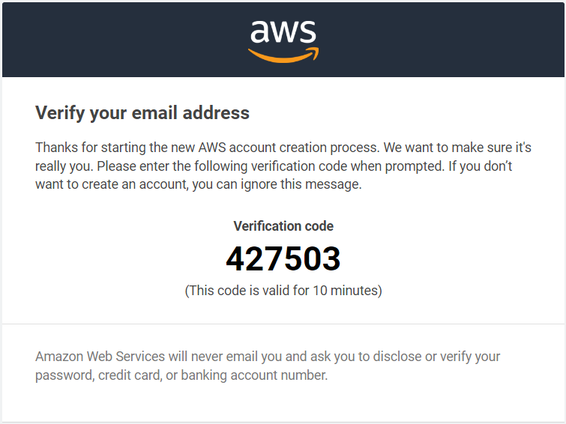

1. Fill the verification code and Click **Verify**.

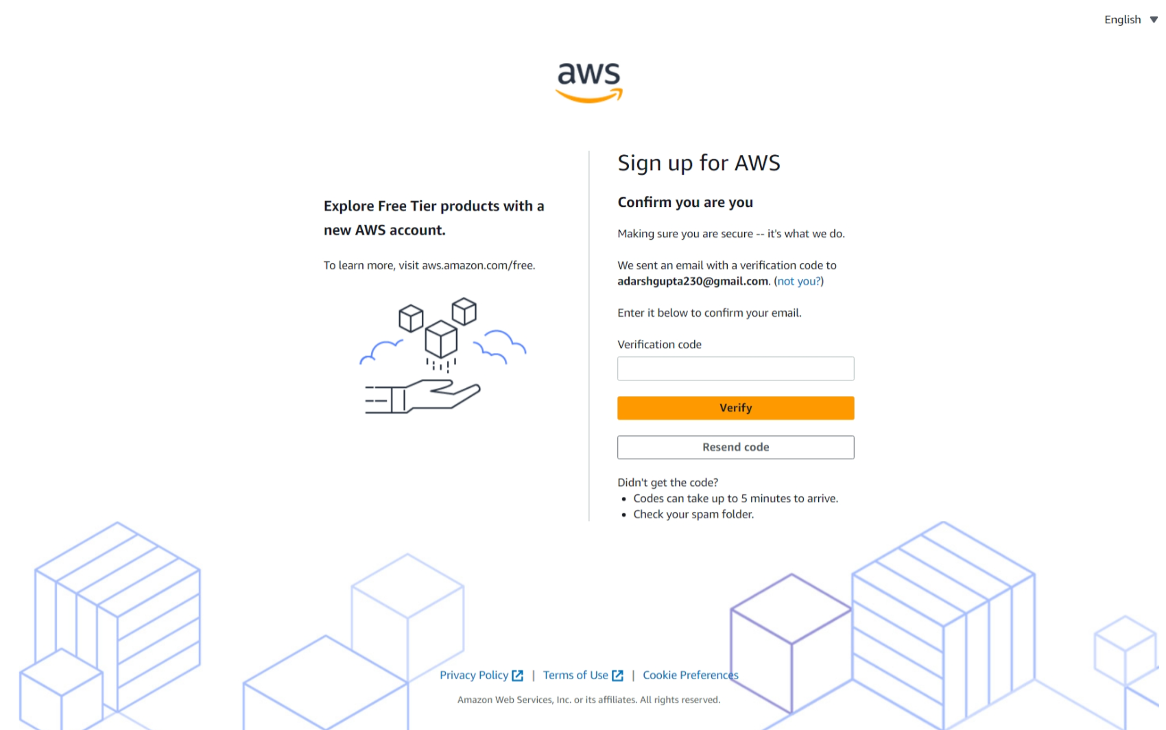

1. Email address has been successfully registered. Then set Root user password. Then **Continue.**

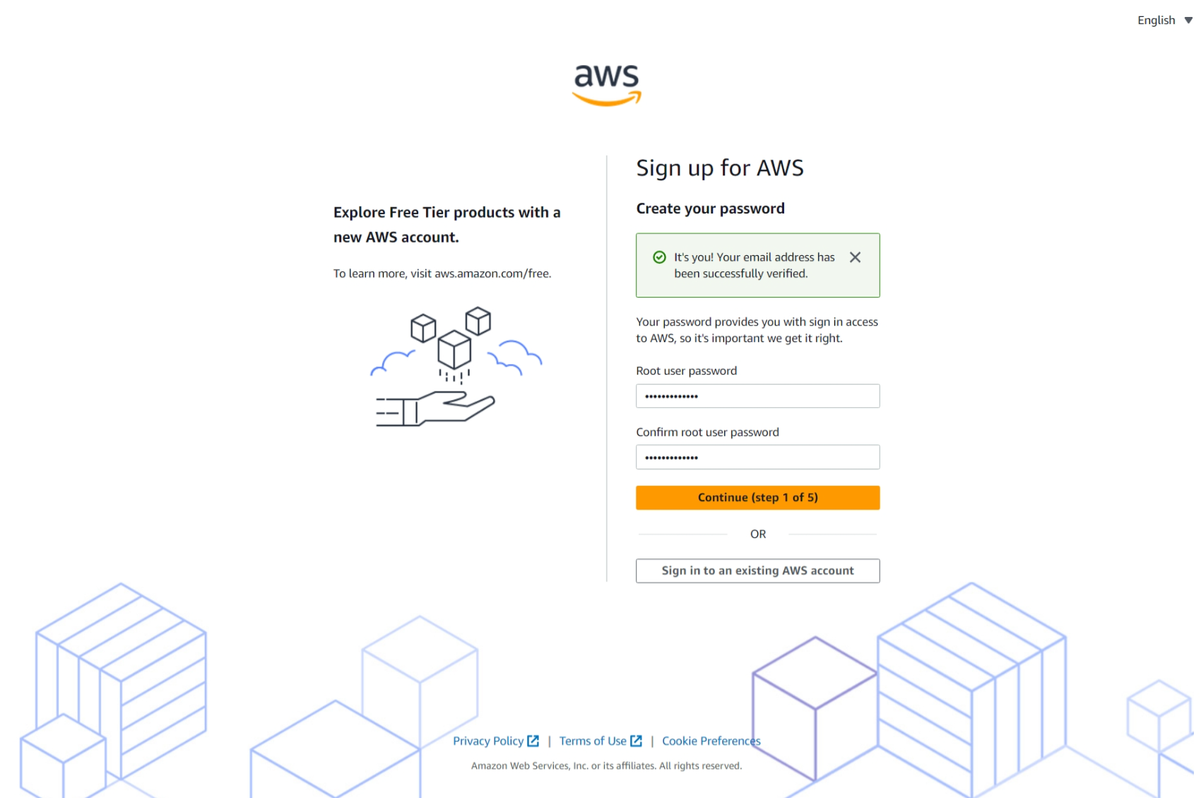

1. Now, the registration process will ask you Personal Information. You should enter the valid Information.

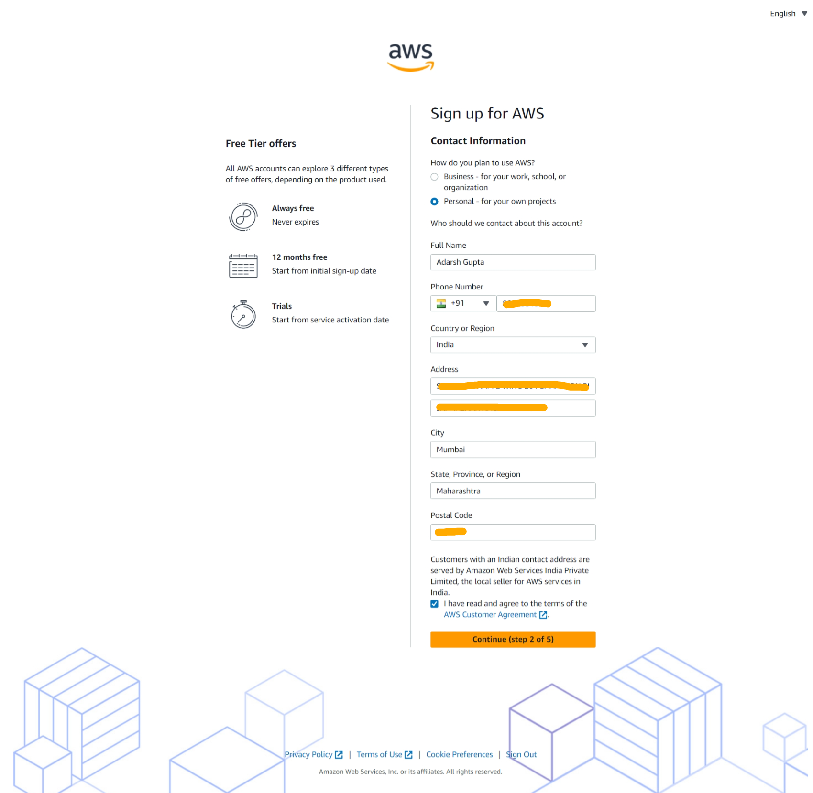

1. Now, you will provide your payment information. Don’t worry about charges right now.

According to AWS: Please type your payment information so, we can verify your identity. We will not charge you unless your usage exceeds the [AWS Free Tier Limits](https://aws.amazon.com/free/)

In fact, depending on your credit card or debit card company, may be AWS could charge you about **USD $1.00** to check if it is a valid credit card or debit card. They usually undo this charge later.

Click **verify and continue.**

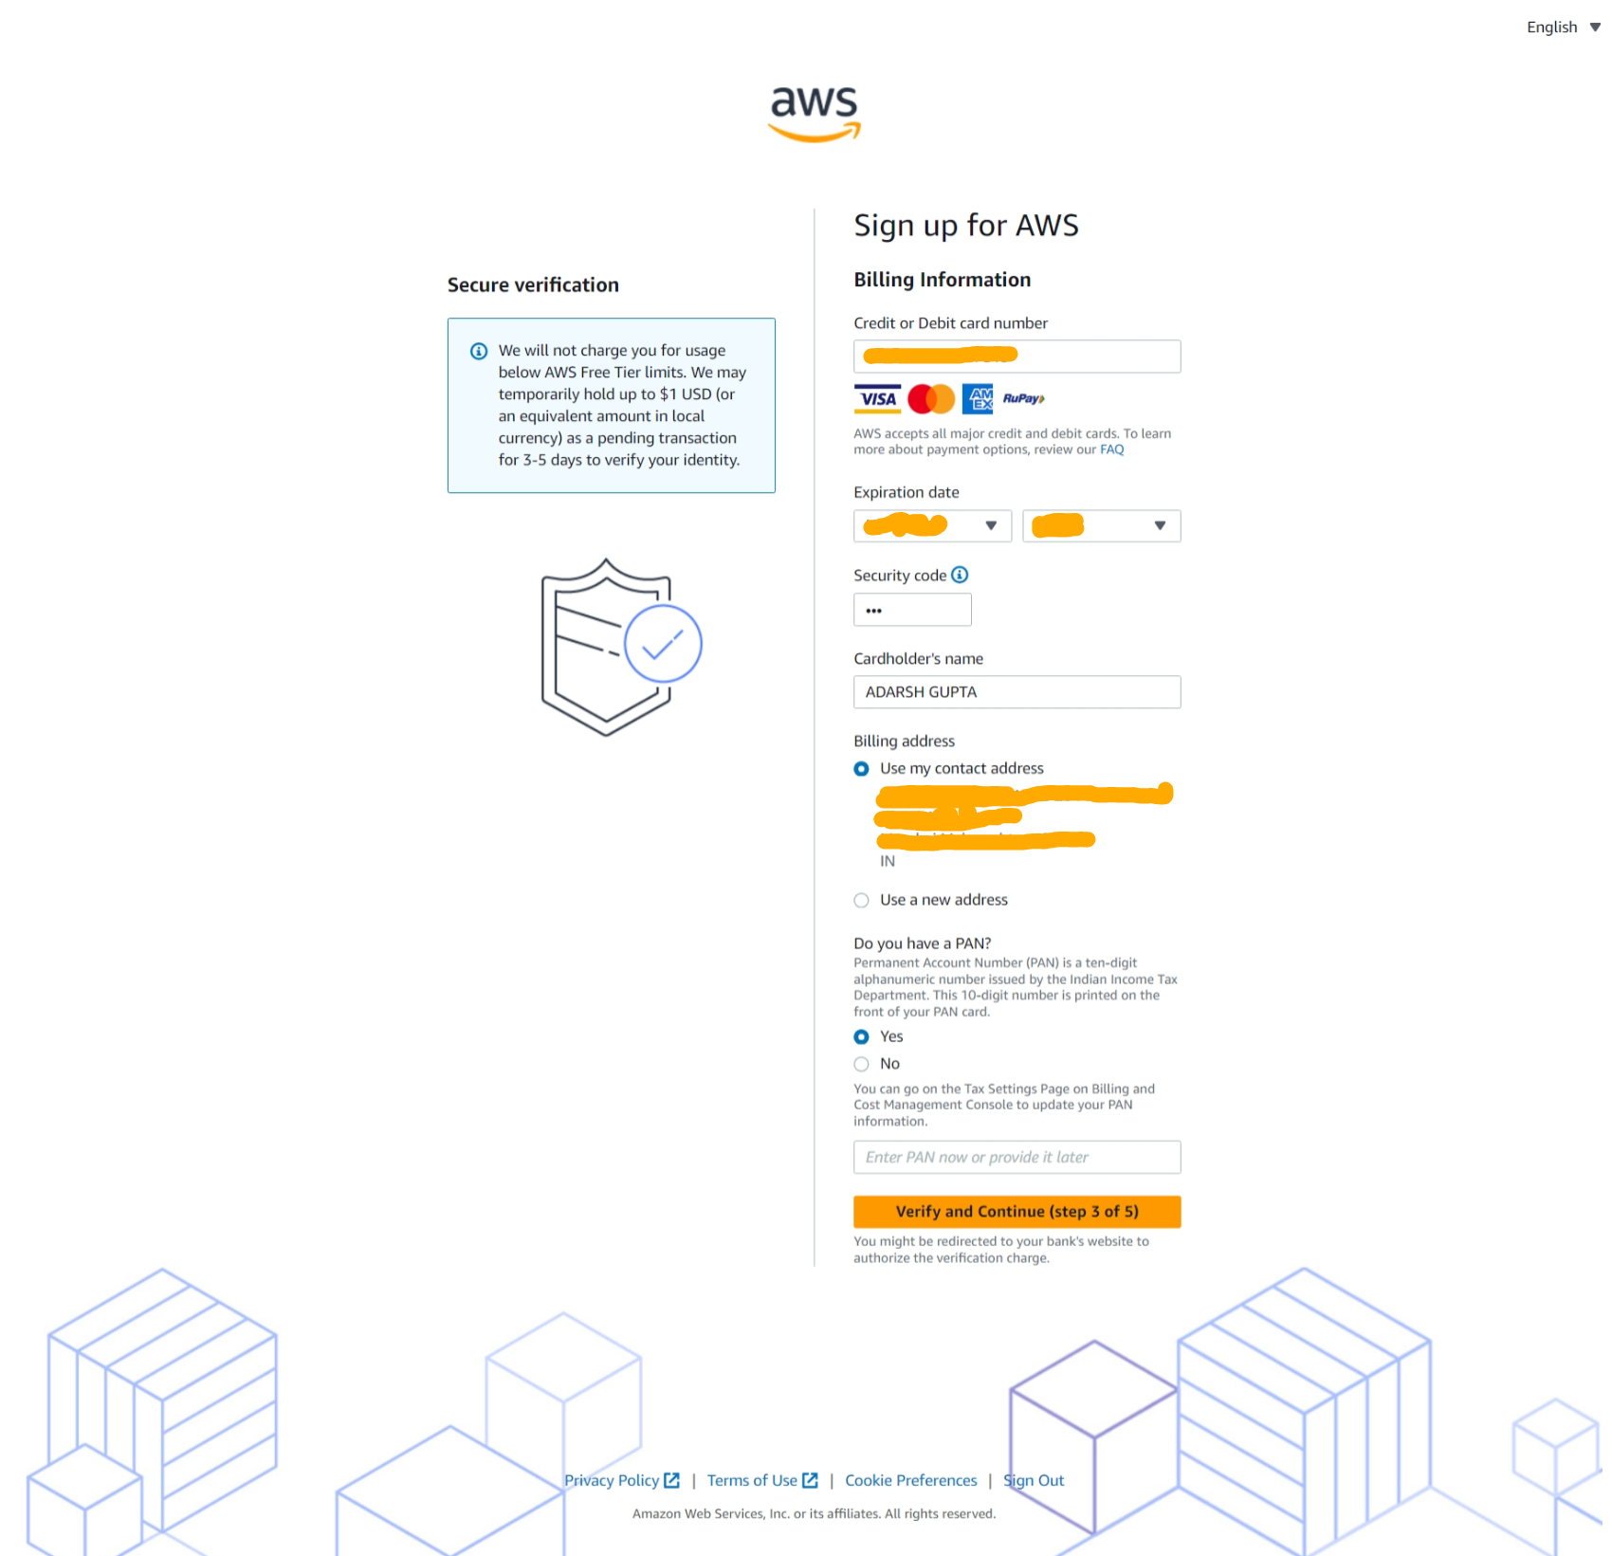

1. Processing the payment process.

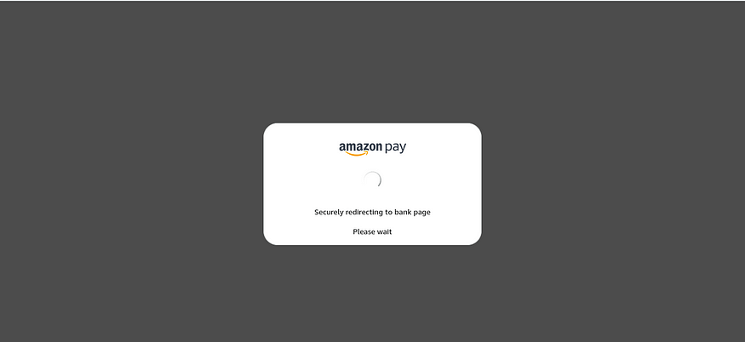

1. One Time Password will send the respective phone number.

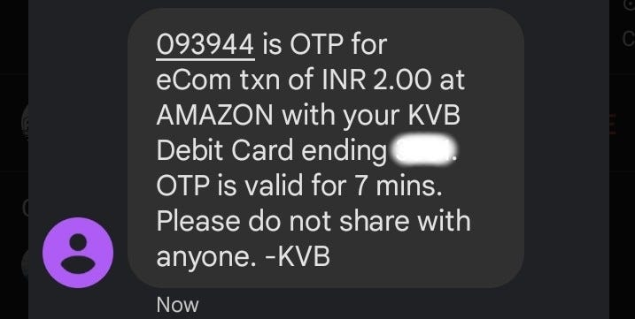

1. Now, Enter the one-time password in respective **bank** page. and then submit.

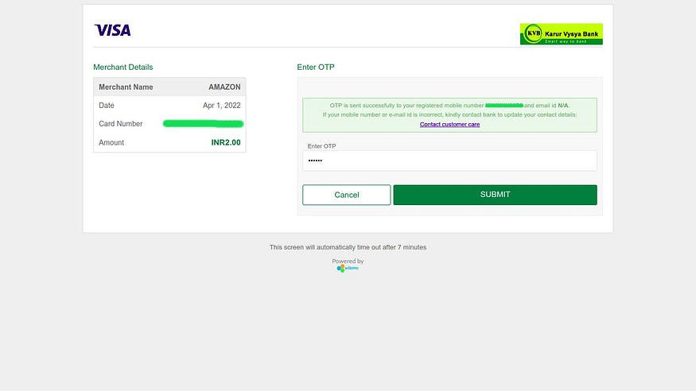

1. Now you must confirm your identity to activate your account. You can choose a Text message(SMS) or a Voice call to receive the verification code. And also presented with a CAPTCHA, enter the displayed code, and then **send**.

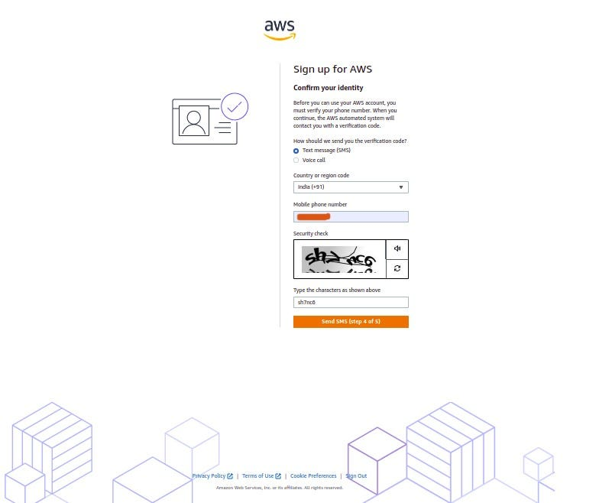

1. Click on the **Send** button to continue. After the Verification send to Respective phone number.

In my case, I choose Text message(SMS). After receiving verification code, to copy the verification code.

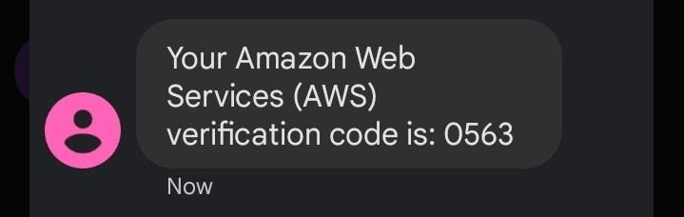

1. Fill the verification code and Click **Continue**.

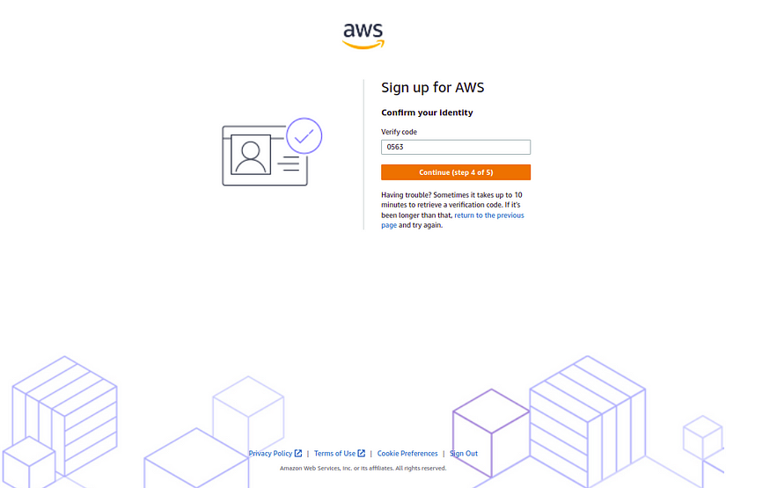

1. On the Select a support plan page, choose one of the available Support plans.

You can start with the **Basic support - Free** . I strongly recommend reading about the Support Plans to be aware of what each one covers.

In my case, I choose **Basic support - Free.**

Then, Choose **Complete sign up**.

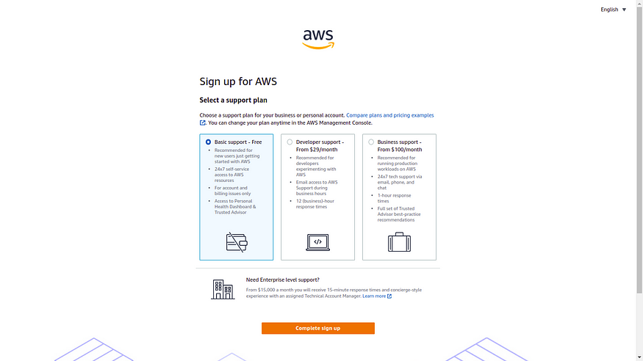

1. **Amazon Web Services** account has successfully created. Click **Go to the AWS Management Console**.

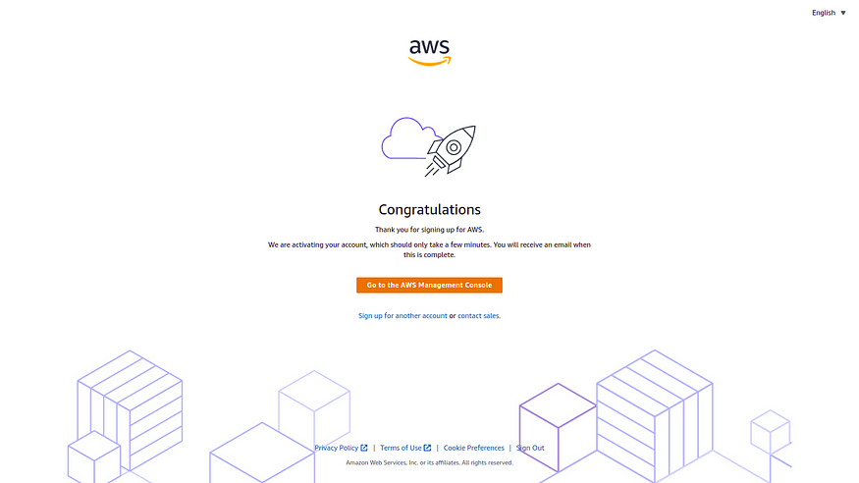

1. **Now, Enter your** Personalize Your Experience**. Click** Submit.

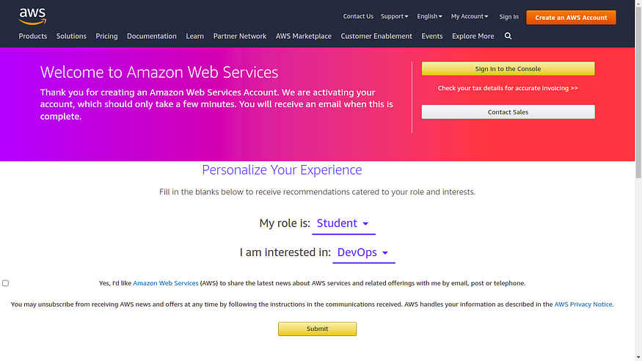

1. **Click** Sign in to the Console.

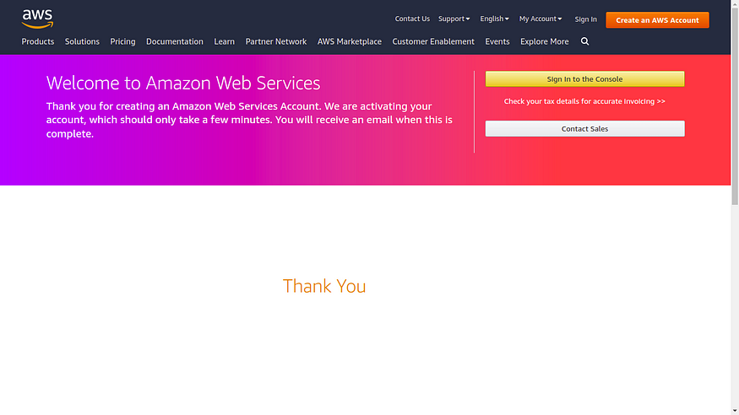

1. **Choose** Root user **and enter registered email and then click** Next.

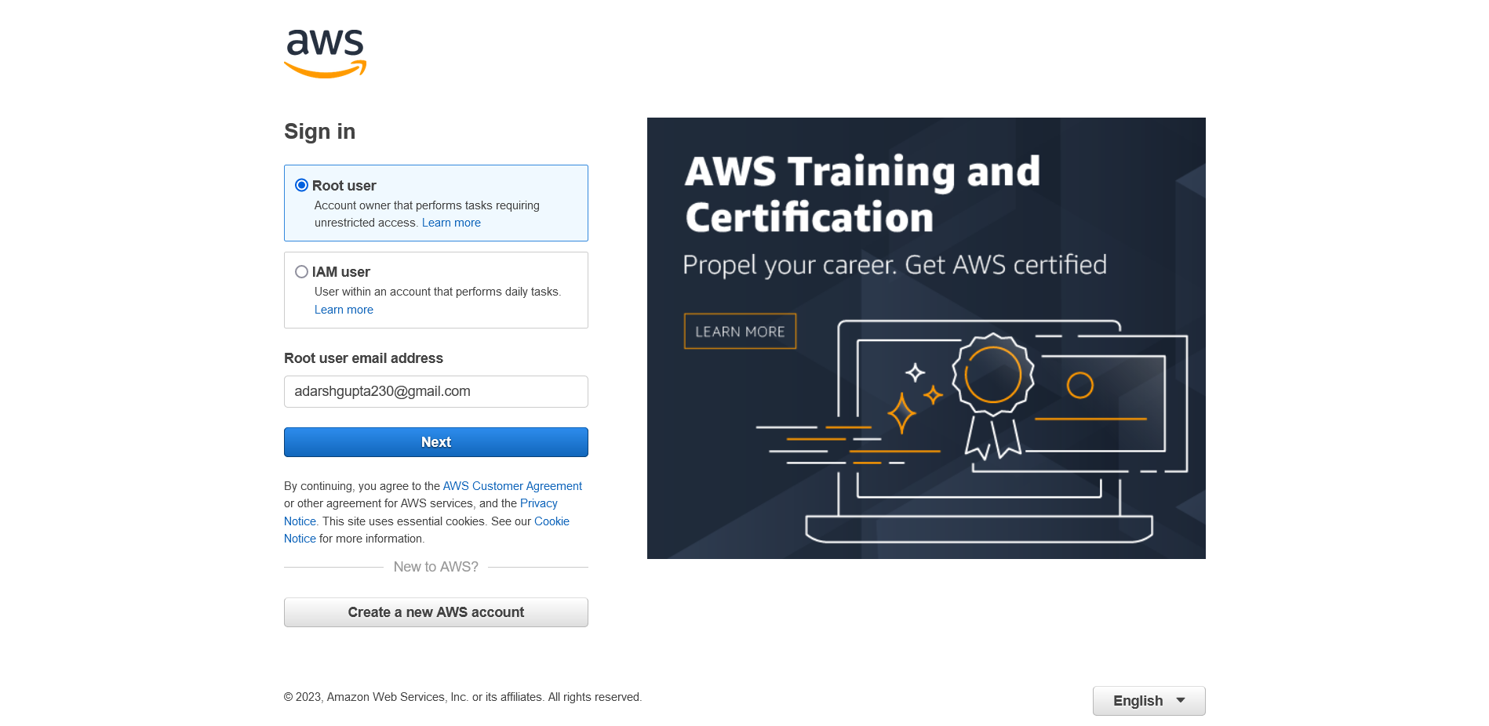

1. **Enter the root password and click** Sign In.

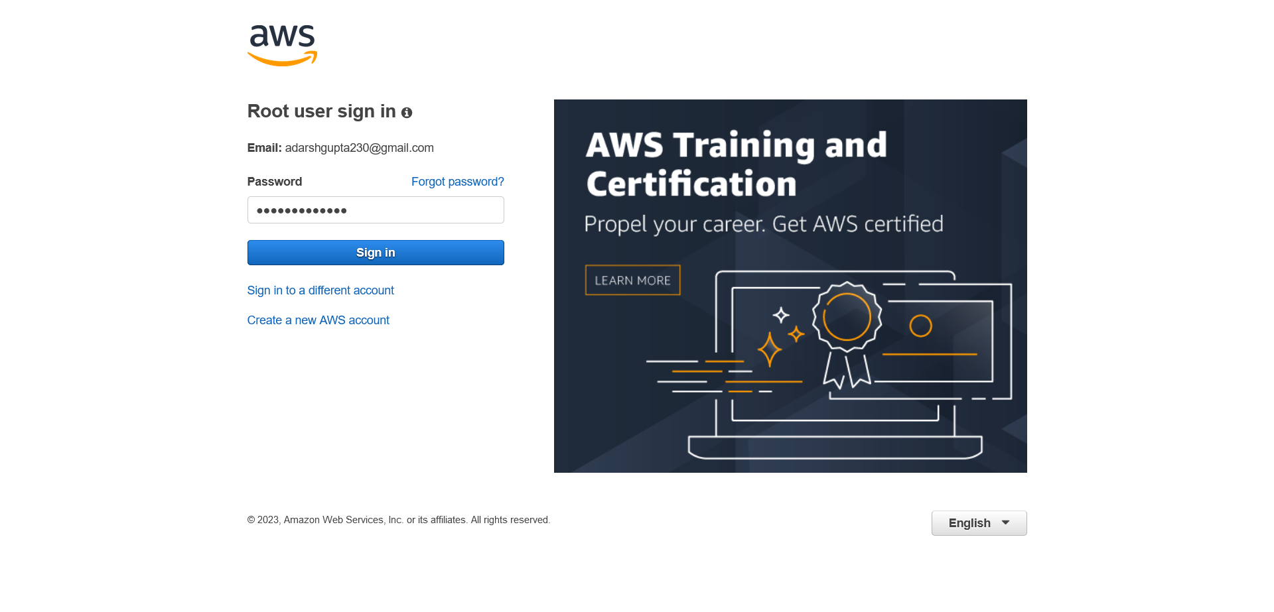

1. **Now,** Amazon Web Services **account has successfully logged in.**

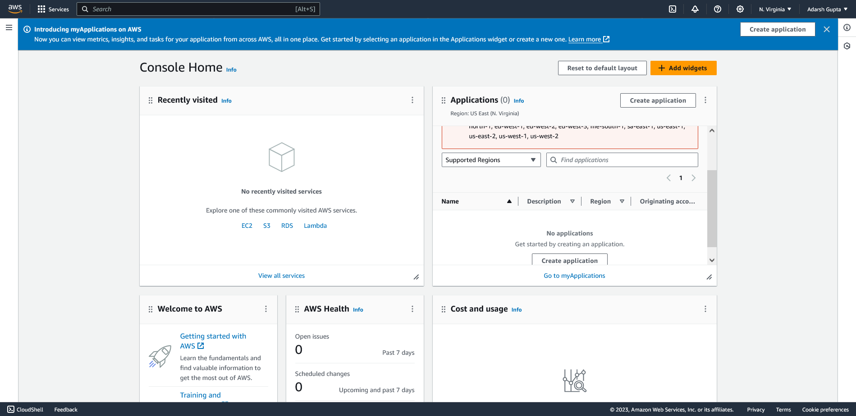

1. **Explore** All services**.**

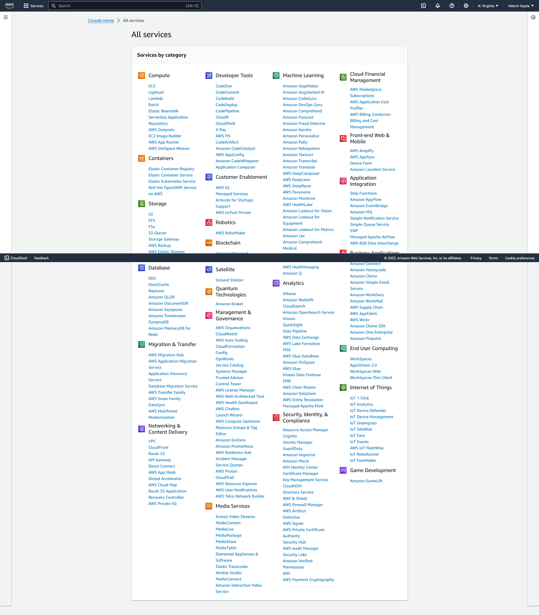

# Experiment No.8

**Step1:** Open Power BI Desktop. In the Home tab, click on the "Get Data" option. Choose the type of data source you want to connect to. Common options include Excel, CSV.

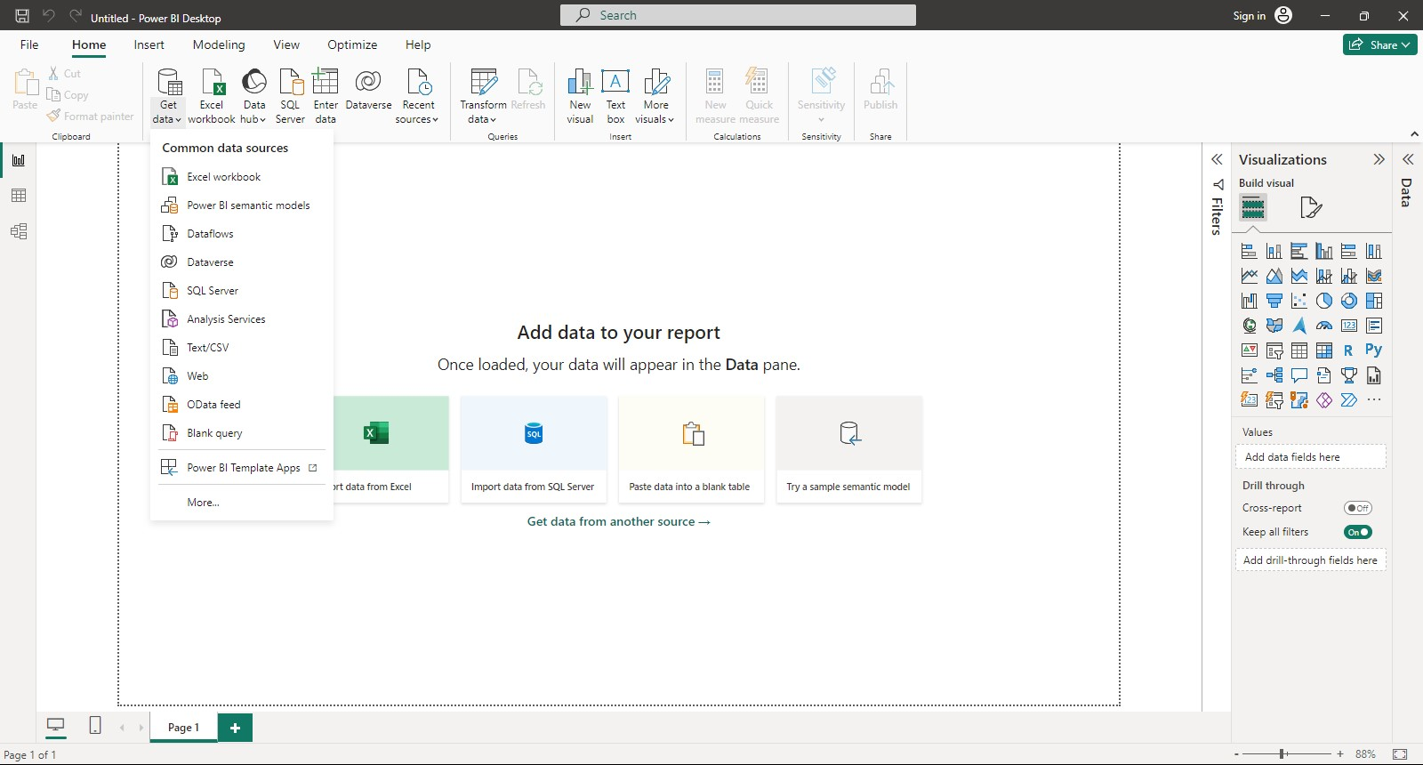

**Step2:** Click "Transform Data" if you need to make adjustments in Power Query Editor. Click the "Close & Apply" button to load the data into Power BI.

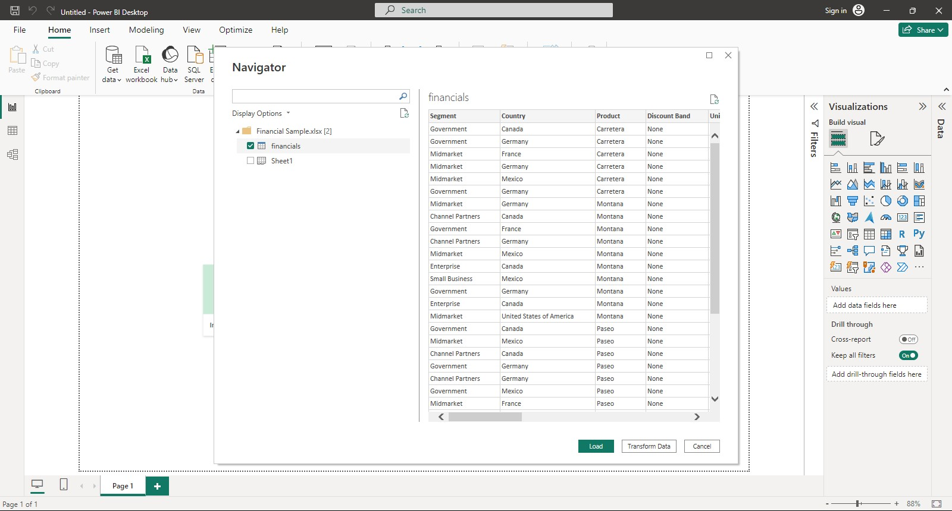

**Step3:** Once loaded, you'll see the data fields in the Fields pane on the right side of the Power BI window. Now, your dataset is loaded into Power BI, and you can start creating visualizations, reports, and dashboards with the imported data.

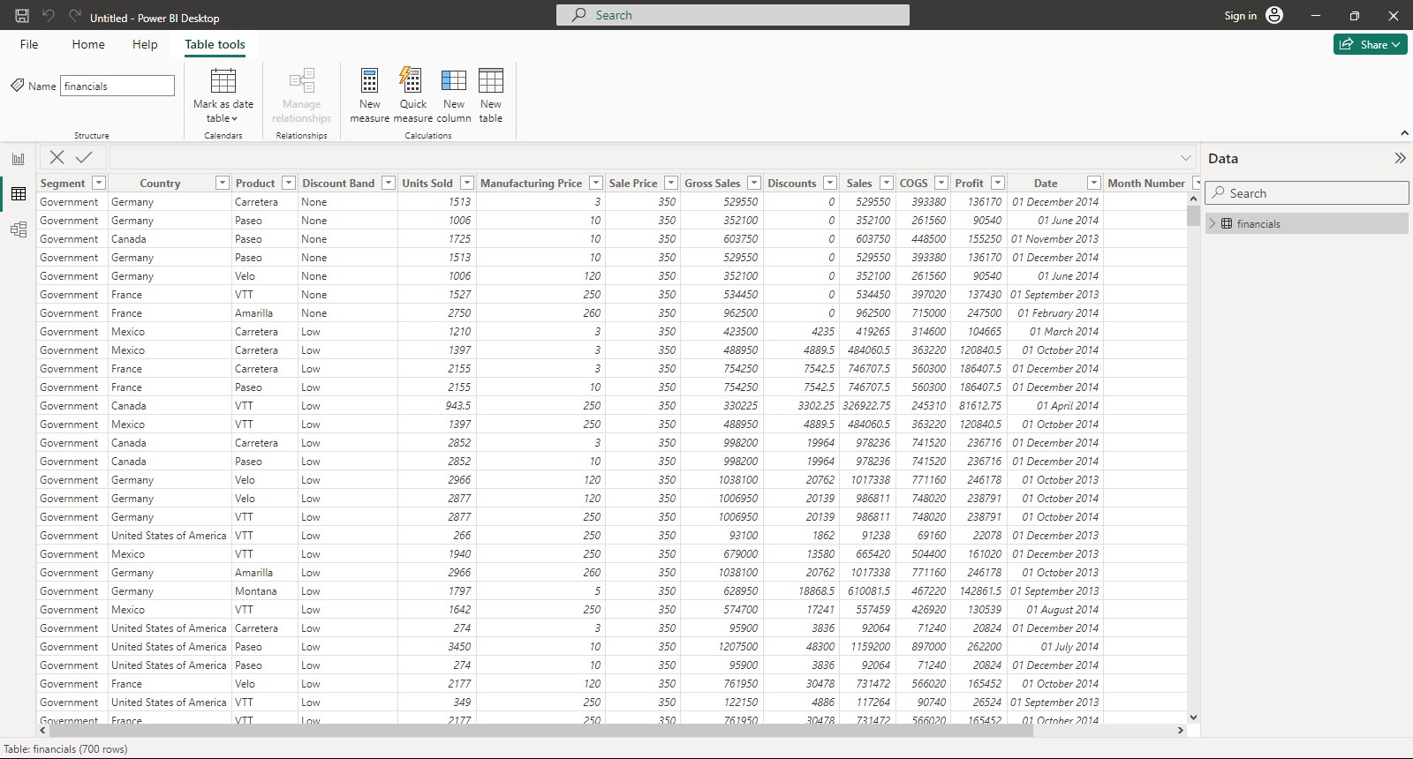

**Step4:** Go to the "Visualizations" pane on the right side. Drag and drop fields from your dataset into the "Fields" pane to create visualizations.

Here, 10 quetsion are cretaed based on dataset to show the visualizations

1. **What is the overall sales trend over time?**

**“Gross Sales Trend”:** Line chart showing gross sales.

1. **Which product category contributes the most to total sales?**

**“Product Category Contribution”:** Donut chart depicting the percentage contribution of each product category.

1. **Who are the top customers based on purchase amount?**

**“Top Customers and Their Purchases”:** Donut chart depicting the percentage contribution of each product category.

1. **What is the distribution of sales across different countries?**

**“Regional Sales Distribution”:** Map visualization or stacked bar chart showing sales by country.

1. **Which month had the highest sales?**

**“Highest Sales Month Analysis”:** Bar chart highlighting sales for each month.

1. **What is the average gross value?**

**“Average Gross Value Overview”:** Bar Chart visualization displaying the average gross value.

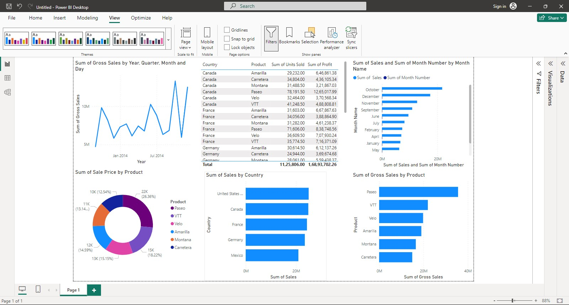

1. **How does product vary by sales prices?**

**“Sales prices Analysis”:** Waterfall chart showing sales prices for each product.

1. **Which product category shows the high discount?**

**“Product discount Distribution”:** Pie chart showing the discount percentage of product based on the region.

1. **What is the correlation between sum of discounts and product category?**

**“Discounts vs. Product Correlation”:** Scatter plot showing the correlation betweenof discount and product category.

1. **What is the distribution of sales by time period?**

**“Sales Distribution”:** Ribbon chart to visualize the distribution of sales by time period.

